UNITED STATES

SECURITIES AND EXCHANGE COMMISSION

Washington, D.C. 20549

SCHEDULE 14A

Proxy Statement Pursuant to Section 14(a) of the

Securities Exchange Act of 1934

(Amendment No. )

Filed by the Registrant ☒

Filed by a Party other than the Registrant ☐

Check the appropriate box:

- Preliminary Proxy Statement
- Confidential, for Use of the Commission Only (as permitted by Rule 14a-6(e)(2))

- Definitive Proxy Statement

- Definitive Additional Materials

- Soliciting Material Pursuant to §240.14a-12

ELI LILLY AND COMPANY

(Name of Registrant as Specified In Its Charter)

(Name of Person(s) Filing Proxy Statement, if other than the Registrant)

Payment of Filing Fee (Check all boxes that apply):

- No fee required

- Fee paid previously with preliminary materials

- Fee computed on table in exhibit required by Item 25(b) per Exchange Act Rules 14a-6(i)(1) and 0-11

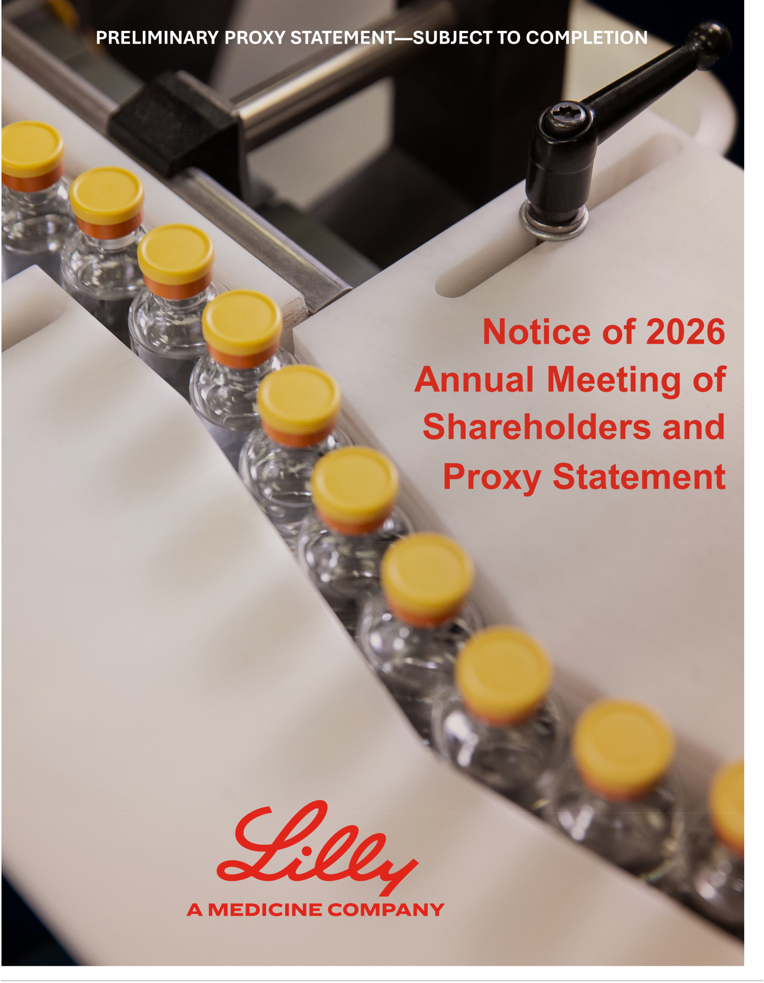

Dear Fellow Shareholders,

Thank you for your continued support of Eli Lilly and Company.

2025 was another year of significant progress for our company. We delivered innovative medicines to more patients, advanced promising research, and expanded our capacity to meet rising global demand. Through year-end 2025, we achieved strong total shareholder returns, driven by share price appreciation and dividends.
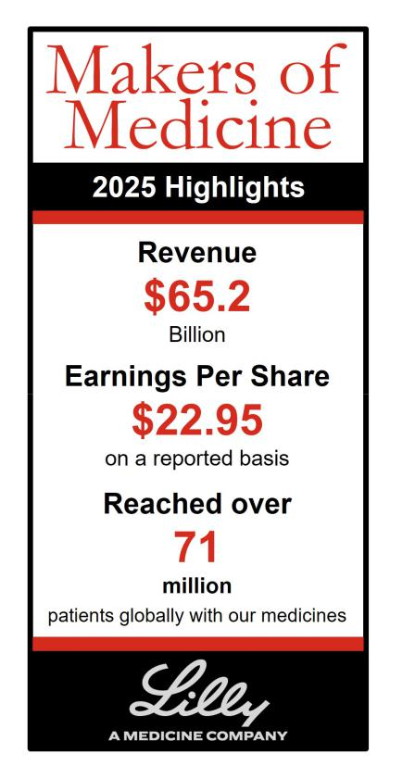

We made significant progress this year with several drug approvals for treating cancer and digestive diseases and submitted orforglipron, our oral GLP-1 therapy, for obesity to regulatory authorities in the U.S. and Japan and for obesity and type 2 diabetes in the EU. We also advanced promising treatments for weight management, heart disease prevention, and various types of cancer through clinical testing.

We worked to expand access to obesity medicines through a landmark agreement with the U.S. government to broaden availability through government programs. This initiative is designed to significantly reduce out-of-pocket costs for millions of Americans and reflects our commitment to affordability and patient access. To support future growth and patient needs, we announced record manufacturing investments, with new facilities and global expansions expected to strengthen our supply chain and enable delivery of medicines at scale.

We pursued breakthrough discoveries on three fronts. Significant investments were made in expanding our research laboratories and capabilities, including building out advanced drug development platforms that could unlock new approaches to targeting disease. Partnerships were forged to deploy AI to help decode biology, with the potential to accelerate the discovery of new treatments with unprecedented speed and precision. We also expanded our network of collaborators, partners, and strategic biotech acquisitions, allowing us to harness collective expertise and assets. Together, these investments position us to strive toward delivering breakthrough therapies to patients faster than ever before.

Our global health and sustainability initiatives remain central to our

purpose. We continue to progress our 30x30 goal of improving quality health care access for 30 million people living in resource-limited settings annually by 2030. We remain committed to advancing healthcare access and ensuring our innovative medicines are available to more people living in resource-limited settings. We also advanced toward our 2030 climate goals, including generating or purchasing approximately 80% of our electricity in 2025 from renewable sources (including onsite-generation, purchased energy, and renewable energy certificates).

Your input continues to shape our governance priorities. Based on investor feedback, we again are proposing to eliminate the classified board structure and supermajority voting requirements from our articles of incorporation.

As we approach Lilly’s 150th anniversary in May, we remain committed to building on our legacy of innovation to improve human health for generations to come. With your support, we will continue to invest in pioneering research and deliver medicines that make a meaningful difference for more people worldwide.

We look forward to welcoming you to the annual meeting.

Sincerely,
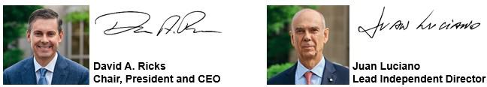

Table of Contents

Notice of 2026 Annual Meeting of
Shareholders | 1
Proxy Statement Summary | 2
Governance | 8
Director Qualifications | 8
Item 1 - Election of Directors | 10
Director Nominations | 24
Director Compensation | 26
Leadership Structure | 29
Board Structure | 31
Governance Practices | 34
Board Alignment | 39
Communication with the Board of Directors | 41
Shareholder Engagement on Governance | 41
Issues
Ownership of Company Stock | 42
Compensation | 44
Item 2 - Approval, on an Advisory Basis, of the
Compensation Paid to the Company’s Named | 44
Executive Officers
Talent and Compensation Committee Matters | 44
Compensation Discussion and Analysis | 46
Executive Compensation Tables | 59
CEO Pay Ratio | 67
Pay versus Performance | 67
Audit Matters | 71
Item 3 - Ratification of the Appointment of the | 71
Independent Auditor
Management Proposals | 74
Item 4 - Proposal to Amend the Company’s
Articles of Incorporation to Eliminate the | 74
Classified Board Structure
Item 5 - Proposal to Amend the Company’s
Articles of Incorporation to Eliminate | 75
Supermajority Voting Provisions
Shareholder Proposals | 77
Item 6 and Item 7 | 77
Other Information | 82
Meeting and Voting Logistics | 82
Other Matters | 86
Appendix A - Summary of Adjustments
Related to the Annual Cash Bonus | A-1
Appendix B - Proposed Amendments to
the Company’s Articles of Incorporation | B-1

Frequently Referenced Topics


Director Biographies | 10
Director Skills Matrix | 23
Director Compensation | 26
Board Leadership Structure | 29
Board and Committee Oversight of:
Sustainability | 37
Cybersecurity | 37
Artificial Intelligence | 37
Political Activities | 37
Human Capital Management | 38
Transactions with Related Persons | 39
Share Ownership and Retention Guidelines | 58
Compensation Recovery Policy (Clawback) | 58

Cautionary Statements

This proxy statement contains forward-looking statements, including those regarding our strategies and financial performance; our development of new products, indications and technologies; our development and use of artificial intelligence and other emerging technologies, including through collaborations with third parties; global health and sustainability metrics, commitments, initiatives, and goals; and other statements that are not historical fact, and actual results could differ materially. Risks that could cause actual results to differ are set forth in the “Risk Factors” section of, and elsewhere in, our 2025 Annual Report on Form 10-K and our other filings with the

Securities and Exchange Commission (SEC). Readers are cautioned not to place undue reliance on these forward-looking statements, which speak only as of the date

hereof and are based on management estimates, projections, and assumptions, and we undertake no obligation to update any such statements.

Certain documents and information referenced in this proxy statement are available on our website. However, we are not including the information contained on our website, or any information that may be accessed by links on our website, as part of, or incorporating it by reference into, this proxy statement.

The information contained under the heading “Pay Versus Performance” shall not be incorporated by reference into any filing under the Securities Act of 1933 or the Securities Exchange Act of 1934 (the Exchange Act) except to the extent that we specifically incorporate it by reference in any such filing. All trademarks or trade names referred to in this proxy statement are the property of the company, or, to the extent trademarks or trade names belonging to other companies, the property of their respective owners. Solely for convenience, the trademarks and trade names in this proxy statement are referred to without the ® and ™ symbols, but such references should not be construed as any indicator that the company or, to the extent applicable, their respective owners will not assert, to the fullest extent under applicable law, the company's or their rights thereto. We do not intend the use or display of other companies’ trademarks and trade names to imply a relationship with, or endorsement or sponsorship of us by, any other companies.

Unless otherwise expressly stated or context requires otherwise, information in this proxy statement is as of March 20, 2026.

Notice of 2026 Annual Meeting of Shareholders




 | WHEN | WHERE | RECORD DATE
 | 9:30 a.m. EDT | Virtually at www.virtualshareholder | February 25, 2026
 | Monday, May 4, 2026 | meeting.com/LLY2026
 |  |  | Board Vote | See
Items of Business |  |  | Recommendation | Page
Item 1 Election of each of the four director nominees to serve three-year terms |  |  | FOR each nominee | 10
Item 2 Approval, on an advisory basis, of the compensation paid to the company’s |  |  | FOR | 44
 | named executive officers
Item 3 Ratification of the appointment of Ernst & Young LLP as the independent |  |  | FOR | 71
 | auditor for 2026
Item 4 | Approval of amendments to the company’s articles of incorporation to |  | FOR | 74
 | eliminate the classified board structure
Item 5 | Approval of amendments to the company’s articles of incorporation to |  | FOR | 75
 | eliminate supermajority voting provisions
Item 6 | Shareholder proposal to adopt a policy and amend the bylaws to require an |  | Against | 77
 | independent board chair
Item 7 | Shareholder proposal to prepare an annual lobbying report |  | Against | 80

How to Attend and Vote at the Annual Meeting. The 2026 annual meeting of shareholders (the Annual Meeting) of Eli Lilly and Company will be held virtually via live webcast. To attend the Annual Meeting, vote, and submit questions, visit virtualshareholdermeeting.com/LLY2026 and enter the 16-digit control number found on your proxy card, voting instruction form, or notice.

More Information. See Other Information—Meeting and Voting Logistics for more information on how to vote and Annual Meeting Logistics.

Your Vote is Important. Even if you plan to attend the Annual Meeting, we encourage you to vote prior to the meeting by one of the methods shown below.





ONLINE | BY TELEPHONE | BY MAIL | AT THE MEETING*
Visit the website listed on | Call 1-800-690-6903 and | Sign, date, and return your | virtualshareholdermeeting.com/LLY2026
your notice, proxy card, or | follow the instructions | paper proxy card or voting | on Monday, May 4, 2026, at 9:30 a.m.
voting instruction form | provided | instruction form | EDT

*Shareholders who hold their shares in the 401(k) Plan must vote by April 29, 2026.

By order of the Board of Directors,

Anat Hakim

Executive Vice President, General Counsel and Secretary

March 20, 2026


AVAILABILITY OF PROXY MATERIALS FOR THE MAY 4, 2026 SHAREHOLDER MEETING:

The proxy statement is dated March 20, 2026, and a notice of internet availability of proxy materials was mailed on or about that date to our shareholders of record as of February 25, 2026. The annual report to shareholders and proxy statement are available at ProxyVote.com as well as on our website at lilly.com/about/annual-reports.

1

Proxy Statement Summary

Powered by Purpose

Our purpose is to unite caring with discovery to create medicines that make life better for people around the world. This purpose fuels every aspect of our business, as we aspire to:

Discover first or best-in-class molecules from internal and external sources that address significant unmet needs by integrating disease understanding with innovative scientific capabilities;

Develop molecules faster than competitors by executing clinical plans that maximize the human and economic value of the medicines we launch;

Reach people around the world by creating volume-driven uptake and broad access to a safe and reliable supply of life-changing medicines;

Scale our business by prioritizing investments into medicines and manufacturing capacity that can deliver the greatest value for patients and can drive long-term sustainable growth; and

Reinvest profits into our next wave of innovation and generate value for our investors.

Highlights of 2025 Performance

We continued to progress our strategy in 2025 with respect to operating performance, shareholder return (both absolute and relative), our innovation pipeline and other business development and sustainability matters. See our 2025 Form 10-K for more details on our financial performance.
 Operating Performance

$65.2 | $22.95 | $24.21
billion | earnings per share (EPS) | EPS on a
in revenue | on a reported basis | non-GAAP basis

Reported results were prepared in accordance with U.S. generally accepted accounting principles (GAAP) and include all revenue and expenses recognized during the periods. A reconciliation of EPS on a reported basis to EPS on a non-GAAP basis is included in Appendix A.

 Shareholder Return

40% | Consistently Exceeded S&P 500 and Peer Group¹
2025 Total Shareholder | TSR in 2025 and the three- and five-year periods shown below
Return (TSR)
 | TSR includes both stock price
 | changes and dividends.
 | Dividends are assumed to be
 | immediately reinvested in
 | company stock. TSR results for
 | the Peer Group were calculated
 | using a market capitalization
 | weighted average.
 | 1 The peer group in this chart
 | comprises the same companies as our
 | executive compensation pharma peer
 | group (detailed in the Benchmarking
 | Compensation section), plus Novo
 | Nordisk, which is excluded from
 | compensation benchmarking due to
 | limited disclosed compensation data.
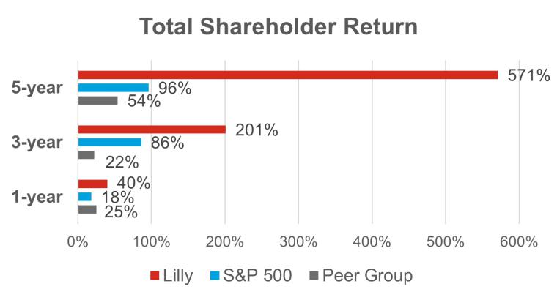

2

 Innovation Pipeline and Other Business Development

Highlights for New Products and Indications




Lilly submitted orforglipron to the FDA for the treatment of obesity.

The FDA approved an updated label for Kisunla with new dosing in early symptomatic Alzheimer’s disease.

The FDA approved Omvoh’s single-injection maintenance regimen in adults with ulcerative colitis.

Key Data Readouts

- Presented positive results from SURMOUNT-5, a head-to-head Phase 3 trial, where patients on Zepbound achieved an average weight loss of 20.2%, versus 13.7% with Wegovy.

- Presented positive results for the orforglipron Phase 3 weight management program (ATTAIN-1 and ATTAIN-2), demonstrating meaningful weight loss, A1C reductions and cardiometabolic improvements compared to placebo.

- Presented results from the Olumiant BRAVE-AA-PEDS Phase 3 trial, showing meaningful hair regrowth outcomes for adolescent patients (ages 12 to <18) with severe alopecia areata.

Other Business Development Activities

- Acquired Verve Therapeutics, a Boston-based clinical-stage company developing genetic medicines for cardiovascular disease.

- Launched a platform, giving biotechnology companies access to artificial intelligence (AI)-enabled drug discovery models.

- Announced an agreement to build the pharmaceutical industry’s most powerful AI supercomputer, developing an “AI Factory” that will provide new AI capabilities to help scientists identify, optimize, and validate new molecules.

 Sustainability Matters


Generated and purchased

~80%

of electricity from renewable sources in 2025, including on-site generation, purchased energy and renewable energy certificates


LEED Gold Certification

(Leadership in Energy and Environmental Design)

for sustainable building design and construction

achieved by our Limerick manufacturing site

Access and Affordability

Lilly announced an agreement with the U.S. government to expand access to its obesity medicines and reduce patient costs, including Medicare access for Zepbound that is expected by July 1, 2026.

LillyDirect™ launched the first retail pick-up option with direct-to-consumer pricing for Zepbound.

Lilly also announced multiple expansions designed to boost capacity to make life saving medicines, including:

- Plans for a new $3 billion facility to boost oral medicine manufacturing capacity in the Netherlands for patients worldwide

- Plans for a more than $1.2 billion investment in our Puerto Rico facility to boost oral medicine manufacturing capacity in the United States

- Plans to build a $5 billion manufacturing facility in Virginia to develop active pharmaceutical ingredients for cancer, autoimmune and other advanced therapies

- Plans to build a $6.5 billion facility to manufacture active pharmaceutical ingredients in Texas

3

Board Leadership and Composition Highlights

Director Nominee Snapshot

 |  |  | Other
 |  | Director | Public |  | Committee
Name | Age | Since | Boards | Principal Occupation | Membership
 |  |  |  | Professor of Chemistry, üEthics and
Carolyn Bertozzi |  |  |  | Stanford University; | Compliance
Carolyn Bertozzi | 59 | 2025 | 1 | Investigator, Howard | ü Science and
Independent Director |  |  |  | Hughes Medical | ü Science and
 |  |  |  | Institute | Technology
 |  |  |  | Sidney Farber | ü Directors and
 |  |  |  | Professor of Medicine, | ü Directors and
 |  |  |  | Harvard Medical | Corporate
William Kaelin, |  |  |  | Harvard Medical | Governance
William Kaelin, | 68 | 2012 | 1 | School; Professor, | Governance
Jr. | 68 | 2012 | 1 | Dana-Farber Cancer | ü Science and
Independent Director |  |  |  | Institute; Investigator, | Technology
 |  |  |  | Howard Hughes | (Chair)
 |  |  |  | Medical Institute | (Chair)
 |  |  |  | Executive Chairman, | ü Audit
 |  |  |  | Former Chairman, | ü Audit
Jon Moeller | 61 | 2024 | 1 | President and Chief | ü Directors and
 |  |  |  | Executive Officer, The | ü Directors and
Independent Director |  |  |  | Executive Officer, The | Corporate
Independent Director |  |  |  | Procter & Gamble | Corporate
Independent Director |  |  |  | Procter & Gamble | Governance
 |  |  |  | Company | Governance
David Ricks |  |  |  | Chair, President and
David Ricks | 58 | 2017 | 1 | Chief Executive Officer,
President, CEO and
President, CEO and |  |  |  | Eli Lilly and Company
Chair |  |  |  | Eli Lilly and Company




Board Leadership and Structure Information

- Lead Independent Director: We have a strong lead independent director empowered with clearly defined responsibilities.

- Independent Committees: All standing board committees are composed solely of independent directors and led by independent committee chairs.

- Executive Sessions: Our board schedules executive sessions of the independent directors that are presided over by the lead independent director at every regular board meeting.

- Access to Management and Advisors: Our independent directors actively engage in board meetings, have direct access to management, and, along with our board committees, have discretion to hire independent advisors at the company’s expense.

- Conflict of Interest Management: Our conflict of interest policy requires disclosures of potential conflicts to Lilly and clarifies when Lilly board service must be disclosed to others.

- CEO Selection and Compensation: Our independent directors lead the board’s process for selecting the chief executive officer (CEO). Our Talent and Compensation Committee (and, in the case of our CEO, in consultation with other independent directors and our external compensation consultant) establishes the compensation for our CEO and other executive officers.

4

- Refreshment: We are committed to maintaining an active and insightful board and seek to balance continuity of experience with fresh perspectives. We also have robust board and committee education programs that cultivate the evolution of director skills as the company evolves.

- Robust Annual Assessment: Our board conducts a robust annual assessment of its performance led by the lead independent director, the Directors and Corporate Governance Committee, and the board chair, including an annual assessment of each director. These assessments help provide the board with valuable perspectives to drive effectiveness and leadership.
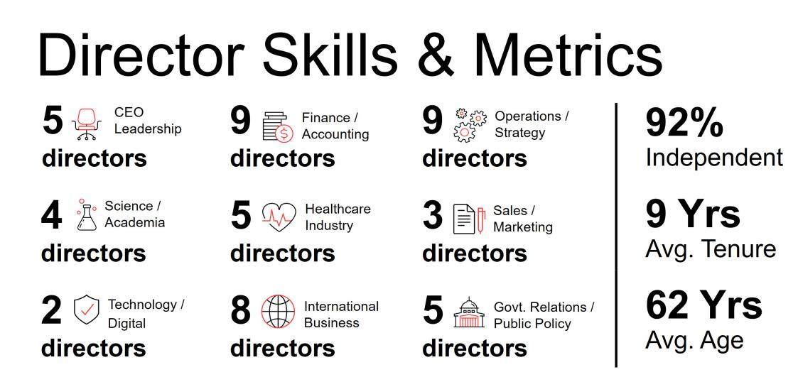

Strategy and Risk Oversight

- Strategy: Our board approves and actively oversees our corporate long-term strategy. Our board and committee meetings are structured to engage our directors in informed reviews of strategic and forward-looking issues, as well as in constructive challenges to management initiatives and programs.

- Code of Conduct: Our code of business conduct reflects principles that are consistent with our company values of integrity, excellence, and respect for people. This code applies to our board and all employees worldwide and is reviewed and approved by the board. We have a supplemental code of conduct for our CEO and all members of financial management, in recognition of their unique responsibilities to ensure proper accounting, financial reporting, internal controls, and financial stewardship.

- Corporate Governance: The charter of each of our board committees clearly establishes the committee’s roles and responsibilities with respect to risk oversight.

- Compliance Program and Enterprise Risk Reviews: Our board reviews the overall state of our compliance program at least annually and reviews our enterprise-level risks on a regular basis and as matters arise. Our Audit Committee oversees the process by which we identify and create mitigation plans for enterprise-level risks. See “Governance—Board Oversight” for additional information.

- Board Oversight of Certain Areas

 |  | Our board oversees our political expenditures and lobbying activities. Directors receive
 |  | regular updates on public policy issues and on the company’s political activity. The
 |  | board also receives semi-annual updates on political engagement, including
 |  | information on the contributions made by LillyPAC and the company, as well as trade
Political Activity |  | association memberships.
 |  | 5



Our board of directors monitors cybersecurity risks and regularly participates in presentations on cybersecurity and information technology. The Audit Committee is responsible for oversight of our programs, policies, procedures, and risk management activities related to information security, cybersecurity and data protection. It meets regularly with management to discuss threats, risks, and ongoing efforts to enhance

Cybersecurity cyber resiliency, as well as changes to the broader cybersecurity landscape. In addition to regular presentations, management promptly updates our board regarding significant threats and incidents as they arise.


Our board, including its Directors and Corporate Governance Committee, oversees and maintains ongoing engagement on key climate and sustainability matters.

Sustainability


Talent

Management

Our board exercises active oversight of the overall talent management process, including human capital management strategies, corporate culture, and inclusion efforts. The board also oversees the work of its committees in connection with the board’s development of corporate policies and frameworks designed to attract, retain, engage, and develop a workforce that aligns with our values and mission.

Responsible AI Use


Our board oversees and receives regular updates from management on AI, including strategy, risks, development, governance, and ethical innovation approaches. As we deploy AI and other emerging technologies in various facets of our operations and continue to explore the responsible development and use of AI technologies, our board continues to deepen its understanding of these transformative technologies.

Shareholder Access and Engagement

Engagement Response

In response to input from our shareholders and consistent with previous years, management is putting forth for consideration at the Annual Meeting proposals to amend our articles of incorporation to eliminate the classified board structure and to eliminate supermajority voting.

Proxy Access

Our bylaws provide proxy access rights for shareholders holding at least three percent of our common stock for at least three years to nominate to the board the greater of two directors or 20 percent of our board seats.

Board Accountability

- We have a majority voting standard.

- We have a resignation policy for the election of directors in uncontested elections.

- We hold annual say-on-pay shareholder advisory votes.

- Our board committee members are all independent directors.

- Shareholders have the ability to amend our bylaws.

- We do not have a shareholder rights plan (known as a “poison pill”).

- We have meaningful stock ownership and retention guidelines for our directors and executive officers to foster alignment with shareholders.

- We have an annual cap on director compensation.

- We have an annual director performance evaluation process.

6

Compensation

Compensation Philosophy and Practices

Our compensation programs are designed to align executive pay with shareholder interests and link pay to performance through a blend of short- and long-term performance measures. Our Talent and Compensation Committee annually reviews our programs to help ensure our incentives deliver long-term, sustainable business results while discouraging excessive risk-taking and other adverse behaviors.

For each of the last five years, greater than 94 percent of votes cast were in favor of our executive compensation programs, including greater than 96 percent in 2025. We believe this overwhelming support validates our compensation program and our performance culture. Some of our important practices and requirements include:

- Robust stock ownership guidelines for executive officers.

- Prohibition of hedging or pledging company stock.

- Compensation recovery or “clawback” policy that aligns with applicable legal requirements and allows the recovery of certain compensation upon a wide range of misconduct.

- Perquisites provided for compelling business purposes.

- Double trigger change-in-control provisions in severance plans.

- At-will employment with all executive officers.

Executive Compensation Summary

In 2025, the target compensation for our named executive officers was competitive when compared to the company’s peer group. Bonus and stock payouts exceeded target, consistent with strong company performance over the respective performance periods.

Pay for Performance

As described in the Compensation Discussion and Analysis (CD&A), we link our incentive pay programs to a mix of measures on three dimensions of company performance: operations; progress within our innovation pipeline; and shareholder return. The Talent and Compensation Committee adjusts reported revenue and EPS results in certain circumstances to eliminate the distorting effect of certain unusual items on incentive compensation.

The summary below highlights how our incentive pay programs are designed to align with company performance. Please see Appendix A for a reconciliation of, and adjustments made to, revenue and EPS for incentive compensation programs.

- Bonus Plan Result: In 2025, the company exceeded its annual bonus target objectives for product revenue, EPS, and pipeline advancements. For bonus purposes, the Talent and Compensation Committee adjusted non-GAAP EPS to exclude the impact of business development transactions and acquired in-process research and development (IPR&D) charges, both of which were not included in original 2025 bonus targets. Foreign exchange impact was also neutralized.

218%

Bonus Plan Payout

- 2023 Shareholder Value Award (SVA) Result: Our stock price growth exceeded our SVA program’s target range at the end of the three-year performance period. This performance resulted in an SVA payout above target.

- 2023 Relative Value Award (RVA) Result: Lilly’s TSR performance exceeded the peer median TSR over the three-year performance period. This performance resulted in an RVA payout above target.

200%

SVA Payout

200%

RVA Payout

7

Governance

How We Build an Effective Board

Our directors are elected by our shareholders to oversee Lilly’s business operations, strategy, and management. The Directors and Corporate Governance Committee, led by our lead independent director, regularly assesses the board to ensure that directors have the skills, experience and diverse perspectives needed to oversee our complex and evolving business. Our board assessment process, corporate governance guidelines, and refreshment efforts have resulted in a board that balances institutional knowledge with fresh viewpoints and reflects diverse backgrounds. This structure creates an effective board capable of providing strategic guidance and rigorous oversight to drive long-term shareholder value.
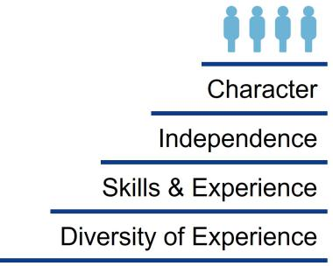

Character: Board members should possess the personal attributes necessary to be effective directors, including unquestioned integrity, sound judgment, a collaborative spirit, and commitment to our company, shareholders, and stakeholders.

Independence: We believe there should always be a substantial majority (75 percent or more) of independent directors on the board. The board annually determines independence based on a review and recommendation by the Directors and Corporate Governance Committee. No director is considered independent unless the board has affirmatively determined that he or she has no material relationship with the company, either directly or as a partner, shareholder, or officer of an organization that has a relationship with the company. Material relationships can include commercial, industrial, banking, consulting, legal, accounting, charitable, and familial relationships, among others. To evaluate the materiality of any such relationship, the board has adopted categorical independence standards consistent with the New York Stock Exchange (NYSE) listing standards.

Lilly’s process for determining director independence is set forth in our Standards for Director Independence, available on our website at lilly.com/about/leadership/governance, along with our corporate governance guidelines.

On the recommendation of the Directors and Corporate Governance Committee, the board determined that each current non-employee director is independent and that the members of our Audit and Talent and Compensation Committees meet the heightened independence standards applicable to those committees. The board determined that none of the current non-employee directors has had during the last three years (i) any of the relationships identified in the company’s categorical independence standards or (ii) any other material relationship with the company that would compromise his or her independence.

The board considered that certain non-employee directors are affiliated with entities that transact with the company in the ordinary course of business. Drs. Baicker, Bertozzi, Kaelin, and Hedley are employed at medical or academic institutions with which the company engages in clinical research, provides grants, or conducts
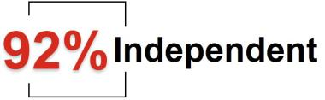

commercial transactions. Mr. Luciano is employed by Archer-Daniels-Midland Company, with which the company engaged in routine business transactions. The board determined that these transactions did not impair the independence of any directors.

Transactions with these entities fell below the applicable thresholds for independence impairment under the NYSE Listed Company Manual and the company's Standards for Director Independence, and did not constitute related party transactions under the company's Related Persons Transactions Policy (discussed more fully on p.39).

Diversity of Experience: The board does not have specific diversity goals or a standalone diversity policy. The board seeks director candidates who represent a mix of backgrounds and experiences that will enhance the

8

quality of deliberations and decisions. Candidates are expected to have substantial experience with one or more publicly traded national or multinational companies or to have achieved a high level of distinction in their chosen field. The company’s current 12 directors range in age from 53 to 70 and include five women and seven men.
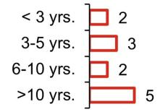

9 Years | Tenure: Our director composition reflects a mix of board tenure,
Average
Average | which provides an effective balance of historical perspective and
Director
Director | an understanding of the evolution of our business with fresh
Tenure | an understanding of the evolution of our business with fresh
Tenure | perspectives and insights.

Director Governance Spotlight


ü

ü

ü

ü

Resignation Policy - In an uncontested election, directors are elected by a majority of votes cast. An incumbent nominee who fails to receive a greater number of votes “for” than “against” will tender a resignation from the board following the certification of the shareholder vote. The board, on

recommendation of the Directors and Corporate Governance Committee, will decide whether to accept the resignation. The company will promptly disclose the board’s decision, including, if applicable, the reasons for rejecting a resignation.

Director Retirement Policy - Non-employee directors must retire from the board no later than the date of the annual meeting that follows their seventy-second birthday, although the Directors and

Corporate Governance Committee may recommend exceptions to this policy. The Directors and Corporate Governance Committee, with input from all board members, also considers the individual director’s contributions annually, with a more robust assessment at least every three years when

considering whether to nominate directors to new three-year terms. The company has not adopted term limits because the board believes that the company benefits from having a mix of longer- and shorter-tenured board members.

Other Board Service Policy - To ensure proper engagement from our directors and effective functioning of our board, we have instituted certain limitations on service on the boards of other public

companies. In general, no director may serve on more than three other public company boards. No director that is an executive officer of a public company may serve on more than two public company boards (inclusive of Lilly). The Directors and Corporate Governance Committee may approve
exceptions if it determines that the additional service will not impair the director’s effectiveness on the Lilly board. In addition, no director serving on the Audit Committee may serve simultaneously on the audit committee of more than two other public companies without the prior approval of the board.

Confidentiality Policy - The board has adopted a Board Confidentiality Policy (available at: lilly.com/about/leadership/governance), applicable to all members of the board. The policy prohibits a director from sharing confidential information obtained in his or her role as a director with any third

party except under limited circumstances where the director is seeking legal advice or is required by law to disclose information.

9

Item 1. Election of Directors

Under our articles of incorporation, the board is divided into three classes with approximately one-third of the directors standing for election each year. The Directors and Corporate Governance Committee has recommended that each of the following four nominees be elected at the Annual Meeting. Each of the director nominees is currently serving as a director.

Nominees


Carolyn Bertozzi | William Kaelin, Jr. | Jon Moeller | David Ricks
Independent Director | Independent Director | Independent Director | President, CEO and Chair

The term for directors to be elected this year will expire at the annual meeting of shareholders held in 2029. Each of the director nominees above has agreed to serve for that term. Nominees are elected to serve until his or her successor is duly elected and qualified. If a nominee set forth in this proxy statement is unable to serve or for good cause will not serve, proxy holders may vote for another nominee proposed by the board or, as an alternative, the board may reduce the number of directors to be elected at the Annual Meeting.


RECOMMENDATION FOR

The board recommends that you vote FOR the election of each of the board’s nominees, Carolyn Bertozzi, William Kaelin, Jr., Jon Moeller, and David Ricks to serve as directors until our 2029 annual meeting of shareholders and until their successors are duly elected and qualified, or until their earlier death, resignation, or removal.

Director Biographies:

Set forth below is information, as of March 20, 2026, regarding our directors and director nominees. We have provided the most relevant experiences, qualifications, attributes, and skills that support the conclusion that each director or director nominee should serve as a director in light of our business and operations.

No family relationship exists among any of our directors, director nominees, or executive officers. To the best of our knowledge, there are no pending material legal proceedings in which any of our directors or nominees for director, or any of their associates, is a party adverse to us or any of our affiliates, or has a material interest adverse to us or any of our affiliates. Additionally, to the best of our knowledge, there have been no events under any bankruptcy laws, no criminal proceedings and no judgments, sanctions, or injunctions during the past 10 years that are material to the evaluation of the ability or integrity of any of our directors or nominees for director. There is no arrangement or understanding between any director or director nominee and any other person pursuant to which he or she was or is to be selected as a director or director nominee.

10

Class of 2026


Carolyn R. Bertozzi, Ph.D.

Age: 59

Director Since: 2025

Board Committees:

– Ethics and Compliance
– Science and Technology

Other Public Boards:

– OmniAb, Inc.

Recent Prior Public Boards:

KEY EXPERIENCE AND QUALIFICATIONS


Dr. Bertozzi is a world-renowned Nobel Laureate, scientist, academician, and pioneer in chemical biology who provides valuable leadership to the board's oversight of Lilly's discovery and development programs.

- Dr. Bertozzi has decades of groundbreaking research experience, offering a valuable perspective and resource to the board and management in pharmaceutical research and discovery across multiple therapeutic areas.

- Through her work founding and advising various biotechnology companies, Dr. Bertozzi has a deep understanding of the challenges, perspectives, and opportunities for translating basic scientific research into therapeutic application.

- Dr. Bertozzi also brings commercialization experience to the board through her work founding biotechnology companies and leadership roles in more than a dozen academic and scientific advisory boards and life sciences companies, bridging academic discovery and pharmaceutical innovation.

– Alnylam Pharmaceuticals, Inc.

Key Skills:
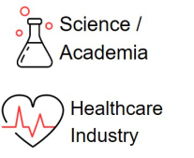

CAREER HIGHLIGHTS

- Stanford University

– Anne T. and Robert M. Bass Professor of Chemistry, Professor of Chemical and Systems Biology and Radiology by courtesy (2015 - present)

– Baker Family Director of Sarafan ChEM-H (2017 - present)

- Howard Hughes Medical Institute

– Investigator (2000 - present)

OTHER HIGHLIGHTS

- Recipient of numerous prizes and honors, including:

– Nobel Prize in Chemistry

– Lemelson-MIT award for inventors

– Whistler Award

– Ernst Schering Prize

– MacArthur Foundation Fellowship

- Member, National Academy of Medicine; National Academy of Sciences; American Academy of Arts and Sciences; and German Academy of Sciences Leopoldina

11



William G. Kaelin, Jr., M.D.

Age: 68

Director Since: 2012

Board Committees:

– Directors and Corporate Governance

– Science and Technology (Chair)

Other Public Boards:

– IQVIA Holdings Inc.

Recent Prior Public Boards:

– None

Key Skills:
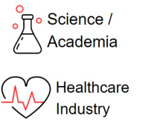

KEY EXPERIENCE AND QUALIFICATIONS


Dr. Kaelin is a world-renowned Nobel Laureate, scientist, academician, and physician who provides valuable leadership to the board’s oversight of Lilly’s discovery and development programs.

- With decades of preeminent medical research and discovery experience, particularly within oncology, Dr. Kaelin offers a valuable perspective and resource to the board and management in pharmaceutical research and discovery in key therapeutic areas.

- Dr. Kaelin has extensive experience as a professor and mentor to medical professionals who are key constituents for Lilly’s business and workforce.

- As an investigator at Howard Hughes Medical Institute, Dr. Kaelin has a deep understanding of the challenges, perspectives, and opportunities for medical researchers.

- Dr. Kaelin also brings commercialization experience to the board through his work with venture capital funds and biotechnology companies.

CAREER HIGHLIGHTS

- Harvard Medical School

– Sidney Farber Professor of Medicine (2018 - present)

– Professor of Medicine (2002 - 2018)

- Dana-Farber Cancer Institute

– Professor (2002 - present)

- Howard Hughes Medical Institute

– Investigator (2002 - present)

– Assistant Investigator (1998 - 2002)

OTHER HIGHLIGHTS

- Recipient of numerous prizes and honors, including:

– Nobel Prize in Physiology or Medicine

– Albert Lasker Basic Medical Research Award

– Canada Gairdner International Award

– Wiley Prize in Biomedical Sciences from the Rockefeller University

– Paul Marks Prize for Cancer Research from the Memorial Sloan Kettering Cancer Center
- Member, National Academy of Medicine; National Academy of Sciences; American College of Physicians; Association of American Physicians; American Society of Clinical Investigation; American Academy of Arts and Sciences; American Philosophical Society

12



Age: 61

Director Since: 2024

Board Committees:

– Audit

– Directors and Corporate Governance

Other Public Boards:

– Procter & Gamble Company

Recent Prior Public Boards:

– None

Key Skills:
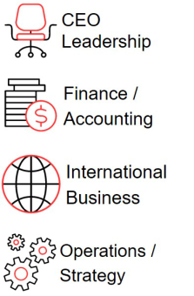

Jon Moeller

KEY EXPERIENCE AND QUALIFICATIONS


Mr. Moeller brings to the board extensive leadership experience, financial acumen, strategic vision, and a commitment to high standards of corporate governance.

- Mr. Moeller has served in various senior capacities at Procter & Gamble (P&G) over the past three decades (including chief executive officer), giving him a wealth of experience in navigating complex regulatory environments and fostering a culture of integrity. His tenure at P&G has been characterized by his ability to drive growth and innovation, including a willingness to change, adapt and create new trends and embrace new technologies.

- Mr. Moeller was P&G’s chief financial officer for more than 12 years, leading its finance and accounting, tax, treasury, corporate strategy, business development and investor relations functions. His financial background has also equipped him with the skills to oversee complex financial operations, manage risks, and ensure fiscal responsibility.

- As chief operating officer, Mr. Moeller optimized P&G's operations to enhance efficiency and performance. He successfully managed the company's supply chain, manufacturing, and overall operational strategies, ensuring that they aligned with the company's goals and objectives.

CAREER HIGHLIGHTS

- Procter & Gamble Company, a multinational consumer goods corporation

– Executive Chairman (2026 - present)

– Chairman, President and Chief Executive Officer (2022 – 2025)

– President and Chief Executive Officer (2021 - 2022)

– Vice Chairman, Chief Financial Officer, and Chief Operating Officer (2019 - 2021)
– Vice Chairman, Chief Financial Officer (2017 - 2019)

– Chief Financial Officer (2009 - 2017)

OTHER HIGHLIGHTS

- Member, The Business Roundtable

- Member, American Society of Corporate Executives

- Director, US China Business Counsel

- Director (Vice-Chair), Alliance to End Plastic Waste

13

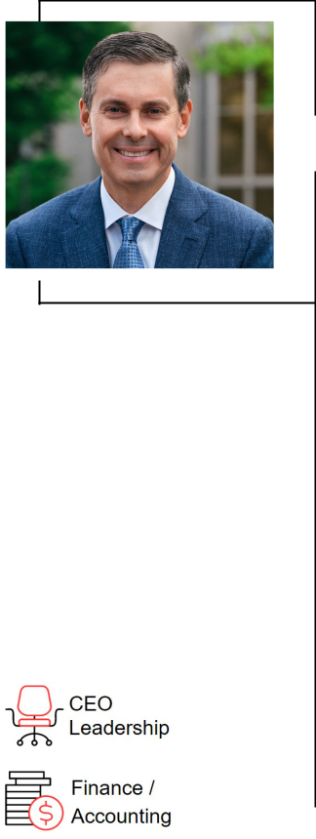

Age: 58

Director Since: 2017

Board Committees:

None

Other Public Boards:

– Adobe Inc.

Recent Prior Public Boards:

– None

Key Skills:
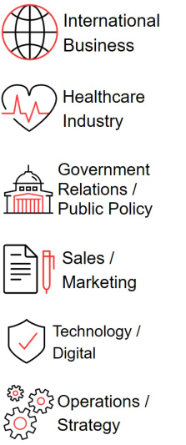

David A. Ricks

Chair, President, and CEO

KEY EXPERIENCE AND QUALIFICATIONS


Mr. Ricks has over 25 years of experience at Lilly, leading and shaping large-scale operations across the world. He has overseen some of the most transformative growth in the company’s history; since assuming the role as Chief Executive Officer, Lilly has (i) experienced revenue growth of approximately 207%, (ii) experienced a five-year total shareholder return of 571%, and (iii) taken important steps to increase the affordability and accessibility of our products around the globe.

- Mr. Ricks embodies the “tone at the top” that strengthens Lilly’s culture, including through his commitment to compliance, talent development, and the expansion of our workforce.

- Mr. Ricks has combined his company-specific and industry knowledge to grow, articulate and implement Lilly’s strategic plan, as reflected by the growth in revenue, robust pipeline, and progressive approach on leveraging technology into the business.

- Mr. Ricks is able to draw on his extensive interactions with various stakeholders to apprise the board of significant developments in our business and industry, as well as to communicate feedback to the board and offer insights.

- Mr. Ricks’ leadership approach is derived from his experience in marketing, sales, drug development, and international operations, as well as his significant experience in public policy.

CAREER HIGHLIGHTS

- Eli Lilly and Company

– Chair, President, and Chief Executive Officer (2017 - present)

– Senior Vice President and President, Lilly Bio-Medicines (2012 - 2016)

– President, Lilly USA (2009 - 2012)

– Served in various marketing, sales and international leadership roles (1996

    - 2009), including:

      - As President and General Manager of Lilly China

      - As General Manager of Lilly Canada

OTHER HIGHLIGHTS

- Director, International Federation of Pharmaceutical Manufacturers & Associations (IFPMA)
- Director, Pharmaceutical Research and Manufacturers of America (PhRMA)

- Member, U.S. Patent and Trademark Office Council for Inclusive Innovation

- Director and executive committee member, Central Indiana Corporate Partnership

- Director, The Business Roundtable

- Trustee, Purdue University Board of Trustees

14

Class of 2027


Katherine Baicker, Ph.D.

Age: 54

Director Since: 2011

Board Committees:

– Ethics and Compliance (Chair)
– Science and Technology

Other Public Boards:

– None

Recent Prior Public Boards:

– HMS Holdings Corp.

Key Skills:

KEY EXPERIENCE AND QUALIFICATIONS


Dr. Baicker’s experience in health economics research and policy at the highest levels, including as a former economic advisor to the White House and a current health advisor to the Congressional Budget Office, provides an invaluable perspective to the board.

- In addition to Dr. Baicker’s own high-impact research, her leadership of a preeminent research and educational institution gives her both insight into and influence over the future of health policy.

- Through Dr. Baicker’s decades of research and policy engagement, including with respect to the effects of health system reforms of public and private insurance coverage and payment policy, she brings to the board insight and context as it oversees the company’s navigation of the complex environment of government regulation, insurance reimbursement, and access to affordable care.

- Drawing on Dr. Baicker’s experience as an advisor to both the executive and legislative branches of the U.S. government, state governments, and numerous healthcare-related commissions and committees provides a keen understanding of government perspectives in our highly regulated industry.

- Dr. Baicker, with extensive involvement with medical and health system research organizations, adds valuable input on the research and development landscape within the pharmaceutical industry.

CAREER HIGHLIGHTS

- University of Chicago

– Provost (2023 - present)

– Emmett Dedmon Professor, Harris School of Public Policy (2017 - present)

– Dean of the Harris School of Public Policy (2017 - 2023)

- Harvard University

– C. Boyden Gray Professor of Health Economics (2014 - 2017)

– Department of Health Policy and Management, chair (2014 - 2016)

– Harvard T.H. Chan School of Public Health (primary)

– Harvard Kennedy School of Government (secondary)

- National Bureau of Economic Research

– Research Associate, Health Care and Public Economics Programs (2007 - present)

- Council of Economic Advisers, Executive Office of the President

– Member, confirmed by U.S. Senate (2005 - 2007)
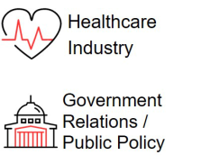

OTHER HIGHLIGHTS

- Panel of Health Advisers to the Congressional Budget Office

- Advisory Board, the National Institute for Health Care Management

- Editorial Board of JAMA Health Forum

- Trustee, the Mayo Clinic

- Trustee, University of Chicago Medicine (ex officio)

- Member, the National Academy of Medicine; the National Academy of Social Insurance; the Council on Foreign Relations; and the American Academy of Arts and Sciences

15



J. Erik Fyrwald

Age: 66

Director Since: 2005

Board Committees:

– Talent and Compensation
– Science and Technology

Other Public Boards:

– International Flavors & Fragrances Inc.

KEY EXPERIENCE AND QUALIFICATIONS


Mr. Fyrwald brings to the board a deep understanding of operational and strategic leadership and international business.

- Mr. Fyrwald’s substantial experience in leading international companies provides valuable perspectives relating to international operations, manufacturing, logistics, and sustainability.

- Mr. Fyrwald has a demonstrated focus on technology and a deep understanding of the challenges of developing and commercializing the results of innovation, as he worked to align Syngenta to digital innovation and new agricultural technologies in their efforts against climate change.

- Mr. Fyrwald has also developed significant corporate governance experience through his current and prior service on the boards of directors of international companies and not-for-profit entities.

Recent Prior Public Boards:

– Syngenta Group

– Bunge Limited

Key Skills:
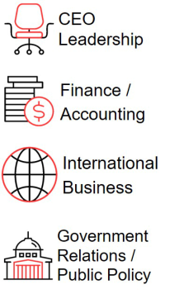

CAREER HIGHLIGHTS

- International Flavors & Fragrances Inc., creator and manufacturer of food, beverage, health and biosciences, scent and pharma solutions

– Chief Executive Officer (2024 - present)

– Member of the board of directors (2024 - present)

- Syngenta Group, a global Swiss-based agriculture technology company that produces agrochemicals and seeds

– President and Chief Executive Officer (2016 - 2023)

– Member of the board of directors (2016 - 2024)

– Member of the sustainability committee (2016 - 2024)

- Univar, Inc., a leading distributor of chemicals and provider of related services

– President and Chief Executive Officer (2012 - 2016)

- Ecolab, Inc., a leading provider of cleaning, sanitation and water products and services

– President (2011 - 2012)

- Nalco Company, a leading provider of water treatment products and services

– Chairman and Chief Executive Officer (2008 - 2011)

- E.I. du Pont de Nemours and Company, a global chemical company

– Various management positions from 1980 to 2008 in production, sales, and marketing, including most recently group vice president, agriculture and nutrition (2003 - 2008)


OTHER HIGHLIGHTS

- Director, Council on Competitiveness (Chair)

16



Age: 57

Director Since: 2016

Board Committees:

– Audit (Chair)

– Directors and Corporate Governance

Other Public Boards:

– None

Recent Prior Public Boards:

– Hibbett, Inc.

Key Skills:
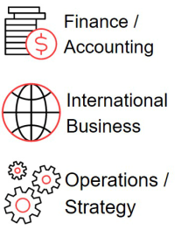

Jamere Jackson

KEY EXPERIENCE AND QUALIFICATIONS


Mr. Jackson brings to the board significant global financial experience and a strong background in strategic planning.

- Mr. Jackson’s global finance experience, including as chief financial officer at multiple Fortune 500 companies, provides extensive knowledge of international business operations and their associated financial complexities.

- Mr. Jackson brings a valuable perspective on the management of complex financial risks and wide-ranging knowledge of finance and accounting matters to his role as Audit Committee Chair.

- Mr. Jackson has also held roles in strategic planning and mergers and acquisitions, including responsibility for driving financial rigor, developing strategy and implementing change.

CAREER HIGHLIGHTS

- AutoZone, Inc., a leading retailer and distributor of automotive replacement parts and accessories in the United States, Mexico and Brazil

– Chief Financial Officer (2020 - present)

- Hertz Global Holdings, Inc., a global vehicle rental, leasing and fleet management business

– Chief Financial Officer (2018 - 2020)

- Nielsen Holdings plc, a global measurement and data analytics company

– Chief Financial Officer (2014 - 2018)

- General Electric Corporation, an American multinational company and leader in the power renewable energy, aviation and healthcare industries

– Vice President and Chief Financial Officer, General Electric Oil and Gas, drilling and surface division (2013 - 2014)

– Senior Executive, Finance, General Electric Aviation (2007 - 2013)

– Finance Executive, General Electric Corporate (2004 - 2007)

OTHER HIGHLIGHTS

- Certified Public Accountant

- Not-for-profit boards of directors:

– Youth Villages

17



Gabrielle Sulzberger

Age: 65

Director Since: 2021

Board Committees:

– Audit

– Directors and Corporate Governance

Other Public Boards:

– Mastercard Incorporated

Recent Prior Public Boards:

– Warby Parker Inc.

– Cerevel Therapeutics Holdings, Inc.

– Brixmor Property Group Inc.

Key Skills:

KEY EXPERIENCE AND QUALIFICATIONS


Ms. Sulzberger brings over 30 years of experience advising public and privately held companies in consumer products, retail, financial services, and life sciences.

- Ms. Sulzberger provides global perspective from her time as chair of global ESG advisory at Teneo, supporting Lilly and the board’s commitment to continuous progress and improving our positive impact on people, the planet, and society.

- Ms. Sulzberger developed deep corporate governance experience through her work with corporate boards, both as a board member and as a governance committee chair.

- Ms. Sulzberger’s career in private equity has given her valuable experience in helping companies navigate disruption and transformation, engage with shareholders, and position businesses for growth and success.

- Ms. Sulzberger also draws on experiences from her prior service as chief financial officer of several publicly and privately held companies and audit committee chair of several public companies, providing leadership as an Audit Committee Financial Expert.

CAREER HIGHLIGHTS

- Centerbridge Partners, a multidisciplinary investment firm

– Senior Managing Director (2024 - present)

– Senior Advisor (2021 - 2024)

- Teneo, a global CEO advisory firm

– Senior Advisor (2024 - 2026)

– Chair of Global ESG Advisory (2021 - 2024)

- Two Sigma Impact, a private equity firm based in New York, New York

– Senior Advisor (2021 - 2023)

- Rustic Canyon/Fontis Partners L.P., a private equity firm based in California

– General Partner (2005 - 2018)

OTHER HIGHLIGHTS

- Director or trustee of the following not-for-profit organizations:

– Metropolitan Museum of Art

– Ford Foundation

– Sesame Street Workshop

- Former director, board chair and audit committee chair, Whole Foods Market, Inc.

- Sandra Day O’Connor Board Excellence Award

18

Class of 2028


Ralph Alvarez

Age: 70

Director Since: 2009

Board Committees:

– Audit

– Talent and Compensation (Chair)

Other Public Boards:

– Lowe’s Companies, Inc.

– Traeger, Inc.

– First Watch Restaurant Group, Inc. (Chair)

Recent Prior Public Boards:

– None

Key Skills:
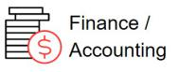

KEY EXPERIENCE AND QUALIFICATIONS


Mr. Alvarez brings to the board more than 40 years of experience in consumer marketing, global operations, international business, and strategic planning, as well as extensive executive leadership experience in managing some of the world’s best-known brands.

- As a senior executive of a leading global foodservice retailer and other global restaurant businesses, Mr. Alvarez developed in-depth knowledge of consumer marketing, talent and brand management and strategic planning.

- Mr. Alvarez also contributes an understanding of international markets and operations, including a special focus on Japan and emerging markets.
- Mr. Alvarez is a leader of people and brings to the board a strong perspective on how to motivate, develop, and engage diverse talent.

- Mr. Alvarez is an Audit Committee Financial Expert based on his public company experience, including his prior service on the Lowe’s audit committee.

CAREER HIGHLIGHTS

- Advent International Corporation, a leading global private equity firm

– Operating Partner (2017 - present)

- Skylark Co., Ltd., a leading restaurant operator in Japan

– Chairman of the board (2013 - 2018)

- McDonald’s Corporation, a leading food service retailer

– President and Chief Operating Officer (2006 - 2009)

OTHER HIGHLIGHTS


- Member, University of Miami President’s Council

- Director, ZUP Holdings GP Corp. (Chair)
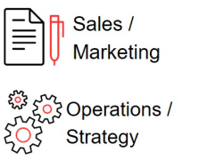

19



Mary Lynne Hedley, Ph.D.

Age: 63

Director Since: 2022

Board Committees:

– Ethics and Compliance
– Science and Technology

Other Public Boards:

– VEEVA Systems Inc.

– Centessa Pharmaceuticals plc

Recent Prior Public Boards:

– None

Key Skills:
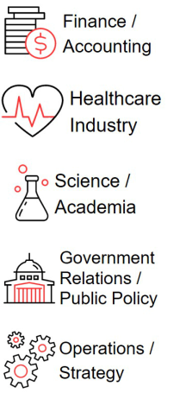

KEY EXPERIENCE AND QUALIFICATIONS


Dr. Hedley’s career has uniquely combined discovery, translational and clinical research and commercialization, bringing to the board extensive business leadership and scientific investigation experience in the biotechnology industry.

- Having served as co-founder, chief executive officer, president, chief scientific officer or chief operating officer of several biotechnology companies throughout her career, Dr. Hedley has experience leading and overseeing the complex operations and risks of these businesses, including building C-suite teams, raising capital, and managing research and development, commercial development, manufacturing and supply chains, quality, regulatory affairs, and corporate strategy.

- Dr. Hedley has extensive experience navigating complex FDA regulatory pathways and achieving successful drug approvals in highly regulated environments.

- Dr. Hedley has substantial experience with developing and commercializing pharmaceutical products, including a deep understanding of regulatory approval, compliance, quality systems, and the requirements for launching therapeutics across multiple jurisdictions.

- Dr. Hedley’s service on the boards of directors and board committees of other public companies and not-for-profit entities, including her service on an audit committee and as chair of a nominating and governance committee, provides a multifaceted governance perspective.

CAREER HIGHLIGHTS

- Broad Institute of Harvard and MIT

– Senior Scientific Fellow (2021 - present)

- Third Rock Ventures, a leading healthcare venture capital firm

– Venture Partner (2023 - present)

- GlaxoSmithKline plc, a leading global pharmaceutical company

– Member of executive research and development team; led integration efforts for TESARO acquisition (2019 - 2020)
- TESARO, Inc., a company focused on the development and global commercialization of oncology therapeutics (acquired by GlaxoSmithKline plc in 2019)

– President and Chief Operating Officer (2010 - 2019)

- Abraxis BioScience, Inc., a biotechnology company (acquired by Celgene Corporation in 2010)

– Executive Vice President and Chief Science Officer (2009 - 2010)

OTHER HIGHLIGHTS

- Member, American Association of Immunologists; American Association for Advancement of Science; American Society of Clinical Oncology; American Association of Cancer Research

- Advisory Board, Boston Museum of Science and chair, Life Science Committee

- Director, Azalea Therapeutics Inc.

- Strategic Advisor to the R&D Committee, Argenx SE

20



Age: 53

Director Since: 2021

Board Committees:

– Talent and Compensation
– Ethics and Compliance

Other Public Boards:

– None

Recent Prior Public Boards:

– None

Key Skills:
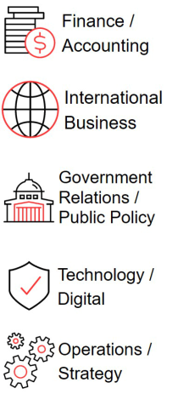

Kimberly Johnson

KEY EXPERIENCE AND QUALIFICATIONS


Ms. Johnson brings to the board considerable financial and operational experience and a strong background in technology, governance, talent management and strategy for global risk management.

- Ms. Johnson’s wide-ranging operational experience at two complex financial institutions has included leadership over various departments focused on cybersecurity, technology, operations, account services, enterprise change, data, modeling, analytics, information security, resiliency, innovation, and corporate strategy.

- Ms. Johnson also brings a deep understanding of enterprise risk management, having served as chief risk officer of Fannie Mae and currently overseeing enterprise risk as part of her role at T. Rowe Price.

- Ms. Johnson also brings to the board knowledge of technology operations, having led Fannie Mae’s digital transformation, establishing a four-year enterprise modernization plan and an operational roadmap for redesigning business processes and reengineering core technology.

CAREER HIGHLIGHTS

- T. Rowe Price Group, Inc., a global leader in asset management

– Vice President and Chief Operating Officer (2022 - 2025)

- Federal National Mortgage Association (Fannie Mae), a provider of affordable mortgage financing in the United States

– Executive Vice President and Chief Operating Officer (2018 - 2022)

– Executive Vice President and Chief Risk Officer (2017 - 2018)

– Senior Vice President and Chief Risk Officer (2015 - 2017)

– Senior Vice President and Deputy Chief Risk Officer (2013 - 2015)

- Credit Suisse AG, a global wealth manager, investment bank, and financial firm founded and based in Switzerland

– Director, Interest Rate Derivative Products (2005 - 2006)

OTHER HIGHLIGHTS

- Trustee, Princeton University

21



Juan R. Luciano

Age: 64

Director Since: 2016

Board Committees:

– Talent and Compensation
– Directors and Corporate Governance (Chair)

Other Public Boards:

– Archer-Daniels-Midland Company

Recent Prior Public Boards:

– None

Key Skills:
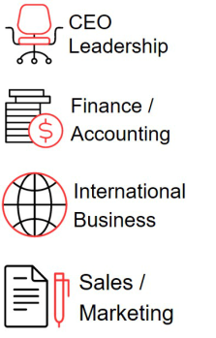

Lead Independent Director (2019)

KEY EXPERIENCE AND QUALIFICATIONS


Mr. Luciano’s decades of experience, including as a chair and chief executive officer, as a leader of large organizations, and in international business, strategy, and operations, bring to the board valuable insights into the complexities of operating in a rapidly changing global market.

- As chair and chief executive officer of a major global enterprise, Mr. Luciano contributes extensive knowledge of international business and the development and execution of strategy, such as the increased use of innovative technologies to meet customer needs and the management of complex global supply chains.

- Mr. Luciano’s experience as a chief operating officer and line executive in several product areas also bring a thorough understanding of operations, especially in highly regulated sectors.

- Mr. Luciano’s results-oriented perspective and his experience in leading a major multinational company are particularly valuable to the board and make him a strong and engaged lead independent director.

- Mr. Luciano is a well-respected leader and strong lead independent director for the board, with the willingness and ability to provide direct, candid feedback to the chief executive officer while acting as a facilitator of discussion.

CAREER HIGHLIGHTS

- Archer-Daniels-Midland Company, a global food processing and commodities-trading company
– Chair of the Board (2016 - present)

– Chief Executive Officer and President (2015 - present)

– President and Chief Operating Officer (2014 - 2015)

- The Dow Chemical Company, a multinational chemical company

– Executive Vice President and President, Performance Division (2010 - 2011)

OTHER HIGHLIGHTS

- Alternate director, Wilmar International

- Director, Intersect Illinois

- Member, Rush System Board of Directors

- Member, The Business Roundtable; Civic Committee at the Commercial Club of Chicago; Economic Club of Chicago


22

Director Skills and Experience:

Our directors are responsible for overseeing the company’s business consistent with their fiduciary duties. This significant responsibility requires highly skilled individuals with various qualities, attributes, and professional experiences. We believe the board is well-rounded, with a balance of relevant perspectives and experience, as illustrated in the following chart.
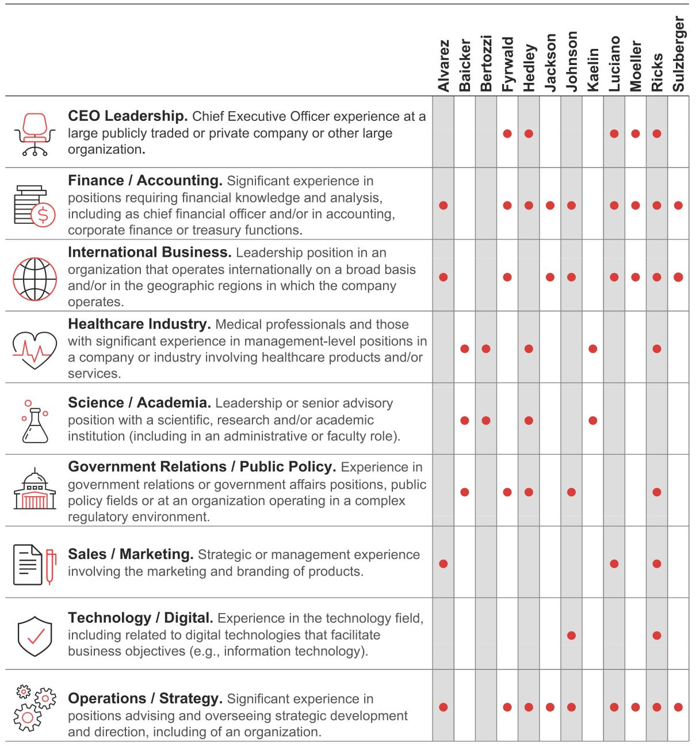

23

Director Nominations

Each year, the board proposes a slate of director nominees for election by shareholders at the Annual Meeting. The board has delegated the process of screening potential director candidates to the Directors and Corporate Governance Committee, which receives input from other board members.

Incumbent Directors
 |  |  | Recommend
Shareholders |  |  | Recommend
Shareholders | Candidate | In-Depth | Selected
 | Pool | Review | Candidates for
Executive Search Firms | Pool | Review | Candidates for
Executive Search Firms |  |  | Election to the
 |  |  | Board
Management

Candidate Pool Identification: Director candidates can be identified from several sources, including incumbent directors, shareholders, executive search firms retained by the committee, and management. For example, Jon Moeller and Carolyn Bertozzi were recommended by a third-party search firm and management.

In-Depth Review: The Directors and Corporate Governance Committee employs the same process to evaluate all candidates, including those submitted by shareholders, in accordance with our bylaws and corporate governance guidelines.

- Evaluate Director Qualifications. The committee initially evaluates a candidate based on publicly available information and additional information supplied by the party recommending the candidate. The committee, assisted by management or a search firm, may gather additional data as needed, including on the candidate’s qualifications, relationships or transactions with related parties, availability, probable level of interest, and any potential conflicts of interest.

Incumbent Directors - For incumbent directors being considered for re-nomination, the Directors and Corporate Governance Committee has the additional benefit of (i) feedback from the annual board and committee evaluations and related individual discussions between each director and the chair and/or the lead independent director; (ii) knowledge of attendance and participation at, and preparation for, prior board and committee meetings; and (iii) shareholder feedback, if such nominee has been elected at a prior annual meeting.

- Meetings with Select Directors. If the committee’s subsequent evaluation continues to be favorable, the candidate is contacted by the chair of the board and one or more of the independent directors, including the lead independent director, for direct discussions to determine the mutual level of interest in pursuing the candidacy.

Recommendation for Election: If these discussions are favorable, the committee recommends that the board nominate the candidate for election by the shareholders (or for the board to elect the candidate to fill a vacancy, as applicable).

24

Shareholder Director Candidates


Shareholder Recommendations of Director Candidates - A shareholder who wishes to recommend a director candidate for evaluation should forward the candidate’s name and information about the candidate’s qualifications by delivery and email to:

Chair of the Directors and Corporate Governance Committee

c/o General Counsel and Secretary

Lilly Corporate Center

Indianapolis, IN 46285

Email: shareholderproposals@lilly.com

The candidate must meet the selection criteria described in our corporate governance guidelines (available online at lilly.com/about/leadership/governance) and must be willing and expressly interested in serving on the board.

Shareholder Nominations for Director Candidates for Inclusion in the Proxy Statement (“Proxy Access”) - If a shareholder or shareholder group wishes to nominate director candidates to be included in the proxy statement for the 2027 annual meeting pursuant to the “proxy access” provisions of the company’s bylaws, written notice must be received by the company’s Secretary no later than November 20, 2026, and no earlier than October 21, 2026. If the date of the 2027 annual meeting is changed by more than 30 days from May 3, 2027 (the date contemplated for the 2027 annual meeting), a shareholder must deliver written notice no earlier than 150 days in advance of the date of the 2027 meeting and no later than the close of business on the later of 120 days in advance of the 2027 annual meeting or, if later, within 10 days following the date we first publicly announce the date of 2027 annual meeting. Any such notice must also comply with the timing, disclosure, procedural, and other requirements as set forth in our bylaws.

Other Shareholder Nominations for Director Candidates - In addition, under Section 1.9 of the company’s bylaws, if any shareholder of record wishes to directly nominate a director candidate at the 2027 annual meeting of shareholders (i.e., to propose a candidate for election who is not otherwise nominated by the board through the recommendation process described above and not pursuant to the “proxy access” provisions described above) must deliver written notice to the company’s Secretary no later than the close of business on November 20, 2026, and no earlier than the close of business on September 21, 2026. If the date of the 2027 annual meeting is changed by more than 30 days from May 3, 2027 (the date contemplated for the 2027 annual meeting), a shareholder must deliver written notice to the company’s Secretary no later than the close of business on the later of 120 days in advance of the 2027 annual meeting or, if later, within 10 days following the date we first publicly announce the date of 2027 annual meeting. Any such notice must also comply with the timing, disclosure, procedural and other requirements as set forth in our bylaws. A copy of our bylaws is available online at lilly.com/about/leadership/governance.

Universal Proxy for Shareholder Nominations - In addition to satisfying the requirements under our bylaws, if a shareholder intends to comply with the SEC’s universal proxy rules and to solicit proxies in support of director nominees other than the company’s nominees, the shareholder must provide notice that sets forth the information required by Rule 14a-19 under the Exchange Act which notice must be postmarked or transmitted electronically to us at the address stated above for shareholder recommendations no later than 60 calendar days prior to the one-year anniversary date of the Annual Meeting (for the 2027 annual meeting, no later than March 5, 2027). If the date of the 2027 annual meeting is changed by more than 30 calendar days from such anniversary date, however, then the shareholder must provide notice by the later of 60 calendar days prior to the date of the 2027 annual meeting and the 10th calendar day following the date on which public announcement of the date of the 2027 annual meeting is first made by the company.

25

Director Compensation

Non-employee director compensation is reviewed and approved by the board. Directors who are employees receive no additional compensation for serving on the board.

67% | 5x | CAPPED
Percentage of board service annual | required multiple of the annual | total annual compensation for non-
retainer linked to the long-term | board retainer in share ownership | employee directors
performance of Lilly stock | for non-employee directors

Director Compensation Governance

The Directors and Corporate Governance Committee performs an annual review of non-employee director compensation, which includes:

- conducting a general industry and pharmaceutical company peer group analysis with the assistance of an outside compensation consultant,

- avoiding excess compensation by positioning non-employee director compensation near the market median of the general industry peer group, and

- linking most of the compensation to the long-term performance of Lilly stock.

If the Directors and Corporate Governance Committee determines adjustments to non-employee director compensation are warranted, it will make recommendations to the full board for consideration.

Compensation Elements

The following table shows the compensation elements in effect for all non-employee directors in 2025:

Compensation Element | Payment or Value
Board Service1
Annual board retainer | $110,000
Annual stock grant² | $220,000 in deferred stock units
Lead independent director | $40,000
Committee Service3
Annual Committee Retainer | Chair | Member
Audit Committee | $29,000 | $6,000
Science and Technology Committee | $23,000 | $6,000
Talent and Compensation Committee | $22,000 | $3,000
Ethics and Compliance Committee | $22,000 | $3,000
Directors and Corporate Governance Committee | $22,000 | $3,000
Total Compensation Value Cap of $800,000⁴

- Expenses. Directors are reimbursed for customary and usual travel expenses in connection with their travel to and from board meetings and other company events.

- Stock Compensation. Non-employee directors received an annual stock-based award that was credited to each non-employee director’s deferred stock account established under the Lilly Directors’ Deferral Plan. The units were calculated by dividing $220,000 by the closing stock price on a pre-set annual date, yielding approximately 215 units. When applicable, the annual stock-based award was prorated for time served. See “Lilly Directors’ Deferral Plan—Deferred Stock Account”.

- Ad Hoc Committees. Non-employee directors may receive additional cash compensation for serving on ad hoc board committees that may be formed by the board from time to time. Committee chair retainers are in addition to member retainers.

- Annual Compensation Cap for Directors. The board approved a cap to the total annual compensation (cash and stock compensation) for non-employee directors of $800,000. The cap is intended to avoid excessive director compensation and is included in both the Lilly Directors’ Deferral Plan and in the Amended and Restated 2002 Lilly Stock Plan approved by shareholders at the 2018 annual meeting of shareholders.

26

Changes for 2026. Following the Directors and Corporate Governance Committee’s review of non-employee director compensation, the board approved increases to (i) the annual stock grant (to $240,000 in deferred stock units); (ii) the lead director annual retainer (to $50,000); and (iii) the chair retainers for the Audit Committee (to $34,000), the Science and Technology Committee and Talent and Compensation Committee (to $30,000 each), and the Directors and Corporate Governance Committee and Ethics and Compliance Committee (to $25,000 each), effective January 1, 2026. No other changes were implemented.

Share Ownership Guidelines

Non-employee directors are required to hold Lilly stock, directly, through units representing the right to receive shares of Lilly stock or as notional units that will be later paid in cash under the Lilly Directors’ Deferral Plan, valued at no less than five times their annual board retainer. New non-employee directors are allowed five years to reach the required ownership level. All non-employee directors are compliant with these guidelines.

Lilly Directors’ Deferral Plan

The Lilly Directors’ Deferral Plan allows non-employee directors to defer their compensation during active service as described below.

- Annual Stock Allocation. Each non-employee director receives an annual allocation of Lilly stock, which is mandatorily deferred. Funds are credited as units representing the right to receive shares of company stock. Hypothetical dividends are deemed “reinvested” in additional units based on the market price of the stock on the date dividends are paid.

- Cash Compensation Deferral. Non-employee directors may voluntarily elect to defer receipt of all or part of their cash compensation (meeting fees, retainers, and committee fees). Participants choose from a selection of investment funds (including company stock), and the deferred compensation in their account earns returns based on the performance of the investment funds they have selected.

The aggregate investment return that accrued in 2025 for the participating directors was $292,742.

Deferrals may be paid as a lump sum or in annual installments for up to 10 years in alignment with individual elections made at the time of deferral. All payments begin in January of the second year following the director's departure from board service.

2025 Compensation for Non-Employee Directors

 | Fees Earned |  | All Other
 | or Paid in Cash | Stock Awards | Compensation | Total
Name | ($) | ($)¹ | and Payments ($ )² | ($)³
Mr. Alvarez | 141,000 | 220,000 | — | 361,000
Dr. Baicker | 141,000 | 220,000 | — | 361,000
Dr. Bertozzi | 7,677 | — | — | 7,677
Mr. Fyrwald | 119,000 | 220,000 | 4,803 | 343,803
Dr. Hedley | 119,000 | 220,000 | — | 339,000
Mr. Jackson | 148,000 | 220,000 | — | 368,000
Ms. Johnson | 116,000 | 220,000 | — | 336,000
Dr. Kaelin | 142,000 | 220,000 | 30,000 | 392,000
Mr. Luciano | 178,000 | 220,000 | — | 398,000
Mr. Moeller | 119,000 | 238,333 | — | 357,333
Ms. Sulzberger | 119,000 | 220,000 | 26,500 | 365,500

- Each non-employee director received an equity-based award of units valued at $220,000 (approximately 215 units) for service in 2025. Mr. Moeller, who joined the board in 2024 after the annual stock award allocation date, also received a prorated award of units valued at approximately $18,333 (approximately 18 units) in 2025 for his service in 2024. These units, and all prior awards of such units, are fully vested; however, the shares subject to such awards of units are not issued until the second January following the director’s departure from board service when, as described above under “Lilly Directors’ Deferral Plan,” the units are converted into shares of company stock and distributed to the former director. The column shows the grant date fair value for each director’s equity-based award computed in accordance with FASB ASC Topic 718, based on the closing

27

stock price on the grant date. See Note 12 of the consolidated financial statements in the company’s Annual Report on Form 10-K for the fiscal year ended December 31, 2025, for additional detail regarding assumptions underlying the valuation of equity awards. Aggregate outstanding stock awards are shown in the “Common Stock Ownership by Directors and Executive Officers” table in the “Stock Units Not Distributable Within 60 Days” column.

- This column includes amounts donated by the Eli Lilly and Company Foundation, Inc. (the Foundation) under its matching gift program, which is generally available to U.S. employees as well as non-employee directors. Under this program, the Foundation matched 100 percent of charitable donations made to eligible charities in a calendar year, up to a maximum of $30,000 per year for each individual. However, donations made by an eligible individual at the end of a calendar year may not be matched by the Foundation until the beginning of the next calendar year, in which case the match will be included in the table in the calendar year in which the match is actually paid by the Foundation. The Foundation matched these donations via payments made directly to the recipient charity. The expected payments in 2026 related to matching contributions for donations made by non-employee directors at the end of 2025 include for Mr. Fyrwald - $30,000; Dr. Kaelin - $2,500; Ms. Sulzberger - $30,000.

- Non-employee directors do not participate in a company pension plan or non-equity incentive plan. 28

How We Operate an Effective Board
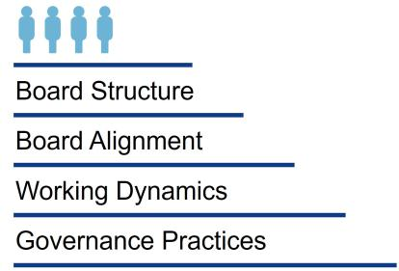

We believe that high board effectiveness promotes the long-term interests of our shareholders, strengthens the accountability of the board of directors and management, and improves our standing as a trusted member of the communities we serve. There are many factors involved in our board’s effectiveness, including a combined chair and CEO leadership structure with a strong lead independent director that provides robust independent oversight, comprehensive annual assessments driving continuous improvement, and a committee structure composed of only independent directors, which provide focused oversight across critical areas.

Working Dynamics

Leadership Structure

Approach. Under our bylaws, the positions of chair of the board and chief executive officer are separate positions that may be occupied by the same person at the discretion of the board. This gives the board flexibility to choose its optimal leadership structure that will best serve the interests of the company and its shareholders as those interests evolve over time. The board currently combines the role of chair of the board with the role of chief executive officer, and designates an independent and clearly defined lead independent director to further strengthen the company’s governance structure. The board periodically reviews its leadership structure to ensure that the chosen structure continues to strike the appropriate balance for the company and our stakeholders and enables us to promote the long-term interests of our shareholders.

Why our Board Leadership Structure is Appropriate at this Time. After thoughtful consideration of our business, long-term strategy, related risks, and other factors described below, the board believes that the combination of the chair and CEO roles, combined with a strong lead independent director, continues to be in the best interest of the company and our shareholders. Combining the chair and CEO roles fosters clear accountability, effective decision making, and alignment on corporate strategy.

The board has also implemented governance practices that facilitate effective independent oversight, including:

- Executive Sessions of the Independent Directors: Slated at each regularly scheduled board meeting and presided over by the lead independent director.

- Annual Performance Evaluation of the Chair and CEO: Conducted by the independent directors, the results of which are reviewed with the CEO and considered by the Talent and Compensation Committee and independent directors in establishing the CEO’s compensation for the following year.

- Lead Independent Director Assessment: The lead independent director is elected by and from the independent directors of the board, and the board annually conducts an assessment of the lead independent director’s performance as part of the annual board assessment process.

- Director Access to Independent Advisors: Independent directors and all committees can retain their own independent advisors, at the company’s expense, whenever they deem it desirable to do so.

- Director Access to Management: Independent directors have direct access to members of management whenever they deem it necessary, and certain of the company’s executive officers attend part of each regularly scheduled board and committee meeting.

- Independent Board: The board is independent (other than Mr. Ricks) and has fully independent board committees with independent chairs.

The board believes that this structure provides the company and the board with strong leadership, appropriate independent oversight of management, and the ability to communicate the company’s strategy to regulators and stakeholders in a single voice.

29

Mr. Ricks’ extensive knowledge of, and experience in, the pharmaceutical industry enables him to effectively drive the long-term strategic direction of the company and provide diligent, leadership and direction for management and our board. This is vital to our innovative research and development business with prolonged product development cycles and a challenging regulatory environment.

Lead Independent Director Responsibilities. The lead independent director is empowered with and exercises, robust, well-defined duties, including the following:


Lead

- Lead the board’s process for selecting the CEO

- Oversee the independent directors’ annual performance evaluation of the chair and CEO

- Call meetings of the independent directors, as appropriate

Facilitate

- Preside at executive sessions of the independent directors

- Preside at all meetings of the board at which the chair is not present

- Approve meeting agendas and schedules and review information to be provided to the board

Advocate |  |  |  |  | Shape
• Be available for |  |  |  | • Conduct the annual
consultation and direct |  |  |  | board assessment
communication with |  |  |  | process with the
shareholders, as |  |  |  | Directors and
appropriate |  |  |  | Corporate Governance
• Serve as a liaison |  |  |  | Committee and chair
between the chair and |  |  |  | • Lead the director
the independent |  |  |  | succession planning
directors |  |  |  | process
• Retain advisors for the
independent directors,
as appropriate

How We Select a Lead Independent Director. Each year the Directors and Corporate Governance Committee reviews the qualifications and attributes of a strong lead independent director and makes a recommendation to the independent directors of one from among them to be appointed as lead independent director.

Mr. Luciano serves as the current lead independent director and fulfills the duties below. As the CEO and president of Archer-Daniels-Midland Company, he brings valuable and diverse experience and outside perspective to his lead independent director role, which permits him to serve as a trusted adviser to the independent directors as well as Mr. Ricks and ensures effective board management and risk oversight.

In 2025, the independent directors, led by Mr. Luciano, met at each regularly scheduled board meeting in executive session to discuss various matters related to the oversight of the company, the management of the board’s affairs, and the CEO’s performance. We believe Mr. Luciano fosters an open and constructive dialogue during these sessions as well as during individual discussions with independent directors. As appropriate, Mr. Luciano informs Mr. Ricks of the independent directors’ discussions, including providing performance feedback.

Board and Director Assessment

Reexamine | Questionnaire |  | Evaluation Summary
Evaluation Process | One-On-One Discussions |  | Closed Session Discussions
• Our lead | • Directors provided written |  | • A summary of board and
independent director | feedback on an unattributed |  | committee evaluation results
and Directors and | basis. |  | was provided to the board and
Corporate |  |  | its committees.
Governance | • Each director had one-on-one
Committee reviewed |  |  | • Closed session evaluation
the evaluation | discussions with the lead |  | • Closed session evaluation
process. | independent director and/or with |  | discussions of the board and
 | the board chair. |  | committees were led by our
 |  |  | lead independent director and
 |  |  | independent committee chairs.

Follow Through

- Incorporated feedback into nomination process and the 2026 board and committee planning process, as applicable.

30

Every year, the Directors and Corporate Governance Committee, together with the chair and the lead independent director, conducts a robust assessment of the board and board committee performance and processes based on input from all directors. The committee also conducts an annual assessment of each director’s individual performance, and conducts a more in-depth review of individual director performance every three years when considering whether to nominate the director to a new three-year term.

The results of these assessments inform the board’s nominations for directors at the annual meeting of shareholders each year and help identify the experiences, skills, perspectives, and other characteristics needed in future director candidates. Together with our lead independent director, the committee periodically evaluates the board’s overall composition and skills as they actively engage in succession planning for directors to ensure that our board reflects the diversity of viewpoints and expertise necessary to support our complex and evolving business.

Board Education

Periodic briefing sessions are provided to members of the board and committees on subjects that would assist them in discharging their duties and enhancing their understanding of emerging trends and recent developments. Directors also attend regular continuing education sessions on areas of relevance or importance to our company, and we hold regular mandatory training sessions for the Audit Committee.

Beyond the Boardroom

Director Orientation

Each new director participates in an orientation program upon joining the board. The program includes presentations by senior management to familiarize new directors with, among other things, Lilly’s ethics, compliance and governance programs, business units, financial position, strategic plans, and human capital management programs.

“Day in the Business,” Deep Dives, and Site Visits

Directors are expected to dedicate a full day to independently explore and learn more about Lilly’s day-to-day business. These “Day in the Business” visits can take a variety of forms, such as a medical conference where a Lilly representative is presenting, a manufacturing site visit, or a ride-along with a sales representative.

Periodically, directors are invited to or may request to visit the company’s manufacturing or other operating sites, and management prepares educational sessions for directors relevant to the location’s business and culture.

Additionally, directors are invited to or may request “deep dive” educational sessions with respect to a particular business unit or other aspect of our business. Examples include sessions on product launches, field sales, medical conferences, technology initiatives, financial accounting, and affordability initiatives.

Employee Events

Directors have the opportunity to participate in a variety of Lilly events, both as presenters and as participants. This offers a chance for directors to connect with Lilly employees, show their support for these activities, and see our corporate culture, inclusion, and other human capital management strategies in action.

Shareholder Engagement

The board receives periodic updates on shareholder engagement led by management. From time to time, directors participate in communications and direct engagement with shareholders to discuss specific matters of mutual importance.

Board Structure

The board has established five standing committees: Audit, Talent and Compensation, Directors and Corporate Governance, Science and Technology, and Ethics and Compliance. Our independent directors are appointed to committees to take advantage of their diverse skill sets and enable deep focus on a specific scope of matters. The board annually reviews committee memberships and chair positions, seeking the best blend of continuity and innovative perspectives on the committees.

31

Each of our committees:

- operates pursuant to a written charter (available on our website at lilly.com/about/leadership/governance),

- evaluates its performance annually, and

- reviews its charter annually.

The chair of each committee determines the frequency and agenda of committee meetings, subject to any minimums specified in the relevant committee charter, and the committees meet in executive session on a regular basis.

Meetings of the Board and Its Committees

In 2025, our board met nine times, and each director attended at least 75 percent of the total number of meetings of the board and the committees on which he or she served during his or her tenure as a board or committee member. In addition, all board members are expected to attend the Annual Meeting, and all directors then serving attended the 2025 annual meeting of shareholders. Key responsibilities, current committee membership and the number of meetings of each committee held in 2025 are shown below.

Committees of the Board


Audit Committee

Members:

  - Mr. Alvarez*

  - Mr. Jackson* (Chair)

  - Mr. Moeller*

  - Ms. Sulzberger*

* Financial Experts

Meetings in 2025: 7

Key responsibilities and areas of risk oversight:

- oversees integrity of financial information provided to our shareholders and others

- oversees management’s systems of internal controls and disclosure controls

- oversees performance of internal and independent audit functions

- establishes qualifications and determines independence of the company’s independent auditor

- has sole authority to appoint or replace the independent auditor

- oversees compliance with legal and regulatory requirements

- oversees processes and procedures related to identifying and mitigating enterprise-level risks

- oversees the company’s programs, policies, procedures, and risk management activities related to information security, cybersecurity and data protection

- together with the Ethics and Compliance Committee, oversees the company’s compliance with the company’s code of ethics

32


Directors and Corporate Governance Committee

Members: |  | Key responsibilities and areas of risk oversight:
• | Mr. Jackson | • reviews and recommends to the board the size and composition of the board
• | Mr. Jackson | and its committees
• | Dr. Kaelin | • leads the process for director recruitment, together with the lead independent
• | Mr. Luciano (Chair) | director
• | Mr. Moeller | • reviews recommendations for nominees for the board of directors
• | Ms. Sulzberger | • oversees matters of corporate governance, including board performance, non-
 |  | employee director independence and compensation, corporate governance
Meetings in 2025: 3 |  | guidelines, and shareholder engagement on governance matters

• identifies and brings to the attention of the board, as appropriate, current and emerging environmental, social, political, and governance trends and public policy issues that may affect the business operations, performance, or reputation of the company

• annually assesses the performance of the board, board committees and board processes, and reviews such findings with the board


Talent and Compensation Committee

Members:

- Mr. Alvarez (Chair)

- Mr. Fyrwald

- Ms. Johnson

- Mr. Luciano

Meetings in 2025: 8

Key responsibilities and areas of risk oversight:

- establishes the compensation of the CEO (in consultation with independent directors and external compensation consultant) and other executive officers
- oversees global compensation philosophy, human capital management, and inclusion efforts

- has authority to appoint or replace the compensation consultant

- acts as the oversight committee for the company’s deferred compensation plans, management stock plans, and other management incentive and benefit programs

- reviews succession plans for the CEO and other key senior leadership positions, including a broad review of our succession management
- advises management and the board regarding other employee compensation and benefits matters

- reviews, monitors, and oversees stock ownership guidelines for executive officers

- oversees the company’s executive compensation recovery policy

- oversees the company’s engagement with shareholders regarding executive compensation matters, including reviewing and evaluating the results of advisory votes on executive compensation

33


Science and Technology Committee

Members:

- Dr. Baicker

- Dr. Bertozzi

- Mr. Fyrwald

- Dr. Hedley

- Dr. Kaelin (Chair)

Meetings in 2025: 7


Key responsibilities and areas of risk oversight:

- reviews and advises the board regarding the company’s long-term strategic goals and objectives and the quality and direction of the company’s research and development programs

- reviews and advises the board and management on the company’s major technology positions and strategies relative to emerging technologies, emerging concepts of therapy and health care, and changing market requirements

- monitors and evaluates developments, technologies, and trends in pharmaceutical research and development (including those related to AI)

- advises the board and management on scientific aspects of major acquisitions and business development transactions

- regularly reviews the company’s product pipeline

- assists the board with its oversight responsibility for enterprise risk management in areas affecting the company’s research and development

Ethics and Compliance Committee

Members:

- Dr. Baicker (Chair)

- Dr. Bertozzi

- Dr. Hedley

- Ms. Johnson

Meetings in 2025: 4

Key responsibilities and areas of risk oversight:

- reviews, identifies and, when appropriate, brings to the attention of the board legal and regulatory trends and issues, and compliance and quality matters that may have an impact on the business operations, financial performance, or reputation of the company

- reviews, monitors, and makes recommendations to the board on corporate policies and practices related to compliance, including those related to employee health and safety

- together with the Audit Committee, assists the board in its oversight of legal and regulatory compliance and oversees the company’s compliance with its code of ethics

Governance Practices

We are committed to good corporate governance, which promotes the long-term interests of shareholders and other company stakeholders, builds confidence in our leadership, and strengthens accountability by the board and management.

Board Oversight

The board exercises oversight over a broad range of areas. The board’s key responsibilities include the following (certain of which are carried out through the board’s committees):

- providing general oversight of the business;

- overseeing major management initiatives, corporate strategy, and capital allocation;

- selecting, compensating, evaluating, and, when necessary, replacing the CEO, and compensating other senior executives;

- ensuring that an effective succession plan is in place for all key senior leadership positions and reviewing the company’s broader talent management process, including human capital management strategies, overall corporate culture, and inclusion programs;

- overseeing the company’s ethics and compliance program and management of significant business risks;

34

- selecting, compensating, and evaluating directors;

- evaluating board processes and performance;

- overseeing the company’s enterprise level risks;

- overseeing the company’s approach to current and emerging environmental, social, political, and governance trends and public policy issues that may affect the business operations, performance or reputation of the company; and

- overseeing the company’s political expenditures and lobbying activities.

Key Areas of Oversight by the Board and Its Committees


Strategy

The board takes an active role in overseeing the development and execution of the company’s business strategy. Each year, the board and executive management conduct an extended review and discussion of the company’s strategy, goals, external environment, and key risks. Board meetings include discussions of company performance relative to its strategy. The board also reviews strategic focus areas for the company, such as innovation (including AI), information security, cybersecurity, and human capital management. Decisions reached in this session are reevaluated throughout the year, including as the board discusses the company’s financial performance, the performance of our business units, and progress in the product pipeline.


Compliance

The board, together with its committees, oversees the processes by which the company conducts its business to ensure the company operates in a manner that complies with laws and regulations and reflects the highest standards of integrity. The Ethics and Compliance Committee meets at least four times per year, including periodic private sessions to discuss compliance with the company’s chief ethics and compliance officer, the general auditor, and the leader of global quality. The Ethics and Compliance Committee receives an update on compliance at each committee meeting. On an annual basis, the full board reviews the company’s overall state of compliance.


Risk Management

Our board, as a whole, is responsible for broad oversight of all existing and emerging enterprise risk (over the short-, mid- and long-term) and of management’s development and execution of mitigation strategies designed to address those risks. In this capacity, the board has designated committees to assist in its oversight of particular key risks as described in Board Structure—Committees of the Board. Oversight of additional matters of potential risk not delegated remain the responsibility of the full board.

While the board and its committees oversee risk management, the company’s senior management is responsible for identifying, assessing, and mitigating risk on a day-to-day basis. Each committee of our board meets regularly with key management personnel and, as desired by the applicable committee, outside advisors (including outside counsel, consultants, and experts) to oversee risks associated with their respective principal areas of focus. In turn, each committee reports to the board regularly, fostering awareness and communication of significant matters among all directors, and promoting a coordinated and cohesive approach to enterprise risk oversight.

The company’s approach to enterprise level risks is overseen by the Audit Committee. Enterprise level risks are identified and prioritized by management through both top-down and bottom-up processes. Management uses robust internal processes and controls to manage risk. The enterprise level risks are reviewed annually at a full board meeting, and relevant enterprise risks are also addressed in periodic business function reviews and at the annual board and senior management strategy session. Management frequently collaborates throughout the year to keep an open dialogue on emerging risks identified from a variety of internal and external sources.

35


Governance

Corporate Governance Guidelines - The board has adopted corporate governance guidelines that set forth the company’s key principles of corporate governance and are available at lilly.com/about/leadership/governance.

Code of Ethics - The board approves the documents that comprise the company’s code of business conduct and ethics. These written standards include:

The Red Book: A code of ethical and legal business conduct applicable to all employees worldwide and to our board. The Red Book is reviewed and approved by the board and is available at lilly.com/about/impact/operating-ethically-and-responsibly.

Code of Ethical Conduct for Lilly Financial Management: A supplemental code for our CEO and all members of financial management in recognition of their unique responsibilities to ensure proper accounting, financial reporting, internal controls, and financial stewardship, is available at lilly.com/about/impact/operating-ethically-and-responsibly/financial-management-ethical-conduct.

In the event of any amendments to, or waivers of, a provision of the code affecting the CEO, chief financial officer, chief accounting officer, controller, or persons performing similar functions, we intend to post on the above website, within four business days after the event, a description of the amendment or waiver as required under applicable SEC rules. We will maintain that information on our website for at least 12 months.


Succession Planning

Management Succession Planning. Our board recognizes the importance of identifying and developing executive talent to ensure the continuity of effective executive leadership in place both now and in the future. At least annually, the Talent and Compensation Committee, full board, and CEO hold an in-depth review of the company’s succession plans for the CEO and other key senior leadership positions. The independent directors also meet without the CEO to discuss CEO succession planning.

During these reviews, the CEO and directors discuss:

- future candidates for the CEO and other senior leadership positions;

- succession timing; and

- development plans for potential candidates to cultivate the experiences, skills and capabilities needed to become our future leaders and prepare them for roles with greater responsibility.

The board considers a number of factors such as experience and skills in its review of the senior leadership team to assess which senior leaders possess or can develop the attributes that the board believes are necessary to lead and achieve the company’s goals. To further the board’s familiarity with senior leaders, the board has direct exposure to senior leaders and high-potential employees in both formal and informal settings during the year to allow them to most effectively assess the candidates’ qualifications and capabilities. This exposure takes many forms, including management presentations to the board or its committees, attendance at board meetings and our annual board strategy retreat, and periodic informal meetings and communications. Board members may also engage with potential external candidates as well.

Emergency Succession Plan. The independent directors and the CEO maintain a confidential plan for the timely and efficient transfer of the CEO’s responsibilities in the event of an emergency or his sudden departure, incapacitation, or death.

Director Succession Planning. Director succession planning is a priority for our Directors and Corporate Governance Committee. This committee, with the lead independent director, guides the director succession planning process, makes nomination recommendations to the board and, with input from the full board, assesses the contributions of directors.

The Directors and Corporate Governance Committee regularly reviews the skills, qualifications, tenures, and projected mandatory retirement dates of our directors. They also review the various board refreshment tools that the board has implemented (as more fully discussed on p.
9), including the Resignation Policy, Director

36

Retirement Policy, Other Board Service Policy, and annual assessment. The board fosters a board refreshment culture that values the importance of ongoing evaluation and the evolution of the board, as necessary, to best suit the company’s evolving needs.


Cybersecurity

Our board of directors monitors cybersecurity risks and regularly participates in presentations on cybersecurity and information technology. The Audit Committee is responsible for oversight of our programs, policies, procedures, and risk management activities related to information security, cybersecurity and data protection. The Audit Committee meets regularly with the senior officers directly responsible for cybersecurity, digital information and data privacy to discuss threats, risks, and ongoing efforts to enhance cyber resiliency, as well as changes to the broader cybersecurity landscape. In addition, the Ethics and Compliance Committee supports the Audit Committee and board in oversight of legal and regulatory compliance. In addition to regular presentations, management promptly updates our board of directors regarding significant threats and incidents as they arise.


Artificial Intelligence

Our board maintains oversight of and receives regular updates from management on AI, including strategy, risks, development, governance, and ethical innovation approaches. As we deploy AI and other emerging technologies across our operations, our board continues to deepen its understanding of these transformative technologies.


Sustainability

Our approach to sustainability includes board oversight, management accountability, corporate policies and management systems, and stated positions on key topics. Our full board is engaged in strategic sustainability oversight, receives regular updates on these matters, reviews our long-term environmental goals, and significant strategic investments, including those related to our overall sustainability priorities. The Directors and Corporate Governance Committee is also responsible for identifying and bringing to the attention of the board, as appropriate, current and emerging environmental, social, political, and governance trends and public policy issues that may affect our business operations, performance, or reputation.

In addition, we have an executive sustainability committee that monitors sustainability strategy, priorities, performance, and disclosure, while a sustainability operations committee that includes senior leaders across many of our business functions provides operational oversight of sustainability initiatives.

Our approach to sustainability efforts incorporates internal and external input to better determine the issues that matter most to our company and stakeholders. We set ambitious, measurable goals that are integrated into our business strategy and operations to directly support Lilly’s purpose.

We are striving to improve access to medicines, improve healthcare for people with limited resources, strengthen communities, and address social issues that impact health, empower an inclusive workforce, minimize our environmental impact, and operate ethically and responsibly.

Our Sustainability Report provides a central location for information about goals, efforts, and progress on these initiatives.


Political Activities

We believe that as a biopharmaceutical company that develops treatments for serious diseases, we are in a position to help promote access to needed medications through engagement with policymakers. Public policy engagement provides a way to offer Lilly’s perspective on the political environment in a manner that supports access to innovative medicines and a way to engage on issues specific to local business environments.

37

Our board exercises governance oversight of our political expenditures and lobbying activities, ensuring our commitment to stewardship of corporate funds and risk minimization with respect to such activities. The Directors and Corporate Governance Committee is responsible for identifying current and emerging environmental, social, political, and governance trends and public policy issues that may affect the business operations, performance, or reputation of the company. In addition, the board receives regular updates at board meetings from management, which include updates on public policy issues and the company’s political corporate activity, as needed. The board also receives semi-annual updates on political engagement, including information on the contributions made by our employee political action committee (LillyPAC) and the company, as well as trade association memberships.

We provide information on our website related to direct company contributions and LillyPAC contributions to support candidates for political office, political parties, officials, or committees in the United States, as well as information regarding our trade association memberships and the company’s oversight of these activities. In response to input from our stakeholders, over time we have reviewed and enhanced the information available on our website.


Human Capital Management

The board exercises active oversight of our overall human capital strategy, including our talent management process, corporate culture, and inclusion efforts. The board also oversees the work of its committees in developing corporate policies and frameworks designed to attract, retain, engage, and develop a workforce that aligns with our values and mission. The Talent and Compensation Committee advises the board and management on oversight of human capital management, inclusion efforts, and employee compensation and benefits matters, and annually reviews our leadership development and succession planning practices.

The board also oversees human capital management by regularly engaging with management and facilitating a system of reporting that highlights the importance of inclusion to Lilly. Our board also oversees the activities of our CEO and executive committee in setting expectations for inclusivity in our workforce. Our Chief People Officer has responsibility for all aspects of talent management in the company, which enables building a strong and inclusive culture. Our executive team and board are active in our talent management strategy, fostering a supportive and rewarding workplace.

Talent Management Approach

Our comprehensive approach to human capital management is grounded in our core values of integrity, excellence, and respect for people, which reflect our commitment to creating a safe, supportive, ethical, and rewarding work environment. We are committed to fairness and nondiscrimination in our employment practices, and we deeply value diverse backgrounds, skills, and global perspectives. To fulfill our purpose, we believe we must look at challenges from multiple viewpoints and understand the varied experiences of the patients who depend on us. In short, we believe that an inclusive culture makes us better. It helps us attract and retain the best people and strengthens our understanding of the patients we serve while fostering a great workplace. At all times, we seek to hire the most qualified candidate for each open position.

Empowering a global culture of inclusion and belonging also encompasses building a disability-confident workplace that promotes barrier-free experiences and empowers productivity for all employees and customers. Our initiative to increase inclusion for employees with disabilities is grounded in three key pillars: physical accessibility, digital accessibility and attitudinal awareness – covering multiple categories, including learning and development, facilities, and information systems. Accessibility and inclusion are embedded in our strategy.

Employee Development

Recruiting: We believe attracting and retaining the best talent begins with an inclusive recruiting process. Our recruitment strategy focuses on opportunities to reach more qualified candidates across a variety of experiences and backgrounds. We believe that recruiting in this way helps ensure that everyone will have an equal opportunity to be considered for employment at Lilly. Lilly makes hiring decisions in accordance with applicable anti-discrimination laws and regardless of a candidate’s race, gender, or other protected characteristics.

Onboarding and Continuing Education: Beginning with our 6-month new employee onboarding program, we offer training to enable our employees to perform their duties in our highly regulated industry. We also strive to cultivate a culture that promotes ongoing learning by encouraging employees to seek further education and growth experiences, helping them build rewarding careers. We have online programming to facilitate access to

38

our learning and development offerings in addition to our in-person programs. Across Lilly, we are continuously working to design learning experiences to be more inclusive and effective. In addition, we have broadened access to development tools, mentorships and coaching resources, implemented an 18-month curriculum for new leaders focused on developing five essential skills, and increased transparency regarding career development and advancement at Lilly.

Compensation, Benefits, and Pay Equity

While our rewards programs vary around the world, we take a holistic approach to employee benefits. These may include flexible work arrangements, on-site conveniences, such as cafes, fitness centers, and child development centers, competitive time-off programs, retirement benefits, and health and disability programs that are available to eligible employees when they need support.

We are committed to ensuring pay is administered equitably across our workforce. For more than 20 years, we have regularly conducted pay equity studies of our workforce in the United States and have more recently started conducting studies of our workforce outside of the United States. Where appropriate, we have made pay adjustments as warranted and expect to continue to do so moving forward.

Employee Health and Safety

20+

Years

of pay equity studies in the U.S.

We strive to foster a healthy, vibrant work environment, which includes keeping our employees safe. We seek to create a companywide culture where best-in-class safety practices are consistently followed. To do this, we assess and continuously attempt to improve our companywide safety performance to promote the well-being of employees and to help safeguard communities where we operate. We believe a holistic approach and dedication to safety helps us be our best as we deliver on our company purpose to improve lives around the world.

Our Sustainability Report provides additional information about our talent management efforts.

Board Alignment

Conflicts of Interest and Transactions with Related Persons

Conflicts of Interest

Occasionally, a director’s business or personal relationships may give rise to an interest that conflicts, or appears to conflict, with the interests of the company. As outlined in the company’s corporate governance guidelines, directors must disclose to the company all relationships that could create a conflict or an appearance of a conflict. The board, after consultation with counsel, takes appropriate steps to identify actual or apparent conflicts and ensure that all directors voting on an issue are disinterested with respect to that issue. A director may be excused from board discussions and decisions on an issue related to an actual or apparent conflict, as appropriate.

In addition, a director’s relationship with Lilly may give rise to an interest that conflicts, or appears to conflict, with the interests of another company, institution, or other stakeholder. A director must disclose his or her relationship with Lilly in connection with any scientific publication, using the International Committee of Medical Journal Editors conflict of interest form for this purpose when possible. Each director must disclose his or her service on the board to his or her employer and any other organization with which the director has a relationship of trust and where the relationship with Lilly is relevant. In addition, directors must follow the internal conflict of interest policies and procedures of each such organization.

Review and Approval of Transactions with Related Persons

The board has adopted a written policy and procedures for review, approval, and monitoring of transactions involving the company and related persons (including current executive officers, directors, or director nominees and persons who served in those roles at any time since the beginning of our last fiscal year, greater than five percent shareholders of the company, and immediate family members of such persons). The policy covers any related person transaction that meets the minimum threshold for disclosure in this proxy statement under relevant SEC rules (generally, transactions involving amounts exceeding $120,000 in which a related person has a direct or indirect material interest).

39

Policy:

Related person transactions must be preapproved by the Directors and Corporate Governance Committee of the board or another independent body of the board, who will approve the transaction only if the Directors and Corporate Governance Committee or such independent body determines it to be consistent with the interests of the company and its shareholders. In considering the transaction, the Directors and Corporate Governance Committee or such independent body will consider all relevant factors, including:

- the company’s business rationale for entering into the transaction;

- the purpose of, and potential benefits to the company of, the transaction;

- the alternatives to entering into a related person transaction;

- whether the transaction is on terms comparable to those available to unrelated third parties, or in the case of employment relationships, to employees generally;

- the potential for the transaction to lead to an actual or apparent conflict of interest and any safeguards imposed to prevent such actual or apparent conflicts;

- the overall fairness of the transaction to the company;

- the approximate dollar value of the amount involved in the transaction, particularly as it relates to the related person;

- the related person’s interest in the transaction; and

- any other information regarding the transaction or the related person that would be material to the company’s shareholders in light of the circumstances of the particular transaction.

Procedures:

- Before entering into a transaction that may qualify as a related person transaction, the related person (or, in the case of an immediate family member of an executive officer or director, the respective executive officer or director), should promptly notify the chair of the board or the lead independent director, as well as the general counsel.

- The chair and lead independent director will decide if the matter should be reviewed by the Directors and Corporate Governance Committee or another independent body, unless one of them is involved in the transaction. In that case, the decision will be made by the person who is not involved in the transaction together with the chair of the Directors and Corporate Governance Committee (unless the chair of the Directors and Corporate Governance Committee is involved in the transaction, in which case the chair of the Audit Committee will be substituted).

- If a director or an immediate family member of a director is involved in the transaction, the director will be recused from all discussions and decisions relating to the transaction.

- The Directors and Corporate Governance Committee or another independent body may approve the related person transaction only if the Directors and Corporate Governance Committee or such independent body determines in good faith that, under all of the circumstances, the transaction is consistent with the interests of the company and its shareholders.

- The Directors and Corporate Governance Committee or the other independent body may set any conditions they consider appropriate for the company or related person when approving a related person transaction.

- Approved recurring transactions will be reviewed annually by the Directors and Corporate Governance Committee or another independent body to determine whether the transaction continues to be consistent with the interests of the company and its shareholders.

When a related person transaction arises that has not previously been approved or ratified or that needs to be re-reviewed, the related person transaction is presented for review and possible approval or ratification in the manner set forth above, which presentation may be, as appropriate, at the next regularly scheduled meeting of the Directors and Corporate Governance Committee or other applicable independent body.

40

In 2025, there were no related party transactions required to be reported pursuant to relevant SEC rules in this proxy statement.

Communication with the Board of Directors

You may send written communications to members of the board, including independent directors, addressed to:

Board of Directors

Eli Lilly and Company

c/o General Counsel and Secretary

Lilly Corporate Center

Indianapolis, IN 46285

Shareholder Engagement on Governance Issues

To ensure that a variety of perspectives are thoughtfully considered on key issues, each year the company engages large shareholders and other key constituents to discuss areas of interest or concern related to corporate governance, as well as any specific issues for the coming proxy season. Since our 2025 annual meeting of shareholders, we have spoken with a number of investors on an array of subjects. We appreciate the thoughtful and constructive feedback that we receive from our stakeholders. While a few shareholders communicated differing views on some of our governance practices, the investors with whom we spoke were generally supportive of our performance and overall compensation and governance policies. This feedback has been discussed with our chair and CEO, the lead independent director, our Talent and Compensation Committee, and our Directors and Corporate Governance Committee, and it was a key input into board discussions on corporate governance topics. As a result of these discussions and its own deliberations, the board decided to recommend in favor of management proposals to eliminate the classified board structure and supermajority voting requirements (see Items 4 and 5).

We are committed to continuing to engage with our investors to ensure that their diverse perspectives on corporate governance and other issues are thoughtfully considered. We will continue to engage with our shareholders on these and other topics to ensure that we continue to demonstrate strong corporate governance and accountability to shareholders.

Shareholder Proposals

Shareholder Proposals under Rule 14a-8

Shareholders interested in submitting a proposal considered for inclusion in the proxy statement for the 2027 annual meeting must follow the procedures set forth in Rule 14a-8 under the Exchange Act. Proposals should be addressed to the General Counsel and Secretary and mailed to Lilly Corporate Center, Indianapolis, IN 46285. For convenience, emailed copies may also be sent to shareholderproposals@lilly.com. In general, to be eligible for inclusion in the proxy statement for the 2027 annual meeting, shareholder proposals must be received no later than November 20, 2026.

Other Shareholder Proposals

In addition, under section 1.8 of the company’s bylaws, any shareholder of record wishing to propose business (other than pursuant to Rule 14a-8 or related to the nomination of directors) at the 2027 annual meeting of shareholders, must give the company written notice no later than the close of business on November 20, 2026, and no earlier than the close of business on September 21, 2026. However, if the date of the 2027 annual meeting is changed by more than 30 days from May 3, 2027 (the date contemplated for the 2027 annual meeting), a shareholder must give the company written notice no later than the close of business on the later of 120 days in advance of the 2027 annual meeting or 10 days following the date we first publicly announce the date of the 2027 annual meeting. Any such notice must also comply with the timing, disclosure, procedural and other requirements as set forth in the bylaws. A copy of the bylaws is available online at lilly.com/about/leadership/governance.

41

Ownership of Company Stock

Common Stock Ownership by Directors and Executive Officers

The following table sets forth the number of shares of company common stock beneficially owned by directors, named executive officers, and all directors and executive officers as a group, as of February 25, 2026. On February 25, 2026, there were 944,818,881 shares of the company’s common stock outstanding. None of the stock or stock units owned by any of the listed individuals has been pledged as collateral for a loan or other obligation.

Common Stock¹

 |  | Stock Units
 |  | Distributable |  | Stock Units Not
 |  | Within 60 | Percent | Distributable Within
Beneficial Owners | Shares Owned² | Days³ | of Class | 60 Days⁴
Ralph Alvarez | 758 | — | * | 55,492
Katherine Baicker, Ph.D. | — | — | * | 23,536
Carolyn Bertozzi, Ph.D. | 2,000 | — | * | —
J. Erik Fyrwald | 1,683 | — | * | 73,437
Anat Hakim | 55,562 | — | * | —
Mary Lynne Hedley | 346 | — | * | 2,005
Jamere Jackson | 200 | — | * | 9,449
Kimberly Johnson | — | — | * | 3,269
William Kaelin, Jr., M.D. | — | — | * | 21,867
Juan Luciano | — | — | * | 16,772
Jonathan Moeller | 71 | — | * | 233
Lucas Montarce | 16,258 | — | * | 1,981
David Ricks⁵ | 815,535 | — | * | —
Daniel Skovronsky, M.D., Ph.D. | 235,688 | — | * | —
Gabrielle Sulzberger | 117 | — | * | 2,849
Jake Van Naarden | 36,270 | — | * | —
All directors and current executive
officers as a group (25 people): | 1,362,076 | — | * | 227,279

* Less than 1.0 percent of the outstanding common stock of the company.

- The sum of the “Shares Owned” and “Stock Units Distributable Within 60 Days” columns represents the shares considered “beneficially owned” for purposes of disclosure in this proxy statement. Unless otherwise indicated in a footnote, each person listed in the table possesses sole voting and sole investment power with respect to their shares.

- This column includes the number of shares of common stock held directly or indirectly, including the number of 401(k) Plan shares held by the beneficial owners indirectly through the 401(k) Plan.

- This column sets forth restricted stock units that vest within 60 days of February 25, 2026.

- For the executive officers, this column reflects restricted stock units that will not vest within 60 days of February 25, 2026. For the non-employee directors, this column reflects the number of units representing the right to receive shares of company stock credited to the directors’ accounts in the Lilly Directors’ Deferral Plan.

- The shares shown for Mr. Ricks include 106,693 shares that are owned by a family foundation for which he is a director. 42

Insider Trading Policy

Lilly has adopted an insider trading policy governing the purchase, sale, and/or other dispositions of its securities by directors, officers and employees, and has implemented processes with respect to the company that are reasonably designed to promote compliance with securities laws, rules, and regulations, and New York Stock Exchange listing standards. The full text of Lilly’s insider trading policy was filed as Exhibit 19 to the company's Annual Report on Form 10-K for the year ended December 31, 2025.

Common Stock Ownership of Certain Beneficial Holders

The following table sets forth the number of shares of company common stock beneficially owned as of December 31, 2025, unless otherwise indicated, by each person known to the company to beneficially own more than five percent of the outstanding shares of the company’s common stock:

 |  | Number of Shares | Percent of Class*
Name and Address |  | Beneficially Owned | Percent of Class*
Lilly Endowment Inc. (the Endowment) | 1 | 92,190,516 | 9.8%
2801 North Meridian Street

Indianapolis, IN 46208

The Vanguard Group

100 Vanguard Blvd.

Malvern, PA 19355

BlackRock, Inc.

55 East 52nd Street

New York, NY 10055

2

3

80,952,595 8.6%

64,376,027 6.8%

The PNC Financial Services Group, Inc. | 4 | 51,153,837 | 5.4%
300 Fifth Avenue

Pittsburgh, PA 15222

* Percent of class is calculated based on the shares of our common stock outstanding as of February 25, 2026.

- Based on information provided to Lilly by the Endowment as of December 31, 2025, and a Schedule 13G/A filed by the Endowment with the SEC on January 23, 2026, the Endowment has sole voting and sole dispositive power with respect to all of its shares.

- Based solely on the Schedule 13G/A filed with the SEC on October 30, 2025, reporting beneficial ownership as of September 30, 2025, by The Vanguard Group, it has shared voting power with respect to 4,843,238 of its shares, sole dispositive power with respect to 73,223,987 of its shares, and shared dispositive power with respect to 7,728,608 of its shares.

- Based solely on the Schedule 13G/A filed with the SEC on January 29, 2024, reporting beneficial ownership as of December 31, 2023, by BlackRock, Inc., it has sole voting power with respect to 58,375,051 of its shares and sole dispositive power with respect to 64,376,027 of its shares.

- Based solely on the Schedule 13G/A filed with the SEC on February 7, 2025, by The PNC Financial Services Group, Inc.; PNC Bank, National Association; PNC Delaware Trust Company; PNC Ohio Trust Company; and PNC Investments LLC (collectively, PNC), PNC beneficially owns 51,153,837 shares in total. PNC has sole voting power with respect to 1,128,657 of its shares and shared voting power with respect to 50,004,717 of its shares. PNC has sole dispositive power with respect to 881,684 of its shares and shared dispositive power with respect to 50,229,518 of its shares. Of the total shares of common stock reported for PNC above, 50,000,000 shares are held in the Eli Lilly and Company Compensation Trust account for which PNC Bank serves as directed trustee. As directed trustee, PNC Bank is deemed to share both voting power and investment discretion with respect to those 50,000,000 shares.

Delinquent Section 16(a) Reports

Section 16(a) of the Exchange Act requires our directors and executive officers and persons who own more than 10% of a registered class of our equity securities to file reports of ownership of, and transactions in, our equity

43

securities with the SEC. Based on a review of the copies of these reports, and on written representations from our reporting persons, we believe that all such reports were timely filed.

Compensation

Item 2. Advisory Vote on Compensation Paid to Named Executive Officers

Section 14A of the Exchange Act provides the company’s shareholders with the opportunity to approve, on an advisory basis, the compensation of the company’s named executive officers as disclosed in this proxy statement. Our compensation philosophy is designed to attract, engage, and retain highly talented individuals from a variety of backgrounds and motivate them to create long-term shareholder value by achieving top-tier corporate performance while embracing the company’s core values of integrity, excellence, and respect for people.

The Talent and Compensation Committee and the board believe that our executive compensation aligns well with our philosophy and with corporate performance. Executive compensation is an important matter for our shareholders. We routinely review our compensation practices and engage in ongoing dialogue with our shareholders to ensure our practices are aligned with stakeholder interests and reflect best practices.

We request shareholder approval, on an advisory basis, of the compensation of the company’s named executive officers as disclosed in this proxy statement. As an advisory vote, this proposal is not binding on the company. However, the Talent and Compensation Committee values input from shareholders and will consider the outcome of the vote when making future executive compensation decisions.


RECOMMENDATION FOR

The board recommends that you vote FOR the approval, on an advisory basis, of the compensation paid to the named executive officers, as disclosed pursuant to Item 402 of Regulation S-K, including the CD&A, the compensation tables, and related narratives provided below in this proxy statement.

Talent and Compensation Committee Matters

Background

Role of the Independent Consultant in Assessing Executive Compensation

The Talent and Compensation Committee has retained Frederic W. Cook & Co., Inc. (FW Cook) as its independent compensation consultant. FW Cook reports directly to the Talent and Compensation Committee, and it is not permitted to have any business or personal relationship with management or members of the Talent and Compensation Committee. FW Cook’s responsibilities are to:

- review the company’s total compensation philosophy, peer group, and target competitive positioning for reasonableness and appropriateness;

- review the company’s executive compensation program and advise the Talent and Compensation Committee of evolving best practices;

- provide independent analyses and recommendations to the Talent and Compensation Committee on the CEO’s pay;

- review the CD&A and related tables for the proxy statement;

- proactively advise the Talent and Compensation Committee on best practices for board governance of executive compensation; and

- undertake special projects at the request of the Talent and Compensation Committee or its chair.

44

FW Cook interacts directly with members of company management only on matters under the Talent and Compensation Committee’s oversight and with the knowledge and approval of the Talent and Compensation Committee chair.

Role of Executive Officers and Management in Assessing Executive Compensation

With the oversight of the CEO and the Chief People Officer, the company’s global compensation group formulates recommendations on compensation philosophy, plan design, and compensation for executive officers (other than the CEO, as noted below). The CEO provides the Talent and Compensation Committee with a performance assessment and compensation recommendation for each of the other executive officers. The Talent and Compensation Committee considers those recommendations with the assistance of its independent compensation consultant FW Cook. The CEO and the Chief People Officer attend Talent and Compensation Committee meetings; however, they are not present for executive sessions or any discussion of their own compensation. Only non-employee directors and the Talent and Compensation Committee’s consultant attend executive sessions.

The CEO does not participate in the formulation or discussion of his pay recommendations. He has no prior knowledge of the recommendations that FW Cook makes to the Talent and Compensation Committee.

Risk Assessment Process

In 2025, with consultation from the independent compensation consultant, the Talent and Compensation Committee reviewed the company’s compensation policies and practices and concluded that the programs and practices are unlikely to have a material adverse effect on the company. The Talent and Compensation Committee noted numerous policy and design features of the company’s compensation programs and governance structure that reduce the likelihood of inappropriate or excessive risk-taking, including, but not limited to:

- Only independent directors serve on the Talent and Compensation Committee.

- The Talent and Compensation Committee engages its own independent compensation consultant.

- The Talent and Compensation Committee has downward discretion to lower compensation plan payouts.

- The Talent and Compensation Committee approves all adjustments to financial results that affect compensation calculations.

- Different measures and metrics are used across multiple incentive plans that appropriately balance cash/stock, fixed/variable pay, and short-term/long-term incentives.

- Incentive plans have predetermined maximum payouts.

- Performance objectives are challenging but achievable.

- Programs with operational metrics have a continuum of payout multiples based upon achievement of performance milestones, rather than “cliffs” that might encourage suboptimal or improper behavior.

- A compensation recovery policy is in place that complies with applicable NYSE listing standards, and additionally provides for discretionary recoupment in the event of misconduct.

- Meaningful share ownership and retention requirements are in place for all members of senior management and the board.

Talent and Compensation Committee Report

The Talent and Compensation Committee evaluates and establishes compensation for executive officers and oversees the deferred compensation plan, management stock plans, and other management incentive and benefit programs. Management has the primary responsibility for the company’s financial statements and reporting process, including the disclosure of executive compensation in the CD&A. With this in mind, the Talent and Compensation Committee has reviewed and discussed the CD&A with management. Based on this discussion, the Talent and Compensation Committee recommended to the board that the CD&A be included in this proxy

45

statement and incorporated by reference into the company’s Annual Report on Form 10-K for the fiscal year ended December 31, 2025, for filing with the SEC.

Talent and Compensation Committee

Ralph Alvarez, Chair

J. Erik Fyrwald

Kimberly Johnson

Juan Luciano

Talent and Compensation Committee Interlocks and Insider Participation

During the year ended December 31, 2025, Mr. Alvarez, Mr. Fyrwald, Ms. Johnson, and Mr. Luciano served on the Talent and Compensation Committee.

None of the Talent and Compensation Committee members:

- has ever been an officer or employee of the company,

- is or has been a participant in a related person transaction with the company (see “Governance—How We Operate an Effective Board —Board Alignment—Conflicts of Interest and Transactions with Related Persons—Review and Approval of Transactions with Related Persons” for a description of our policy on related person transactions), or
- has any other interlocking relationships requiring disclosure under applicable Securities and Exchange Commission (SEC) rules.

Compensation Discussion and Analysis

This Compensation Discussion and Analysis (CD&A) outlines our executive compensation philosophy, as well as the processes and considerations employed by the Talent and Compensation Committee (the Committee) in determining executive compensation, and how our pay-for-performance culture links incentive payouts to company results.

The CD&A provides compensation information for our named executive officers (NEOs) for 2025, including Chief Executive Officer, David Ricks; Chief Financial Officer, Lucas Montarce; and our next three most highly compensated executive officers: Daniel Skovronsky, Anat Hakim, and Jake Van Naarden.

The following section introduces each NEO and highlights 2025 performance achievements that contributed to the incentive payouts detailed in the “Compensation Results” section.


Dave Ricks

Chair, President, and Chief Executive Officer (2017 - Present)

In 2025, under Mr. Ricks’ leadership, Lilly generated positive clinical data in more than 25 Phase 3 trials, and reached over 71 million people around the world with our medicines. Highlights include:

  - Increased company revenue by 45% to $65 billion

  - Increased non-GAAP earnings per share by 86% to $24.21 per share.

  - Obtained FDA approvals for Omvoh for Crohn's disease, Inluriyo for ER+ breast cancer, Amyvid for Alzheimer’s disease diagnosis, and Kisunla for early symptomatic Alzheimer’s disease

  - Secured European Commission marketing authorizations for Jaypirca and Kisunla for the treatment of early symptomatic Alzheimer's disease

- Oversaw major manufacturing investments including facilities in Texas ($6.5B), Alabama ($6B), Virginia ($5B), the Netherlands ($3B), Puerto Rico ($1.2B), and India ($1B)

- Acquired Verve Therapeutics, Scorpion Therapeutics, SiteOne Therapeutics, and Adverum Biotechnologies

- Expanded LillyDirect™, Lilly’s direct-to-patient platform, to reach over 1 million patients

- Drove initiatives including NVIDIA AI supercomputer partnership, and U.S. government obesity medicine access agreement

46


Lucas Montarce

Executive Vice President and Chief Financial Officer (2024 - Present)

Mr. Montarce’s key 2025 highlights include:

- Facilitated the company exceeding its revenue and non-GAAP earnings per share targets

- Drove the company’s strategic planning process, focusing on current execution while also making necessary investments and provisions for the next decade

- Engaged in all business development, balancing near-term risks with long-term outcomes

- Continued to build credibility and trust with the investment community


Dan Skovronsky, M.D., Ph.D.

Executive Vice President, Chief Scientific and Product Officer and President, Lilly Research Labs (2018 - Present)

Dr. Skovronsky’s key 2025 highlights include:

- Directed the performance of Lilly’s R&D organization, which continues to perform above industry peers for clinical development speed, success rate, and the quality of the pipeline as valued by the external market. Lilly’s clinical development is among the fastest in the industry

- Advanced obesity and diabetes pipeline with positive SURMOUNT-5 results (Zepbound: 20.2% weight loss vs. Wegovy's 13.7%), advancement of eloralintide to Phase 3, and eight positive Phase 3 trials for orforglipron for obesity leading to FDA submission

- Oversaw positive SURPASS-CVOT results where Mounjaro demonstrated 8% lower MACE-3 events vs. Trulicity with greater reductions in A1C and weight outcomes
- Presented long-term extension study data on Ebglyss, showing similar levels of skin clearance when administered as a single 250mg injection once every eight weeks
- Opened Gateway Lab in Philadelphia and launched TuneLab for AI-enabled drug discovery


Anat Hakim

Executive Vice President, General Counsel and Secretary (2020 - Present)

Ms. Hakim’s key 2025 highlights include:

- Transformed Lilly’s enterprise risk strategy and structure, leading to a more focused and streamlined approach to risk and issue management

- Navigated an evolving and complex litigation and enforcement environment, providing strategic counsel on legal matters critical to company interests and obtaining numerous favorable litigation outcomes

- Engaged policymakers and industry partners to promote balanced reforms that strengthen U.S. markets and protect innovation

- Led an initiative to combat counterfeiting and compounding across the globe

- Provided strategic leadership on key business development initiatives and complex corporate transactions aimed at advancing long-term growth objectives

47


Jake Van Naarden

Executive Vice President and President, Lilly Oncology and Head of Corporate Business Development (2021 - Present)

Mr. Van Naarden’s key 2025 highlights include:

- Gained FDA approvals for Jaypirca (EU for CLL) and Inluriyo for ER+ breast cancer. Secured FDA Breakthrough Therapy designation for olomorasib in KRAS G12C-mutant lung cancers

- Achieved EU approval for Jaypirca for adults with relapsed or refractory chronic lymphocytic leukemia (CLL) previously treated with a BTK inhibitor

- Delivered positive survival data from monarchE trial showing Verzenio reduced death risk by 15.8% in HR+/HER2- early breast cancer

- Expanded leadership scope to include corporate business development function

Our Compensation Philosophy

Lilly’s purpose is to unite caring with discovery to create medicines that make life better for people around the world. To achieve this, we must attract, engage, and retain highly talented individuals who deliver exceptional performance while upholding our core values of integrity, excellence, and respect for people. Our compensation programs are designed to help us achieve these goals while balancing stakeholder interests.

Objectives of Our Compensation Programs

- Reward Individual and Company Performance: We link pay to individual and company performance to reinforce a high-performance culture. As employees assume greater responsibilities, a greater proportion of total compensation is tied to company performance and shareholder returns. Annual reviews ensure our programs incentivize long-term, sustainable results while discouraging excessive risk-taking.

- Attract and Retain Talented Employees: Our compensation is market-competitive and reflects job impact and responsibilities. Retention of talent is a key factor in designing our compensation and benefit programs.

- Implement Broad-Based Programs: While compensation varies, the structure of our compensation and benefit programs is similar across the organization to align employees to company goals and reward all who contribute to our success.

- Consider Shareholder Input: We consider annual say-on-pay results and other shareholder feedback when designing executive compensation and benefit programs.

Say-on-Pay Results

At our 2025 annual meeting, over 96 percent of votes cast were in favor of the company’s say-on-pay proposal. | 96%
Management and the Committee view this result as broadly supportive of our compensation approach. | Support for
 | Say-on-Pay
The Committee’s Processes and Analyses
Setting Compensation

The Committee considers individual performance assessments, CEO recommendations (for other executives), company performance, peer group data, input from its independent compensation consultant, shareholder feedback, and its own judgment when determining executive compensation.

Individual performance

- CEO: The independent directors, under the direction of the lead independent director, meet with the CEO at the beginning of each year to establish the CEO’s performance objectives. At year end, the independent directors assess the CEO’s achievement of those objectives along with other factors, including contributions to the company’s performance, sustainability goals, ethics, and integrity. The evaluation informs the CEO’s total direct compensation target for the following year.

- Other Executives: The CEO provides the Committee with performance assessments and compensation recommendations for other executive officers. Each assessment is based on achievement of objectives

48

established at the start of the year as well as other factors, including contributions to company performance, sustainability goals, ethics, and integrity. The Committee considers these inputs, its own knowledge of and interactions with each executive officer, and its judgment to finalize assessments. For newly appointed executives, the Committee sets compensation at the time of appointment.

Company performance

Lilly performance impacts compensation in multiple ways:

- Prior-year performance influences target compensation for the upcoming year.

- Annual performance goals, established at the start of the year, determine short-term cash incentive payouts.

- Multi-year performance goals, set before annual stock grants, determine long-term incentive payouts.

Peer group data

The Committee uses peer group data as one input for compensation decisions but does not rely on it exclusively.

Independent compensation consultant input

The Committee considers advice from its independent compensation consultant, FW Cook, when setting executive compensation.

Benchmarking Compensation

This year, given Lilly's position as one of the largest companies in the world, we expanded our competitive benchmarking to include two peer groups: a group of companies with similar business models that require specialized skills for operating a global pharmaceutical company, and a group of large-cap general industry companies. In selecting the general industry group, we considered factors such as business models, revenue, market capitalization, and availability of compensation data. This approach provides a comprehensive view of the competitive landscape for both general and administrative talent and pharmaceutical-specific expertise.

The Committee approved the following peer groups:

Pharma Peer Group

AbbVie | Amgen |  | AstraZeneca | Bristol-Myers Squibb
Gilead | GlaxoSmithKline |  | Johnson & Johnson | Medtronic
Merck | Novartis |  | Pfizer | Roche
Sanofi | Stryker
General Industry Peer Group
3M | Abbott Laboratories |  | Adobe | Advanced Micro Devices
Apple | Applied Materials |  | Broadcom | Cisco
Coca-Cola | Colgate-Palmolive |  | Danaher | Honeywell
IBM | Intel |  | McDonald’s | Micron
Nike | NVIDIA |  | Qualcomm | Salesforce
Tesla | Thermo Fisher

The Committee reviews and approves peer groups at least every three years. The Chair of the Committee and the Committee’s independent compensation consultant review the peer groups annually.

Components of Our Compensation

The primary compensation components and award types remained unchanged.

1. Base Salary

Base salaries are reviewed annually and may be adjusted based on performance, changes in job responsibilities, or to maintain market competitiveness. Salaries deemed appropriate based on job responsibilities, performance, and market competitiveness remain unchanged.

49

2. Annual Cash Bonus (Bonus Plan)

The Committee maintained the Bonus Plan’s three equally weighted measures for 2025: product revenue, EPS, and pipeline progress. The product revenue metric focuses on newer products, while the pipeline metric tracks deliverables by therapeutic area.

Goals and weightings are set annually based on the operating plan and pipeline objectives. Certain product-specific revenue goals and internal pipeline objectives are not publicly disclosed to avoid competitive harm.

The 2025 performance measures and weightings are:

Lilly 2025 Goals | Weighting
Product revenue | 33.3%
EPS performance | 33.3%
Pipeline progression | 33.3%
Bonus multiple | 100%

To incentivize swift delivery of breakthrough medicines, the Committee focused the revenue measure on seven key products: Kisunla, Ebglyss, Omvoh, Jaypirca, Verzenio, Mounjaro, and Zepbound. Together, these products represent significant patient outcomes and support long-term company performance.

The pipeline scorecard provides employees visibility into how their work impacts bonus payouts. For 2025, the scorecard measures progress across four categories:

- Discovery / Early Development: Output from discovery, entries into clinical development, and early-phase clinical readouts (e.g. Proof of Concept)

- Late Development / Regulatory: Entries into registrational studies, Phase 3 readouts, and regulatory outcomes

- Business Development / Strategic Initiatives: Entries into Lilly R&D portfolio from business development and achievement of strategic priorities

- Game Changer Events: Study readouts that achieve significant scientific advances and generate substantial value for Lilly and patients

The Committee maintained the 250 percent maximum bonus payout to encourage outperformance of company goals and maintain market competitiveness. Bonus targets are approved annually by the Committee for each executive officer. All named executive officers participated in the Bonus Plan in 2025.

The Bonus Plan payout is calculated as follows:

Base Salary  Individual Bonus Target Bonus Multiple

The Science & Technology Committee may recommend that the Talent & Compensation Committee apply discretion to the pipeline metric result. Additionally, the Talent & Compensation Committee has the authority to apply discretion to any element of the bonus. Aside from the Committee’s financial result adjustments for incentive programs outlined in Appendix A, discretion was not applied to the bonus payout. Further details regarding Lilly’s performance are detailed under “Compensation Results.”

3. Stock Incentives

Consistent with last year, the company granted two types of stock awards to its named executive officers. The Committee grants annual stock awards on a pre-established date without consideration of material nonpublic information.

Shareholder Value Awards (SVA)

SVAs measure Lilly’s share price performance relative to its cost of capital over a three-year performance period. Payouts range from 0-200% of target, with any earned shares subject to a one-year post-vesting holding requirement. No dividends accrue during the performance period.

50

The SVA target is calculated as follows:

- Starting Price: $787.73 (average closing price of November – December 2024)

- Target Price: Starting price compounded by Lilly’s cost of capital (9.48%) minus assumed dividend yield (0.78%)

- Ending price: Average closing price for November – December 2027

Payouts are determined by comparing the ending price to the target, as illustrated below.

2025 Shareholder Value Award
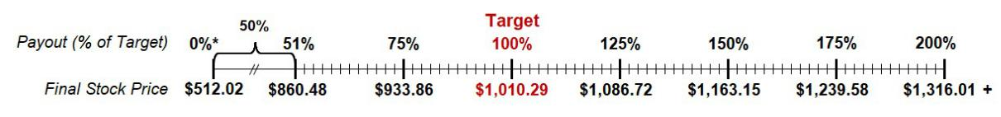

Relative Value Awards (RVA)

RVAs measure Lilly’s three-year TSR performance relative to peers. The peer group may vary annually and may include companies not used in our pay benchmarking. This broader set of companies allows performance to be measured against competitors for investor capital. Once established for a given grant, the peer group remains fixed for that award’s performance period.

Outstanding RVA peer groups are as follows:

Company Name 2025 Award 2024 Award 2023 Award

AbbVie

Amgen

AstraZeneca

Biogen n/a

Bristol-Myers Squibb

Gilead

GlaxoSmithKline

Johnson & Johnson

Medtronic n/a n/a

Merck

Novartis

Novo Nordisk

Pfizer

Roche

Sanofi

Stryker n/a n/a

Takeda n/a

Payouts range from 0 to 200 percent of target, with median peer TSR performance required to achieve target payout. Any shares earned are subject to a one-year post-vesting holding requirement. No dividends accrue during the performance period.

To determine the final RVA payout, TSR for Lilly and each peer company is calculated by comparing average closing prices for November – December 2024 to November – December 2027 (assuming dividend reinvestment).

51

Lilly’s TSR is then compared to the median peer TSR to determine payout. For example, if Lilly’s TSR is 55 percent and median peer TSR is 40 percent, Lilly outperformed by 15 percentage points, resulting in a 150% payout per the schedule below.

2025 Relative Value Award
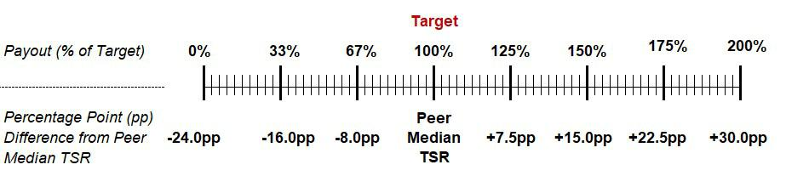

Pay for Performance

A substantial portion of executive compensation is performance-based, linking pay to individual and company performance. The chart below shows the annualized target compensation mix for the CEO and the average mix for our other named executive officers (Mr. Montarce, Dr. Skovronsky, Ms. Hakim, and Mr. Van Naarden).
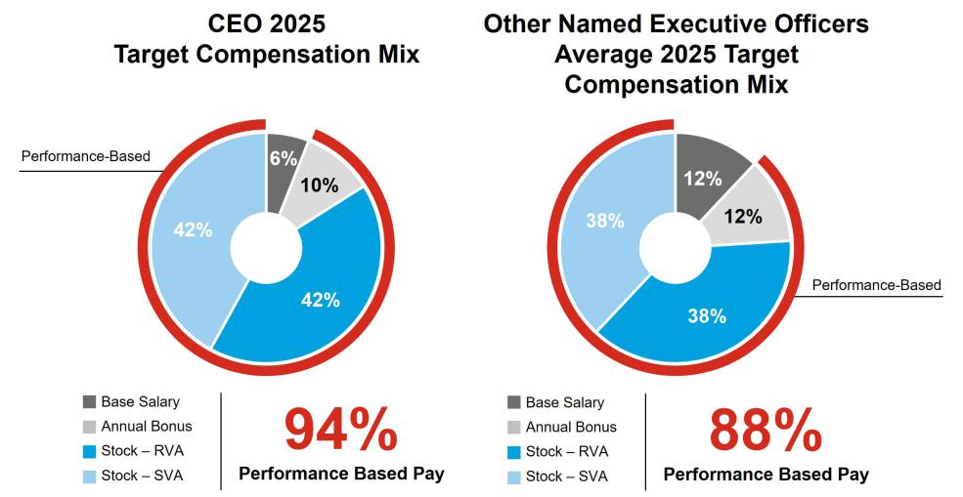

Target Compensation

The Committee considers individual contributions, company performance, internal relativity, peer group data, and CEO recommendations (for other executives) when setting target compensation.

For the CEO, the Committee also considers the following:

- Independent compensation consultant recommendations;

- Prior year actual total direct compensation compared to company performance (absolute and relative basis); and

- Current target total direct compensation compared to recently available peer group data, with emphasis on United States headquartered peers.

Base Salary

The table below shows approved annual salaries for each NEO. Base pay adjustments reflect experience, internal relativity, peer group data, and individual performance. Mr. Montarce’s 2024 base salary is the annual amount approved upon his appointment as Chief Financial Officer. Actual base salaries earned in 2025 are shown in the Summary Compensation Table (SCT) in the “Executive Compensation” section.

52

 | 2024 Annual Base | 2025 Annual Base
Name | Salary | Salary | Increase
Mr. Ricks | $1,700,000 | $1,700,000 | 0.0%
Mr. Montarce | $1,000,000 | $1,000,000 | 0.0%
Dr. Skovronsky | $1,450,000 | $1,500,000 | 3.4%
Ms. Hakim | $1,000,000 | $1,000,000 | 0.0%
Mr. Van Naarden | $900,000 | $925,000 | 2.8%
Annual Cash Bonus Targets

After reviewing internal relativity, peer group data, and individual performance, the Committee maintained the same percent-of-salary bonus targets for all named executive officers except Mr. Ricks, whose target was increased to maintain market competitiveness. Mr. Montarce’s 2024 bonus target is the amount approved upon his appointment as Chief Financial Officer. Actual 2025 bonuses are disclosed in the SCT.

Name | 2024 Bonus Target | 2025 Bonus Target
Mr. Ricks | 150% | 175%
Mr. Montarce | 100% | 100%
Dr. Skovronsky | 100% | 100%
Ms. Hakim | 100% | 100%
Mr. Van Naarden | 100% | 100%

Stock Incentives — Target Grant Values

The Committee set 2025 stock grant target values based on internal relativity, peer group data, and individual performance. Each NEO’s stock target is allocated equally between SVAs (50%) and RVAs (50%). Target values for 2024 and 2025 stock grants were:

 | 2024 Annual Stock | 2025 Annual Stock
Name | Grant | Grant
Mr. Ricks | $19,750,000 | $23,325,000
Mr. Montarce¹ | $800,000 | $5,000,000
Dr. Skovronsky | $7,500,000 | $12,000,000
Ms. Hakim | $3,950,000 | $6,000,000
Mr. Van Naarden | $2,700,000 | $4,500,000

- Mr. Montarce’s 2024 annual stock grant reflects his role prior to becoming the company’s Chief Financial Officer. Mr. Montarce’s 2024 grant was divided equally, with 33.3% allocated to shareholder value awards, 33.3% to relative value awards, and 33.3% to restricted stock units.

Adjustments to Reported Financial Results

The Committee may adjust reported product revenues and EPS used for incentive compensation payouts in certain circumstances to eliminate distortions from unusual events. These adjustments:

- align payouts with core company performance;

- avoid volatile or artificial inflation/deflation from unusual items;

- eliminate certain counterproductive short-term incentives (e.g., deferring acquisitions, asset disposals, or legal settlements); and

- facilitate comparisons with peer companies.

The Committee considers Audit Committee-approved non-GAAP adjustments and other adjustments based on Committee-approved guidelines. Adjustments are reviewed and approved quarterly and may include acquired IPR&D charges, foreign exchange impacts, significant acquisitions or divestitures, and share repurchases that differ significantly from the business plan.

53

See Appendix A for adjustments and rationale. Throughout the CD&A, references to “revenue,” “EPS,” and “adjusted non-GAAP EPS” reflect these approved adjustments for reported metrics.

2025 Compensation Results

This section reflects 2025 Bonus Plan payments and stock payouts from prior years for which the relevant performance period ended in 2025.
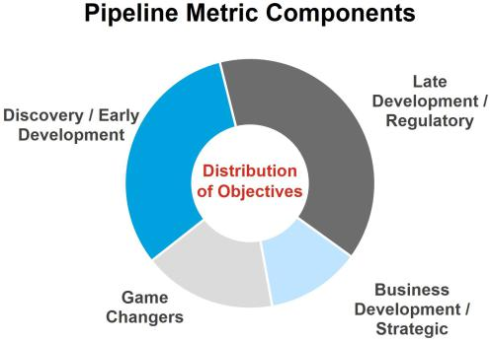

2025 Bonus Plan Results

Strong financial performance resulted in above-target payouts for both product revenue and EPS. See Appendix A for additional details on financial results and adjustments.

The Science and Technology Committee sets annual objectives for each pipeline category. The graphic to the right shows the relative distribution of pipeline objectives.

At year end, the Science and Technology Committee assessed pipeline achievements, including those disclosed in “Innovation Pipeline and Other Business Development” within the Proxy Statement Summary. The assessment resulted in a 230% pipeline bonus multiple.

Strong financial performance combined with a 230% pipeline multiple resulted in an above-target final bonus payout. Product-specific revenue targets and internal pipeline goals are not disclosed to avoid competitive harm. The target set at the beginning of the year for annual EPS was $24.01.

Results for each bonus metric are shown below.
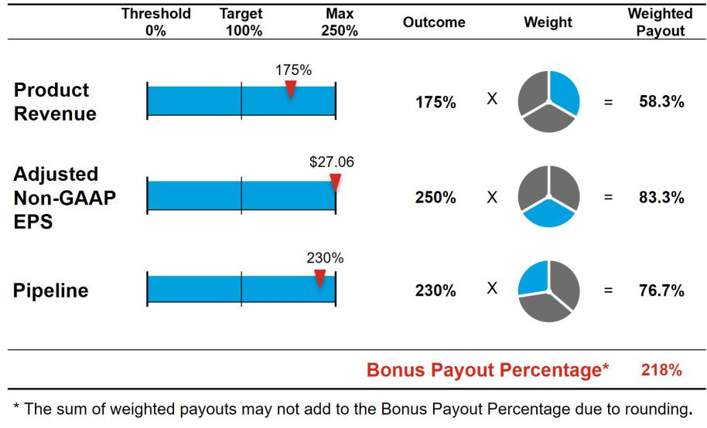

Bonus Plan Payments

The 2025 bonuses paid to the named executive officers were as follows:

Name | 2025 Bonus ($)
Mr. Ricks | $6,485,500
Mr. Montarce | $2,180,000
Dr. Skovronsky | $3,249,039
Ms. Hakim | $2,180,000
Mr. Van Naarden | $2,006,019

54

2023 Shareholder Value Award

The target stock price of $441.12 was set in 2023, and represented a 21.5 percent stock price growth from the starting stock price of

$363.15, which was the average closing price November - December 2022. The ending stock price of $1,028.58 (average closing price November - December 2025) represents 183.2 percent stock price growth over the three-year period, resulting in a 200 percent payout. Shares settled under the SVA remain subject to a one-year post-vesting holding period.
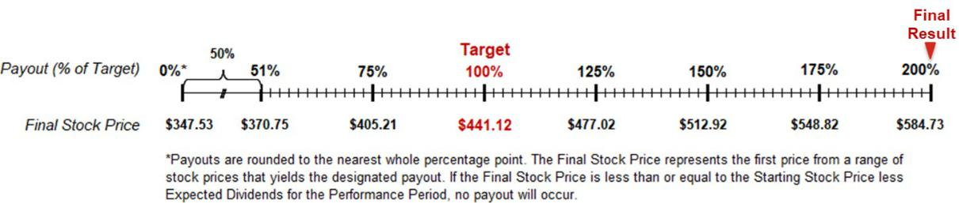

Shares paid to each NEO for the 2023 SVA were:

Name | Target Shares | Shares Paid
Mr. Ricks | 19,512.000 | 39,024.000
Mr. Montarce¹ | 559.000 | 1,118.000
Dr. Skovronsky | 7,750.000 | 15,500.000
Ms. Hakim | 4,093.000 | 8,186.000
Mr. Van Naarden | 2,511.000 | 5,022.000

- Mr. Montarce was not an executive officer on grant date; as such, the one-year post-vesting holding requirement doesn’t apply to this award.

2023 Relative Value Award

The RVA is based on Lilly’s three-year TSR compared to the RVA peer group. TSR is calculated by comparing average closing prices (adjusted for dividend reinvestment) for November - December 2022 to November - December 2025. Lilly’s TSR is then compared to the median peer TSR to determine payout.

Lilly’s TSR over the performance period was 190.1 percent compared to median peer TSR of 22.0 percent. This 168.1 percentage point outperformance resulted in a 200 percent payout. Shares settled under the RVA remain subject to a one-year post-vesting holding period.
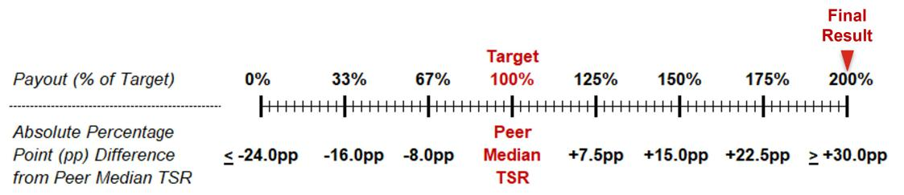

55

Shares paid to each NEO for the 2023 RVA were:

Name | Target Shares | Shares Paid
Mr. Ricks | 15,721.000 | 31,442.000
Mr. Montarce¹ | 503.000 | 1,006.000
Dr. Skovronsky | 6,245.000 | 12,490.000
Ms. Hakim | 3,298.000 | 6,596.000
Mr. Van Naarden | 2,023.000 | 4,046.000

- Mr. Montarce was not an executive officer on grant date; as such, the one-year post-vesting holding requirement doesn’t apply to this award.

Other Compensation Practices and Information

Employee Benefits

The company provides a comprehensive benefits program designed to support employee’s financial security, health, and well-being. These benefits provide financial support and time off during illness or injury, ensure post-retirement income security, and enhance productivity and job satisfaction through well-being-focused programs.

All eligible U.S. employees have access to medical and dental coverage, disability insurance, and life insurance. The company also sponsors the 401(k) Plan and The Lilly Retirement Plan (the Retirement Plan) to provide U.S. employees with a reasonable level of retirement that reflects their career with the company.

When an employee’s calculated retirement benefit exceeds Internal Revenue Service (IRS) limits for qualified retirement plans, the company offers a nonqualified pension plan (Nonqualified Pension Plan) and a nonqualified savings plan (Nonqualified Savings Plan). These plans provide benefits equal to the difference between the calculated benefits and the IRS-imposed limits, using the same benefit formula applied to all participants. Employees, including executive officers, share the cost of these benefits.

Security and Perquisites

The company provides security for employees based on a risk assessment conducted as part of its comprehensive security program, which is designed to help employees safely and securely conduct business. While SEC disclosure regulations require certain security costs to be reported as compensation for NEOs in the Summary Compensation Table, the company does not consider such security costs to be personal benefits as they arise from the nature of the employee’s role and are generally required by the company. Security services include protection at residences and during personal travel, as well as the procurement, installation, and maintenance of residential security equipment. The Committee periodically reviews the security program.

The Committee requires our Chair and CEO to use the company’s corporate aircraft for all travel, including personal travel, whenever possible. The Committee believes these costs are appropriate and necessary business expenses.

Other officers may also use the corporate aircraft for personal purposes up to a maximum incremental cost established by the Committee, enabling them to maximize time available for company business and protecting their health and safety. The incremental cost of personal use of the corporate aircraft is included in the Summary Compensation Table under the heading “All Other Compensation.”

The Lilly Deferred Compensation Plan

Members of senior management may defer receipt of part or all of their annual bonus under The Lilly Deferred Compensation Plan (the “Deferred Compensation Plan”), enabling them to save for retirement in a tax-effective manner. Participants may select from investment funds available under the Deferred Compensation Plan, which, effective January 1, 2025, are substantially the same as those available under the 401(k) Plan. Deferred amounts are credited based on the investment elections made by the participant. Additional details are provided in the “Nonqualified Deferred Compensation in 2025” table.

Severance and Other Post-Termination Benefits

Except in cases of certain terminations following a change in control of the company, the company is generally not obligated to pay severance to executive officers upon termination of employment; any such payments are at the

56

discretion of the Committee. However, if the company enforces restrictive covenant agreements with certain executive officers, those officers would be entitled to post-termination payments, as described and quantified in “Payments upon Termination or Change in Control”.

The company has adopted change-in-control severance pay plans for nearly all employees, including executive officers. These plans aim to preserve employee morale and productivity and encourage retention amidst the potentially disruptive impact of an actual or rumored change in control. The plans also align executive and shareholder interests by enabling executives to evaluate corporate transactions objectively – assessing whether such transactions would benefit shareholders and other company stakeholders – without undue concern over their own employment security.

Highlights of Our Change-in-Control Severance Plans

- All regular employees are covered

- Double trigger required

- No tax gross-ups

- Up to two-year pay protection

- 18-month benefit continuation

Although benefit levels may differ depending on the employee’s job level and seniority, the basic elements of the plans are comparable for all eligible employees:

- Double trigger: The company’s plans require a “double trigger”—a change in control followed by a covered loss of employment within two years. This approach aligns with the plans’ intent to provide employees with financial protection upon loss of employment. For unvested stock awards, performance through the date of the change in control is used to determine the number of shares earned under an award. However, vesting does not accelerate immediately upon a change in control. Instead, the performance-adjusted awards convert to time-based restricted stock units that continue to vest following the transaction. Shares are paid upon the earliest of: completion of the original award period; a covered termination; or failure by the successor entity to assume, substitute, or otherwise replace the awards.

- Covered terminations: Eligible employees may receive payments if their employment is terminated within two years of the change in control, either (i) without cause by the company or (ii) for good reason by the employee, each as defined in the plans. For further details, refer to the section “Compensation—Executive Compensation—Payments upon Termination or Change in Control”.

- Severance and Benefits Continuation: Employees who experience a covered termination are provided with up to two years of base salary and bonus and 18 months of benefits continuation, providing income protection and essential benefits during the transition period.

– Severance: Eligible employees who are terminated receive a severance payment ranging from six months to two years of base salary. Eligible executives receive a severance payment equal to two times the sum of their base salary and target bonus.

– Benefits: Health, dental, life insurance, and long-term disability coverage are maintained for 18 months post-termination, provided the individual does not become eligible for similar benefits with a new employer. Additionally, all employees receive two years of both age and years-of-service credit, calculating eligibility for retiree medical and dental benefits. The additional age and years of service credit are not considered when calculating benefit value.

- Accelerated vesting of stock awards: Any unvested stock awards vest at the time of a covered termination (i.e., a “double trigger” occurs).

- Excise tax: In certain circumstances, an employee’s payments or other benefits resulting from a change in control may exceed limits established under Section 280G of the Internal Revenue Code, triggering an excise tax in addition to the standard federal income tax. The company does not provide tax gross-ups for these additional taxes. However, if reducing the benefits related to the change in control to the 280G limit results in a higher after-tax benefit to the employee the payment is reduced accordingly.

57

Share Ownership and Retention Guidelines

Lilly’s share ownership and retention guidelines are designed to align interests of senior management with those of shareholders. Under the company’s share ownership policy, the CEO is required to hold Lilly shares with a value equivalent to 12 times his annual base salary. The CFO is required to hold shares equivalent to eight times his base salary, and other senior executives must hold shares equivalent to six times their annual base salary. Shares held outright from stock payouts, shares held in the Lilly 401(k) Plan, shares held in the Deferred Compensation Plan, and shares held in family trusts count toward the ownership requirement. Unvested stock awards do not count toward the ownership requirement.

Until the required share ownership level is achieved, executive officers must retain 50 percent of all shares received from stock payouts, net of taxes. Additionally, executive officers are required to hold all shares received from stock program payouts, net of taxes, for at least one year following vesting.

All NEOs are in compliance with the share ownership guidelines; see below for individual requirements and holdings as of December 31, 2025.

 |  | Share Ownership and Retention
 |  | 12x Base Salary Ownership Requirement
Mr. Ricks
Mr. Ricks |  |  |  |  | 412x
 | 8x Base Salary Ownership Requirement
Mr. Montarce
Mr. Montarce | 16x
 | 6x Base Salary Ownership Requirement
Dr. Skovronsky
Dr. Skovronsky |  |  |  | 153x
Ms. Hakim
Ms. Hakim |  |  | 47x
Mr. Van Naarden
Mr. Van Naarden |  | 34x

Prohibition on Hedging and Pledging Shares

Non-employee directors and employees, including executive officers, are prohibited from hedging their economic exposure to company stock through short sales or derivative transactions. Additionally, they are prohibited from pledging company stock as collateral for a loan or holding shares in a margin account.

Executive Compensation Recovery Policy

Lilly has implemented a comprehensive executive compensation recovery policy (Executive Compensation Recovery Policy) that complies with SEC rules and applicable NYSE listing standards. Under this policy, if Lilly is required to prepare an accounting restatement, the company must recoup incentive compensation overpayments to executive officers during the three fiscal years immediately preceding the restatement date, including any transition periods within or immediately following those years, in accordance with the policy’s terms.

Additionally, the policy allows for the recoupment of incentive compensation (cash or stock) and/or non-qualified benefits previously granted or paid to executives (including certain non-executive officers) in the event of: (a) payments based on materially inaccurate assessments of performance, (b) financial restatements due to misconduct, or (c) other misconduct resulting in material violations of law or company policy that causes significant harm to the company. Subsequent changes in status, including retirement or termination of employment, do not affect the company’s rights to recover compensation under the Executive Compensation Recovery Policy. Furthermore, all outstanding stock grants and cash awards and/or non-qualified benefits are subject to forfeiture or reduction in the event an executive is subject to disciplinary action by Lilly for misconduct.

The Executive Compensation Recovery Policy is administered by the Committee. The company will disclose actions taken under the Executive Compensation Recovery Policy in its proxy materials when required by, and in compliance with, SEC rules and regulations and other applicable laws. Additionally, when legally permissible to do so, the company will disclose a decision to act under this policy when the facts and circumstances of the matter that triggered application of the policy have been publicly disclosed in the company’s SEC filings and where

58

disclosure can be made without prejudicing the company and its shareholders. This summary does not purport to be complete and is qualified in its entirety by reference to such policy, which has been filed as Exhibit 97 of Lilly’s Form 10-K for the fiscal year ended December 31, 2025.

Executive Compensation

Summary Compensation Table

 |  |  |  |  | Non-Stock | Change in |  | Total
Name and |  | Salary | Bonus | Stock | Incentive Plan | Pension | All Other | Total
Name and |  |  |  |  |  |  |  | Compensation
Principal |  | Salary | Bonus | Awards | Compensation | Value | Compensation | Compensation
Principal | Year | ($) | ($)
Position | Year | ($) | ($) | ($) ¹ | ($) ² | ($) ³ | ($) ⁴ | ($)
David A. Ricks | 2025 | $1,700,000 | — | $23,325,000 | $6,485,500 | $4,451,636 | $736,201 | $36,698,337
Chair, President, | 2024 | $1,690,385 | — | $19,749,324 | $5,705,049 | $1,746,483 | $351,685 | $29,242,926
and Chief | 2023 | $1,621,154 | — | $18,840,250 | $4,401,433 | $1,439,822 | $263,073 | $26,565,732
Executive Officer
Lucas Montarce | 2025 | $1,000,000 | — | $5,000,000 | $2,180,000 | $243,315 | $60,000 | $8,483,315
Executive Vice | 2024 | $664,639 | — | $1,067,135 | $1,114,558 | $62,309 | $39,878 | $2,948,519
President and
Chief Financial
Officer
Daniel M. | 2025 | $1,490,385 | — | $12,000,000 | $3,249,039 | $887,845 | $159,307 | $17,786,576
Skovronsky,
M.D., Ph.D.
Executive Vice | 2024 | $1,430,769 | — | $7,499,895 | $3,219,230 | $281,870 | $206,980 | $12,638,744
President,
Chief Scientific
and Product
Officer and
President, Lilly | 2023 | $1,330,769 | — | $7,483,400 | $2,408,692 | $551,222 | $79,846 | $11,853,929
Research Labs
Anat Hakim | 2025 | $1,000,000 | — | $6,000,000 | $2,180,000 | $502,948 | $162,570 | $9,845,518
Executive Vice | 2024 | $1,000,000 | — | $3,950,071 | $2,250,000 | $211,521 | $66,834 | $7,478,426
President,
General Counsel ²⁰²³ |  | $980,769 | — | $3,952,500 | $1,775,192 | $239,430 | $58,846 | $7,006,737
and Secretary
Jake Van | 2025 | $920,192 | — | $4,500,000 | $2,006,019 | $87,367 | $72,519 | $7,586,097
Naarden
Executive Vice | 2024 | $890,385 | — | $2,700,248 | $2,003,366 | $66,887 | $113,062 | $5,773,948
President and
President, Lilly | 2023 | $830,769 | — | $2,424,200 | $1,503,692 | $78,013 | $49,846 | $4,886,520
Oncology and
Head of
Corporate

Business

Development

- This column includes the grant date fair value of all stock awards granted to named executive officers computed in accordance with FASB ASC Topic 718. See Note 12 of the consolidated financial statements in the company’s Annual Report on Form 10-K for the fiscal year ended December 31, 2025, for additional detail regarding assumptions underlying the valuation of stock awards. All values in the “Stock Awards” column were based upon the probable outcome of performance conditions as of the grant date, which vary year to year.

The table below shows the target and maximum payouts (valuing the number of shares that would vest at each payout level using the grant date fair value) for the 2025 shareholder value award and the 2025 relative value award, each of which are included in the Summary Compensation Table above. All awards below will pay out in February 2028 and have a minimum payout of $0.

 | 2025 SVA |  | 2025 RVA
Name | Target | Maximum | Target | Maximum
Mr. Ricks | $11,662,500 | $23,325,000 | $11,662,500 | $23,325,000
Mr. Montarce | $2,500,000 | $5,000,000 | $2,500,000 | $5,000,000
Dr. Skovronsky | $6,000,000 | $12,000,000 | $6,000,000 | $12,000,000
Ms. Hakim | $3,000,000 | $6,000,000 | $3,000,000 | $6,000,000
Mr. Van Naarden | $2,250,000 | $4,500,000 | $2,250,000 | $4,500,000

- The amounts in this column reflect payments under the Bonus Plan for performance in the years represented.

- The amounts in this column reflect the change in pension value, calculated by an actuary. The changes in pension values in 2025 were driven by changes in actuarial assumptions offset by pay changes and an additional year of credited service. The design of the pension benefit plan did not change. See the “Pension Benefits in 2025” table for information about the standard actuarial assumptions used. No named executive officer received preferential or above-market earnings on deferred compensation.

59

- The amounts in this column include 401(k) and Nonqualified Savings Plan company matching contributions as follows: Mr. Ricks: $102,000; Mr. Montarce: $60,000; Dr.
Skovronsky: $89,423; Ms. Hakim: $60,000; and Mr. Van Naarden: $55,212.

The amounts in this column also include costs for security services: $276,584 for Mr. Ricks and $102,570 for Ms. Hakim.

Additionally, this column also includes the aggregate incremental cost for personal use of the corporate aircraft: $357,616 for Mr. Ricks, and $69,884 for Dr. Skovronsky. The aggregate incremental costs for personal use of our aircraft are calculated based on our variable operating costs, which include crew travel expenses, on-board catering, landing fees, trip-related hangar/parking costs, fuel, trip-related maintenance, and other smaller variable costs. Because most of the use of the corporate aircraft is for business purposes, fixed costs such as aircraft purchase costs, maintenance not related to personal trips, and flight crew salaries are not included.

Grants of Plan-Based Awards During 2025

The compensation framework detailed in the CD&A includes the Bonus Plan, a non-stock incentive plan, and the Amended and Restated 2002 Lilly Stock Plan, under which Lilly provides all stock grants.

To qualify for an SVA or RVA payout, the recipient must either remain employed with the company through the end of the performance period, retire after December 31 of the year of grant, or experience a termination due to factors beyond the individual’s control, such as death, disability, a plant closing, or workforce reduction. Additionally, annual awards to executive officers are subject to non-compete and non-solicitation covenants that remain in effect for one year following termination. Under the terms of the applicable award agreement, any breach of these covenants results in immediate revocation of the award and forfeiture of any associated rights. No dividends or dividend equivalents accrue on SVAs or RVAs throughout the performance period.

 |  |  |  |  |  | Estimated Future
 |  | Estimated Future Payouts |  |  | Payouts Under Stock
 |  |  | Under Non-Stock
 |  | Incentive Plan Awards ² |  |  | Incentive Plan Awards |  |  | Grant Date
 |  |  |  |  |  |  |  | Fair Value of
 | Compensation | Threshold | Target | Maximum | Threshold | Target | Maximum | Stock and
 | Committee |  |  |  |  |  |  | Option
Award | Grant Date¹ Action Date | ($) | ($) | ($) | (# shares) | (# shares) | (# shares) | Awards ³

Mr. Ricks |  |  |  |  | $743,750 | $2,975,000 | $7,437,500
 | 2025 SVA | 4 | 2/10/2025 | 2/10/2025 |  |  | 5,521.547 |  | 11,043.093 | 22,086.186 | $11,662,500
 | 2025 RVA | 5 | 2/10/2025 | 2/10/2025 |  |  | 5,049.139 |  | 10,098.277 | 20,196.554 | $11,662,500
Mr. Montarce |  |  |  |  | $250,000 | $1,000,000 | $2,500,000
 | 2025 SVA | 4 | 2/10/2025 | 2/10/2025 |  |  | 1,183.611 |  | 2,367.222 | 4,734.444 | $2,500,000
 | 2025 RVA | 5 | 2/10/2025 | 2/10/2025 |  |  | 1,082.345 |  | 2,164.690 | 4,329.380 | $2,500,000
Dr.
Skovronsky |  |  |  |  | $372,596 | $1,490,385 | $3,725,963
 | 2025 SVA | 4 | 2/10/2025 | 2/10/2025 |  |  | 2,840.667 |  | 5,681.334 | 11,362.668 | $6,000,000
 | 2025 RVA | 5 | 2/10/2025 | 2/10/2025 |  |  | 2,597.628 |  | 5,195.255 | 10,390.510 | $6,000,000
Ms. Hakim |  |  |  |  | $250,000 | $1,000,000 | $2,500,000
 | 2025 SVA | 4 | 2/10/2025 | 2/10/2025 |  |  | 1,420.334 |  | 2,840.667 | 5,681.334 | $3,000,000
 | 2025 RVA | 5 | 2/10/2025 | 2/10/2025 |  |  | 1,298.814 |  | 2,597.628 | 5,195.256 | $3,000,000
Mr. Van
Naarden |  |  |  |  | $230,048 | $920,192 | $2,300,480
 | 2025 SVA | 4 | 2/10/2025 | 2/10/2025 |  |  | 1,065.250 |  | 2,130.500 | 4,261.000 | $2,250,000
 | 2025 RVA | 5 | 2/10/2025 | 2/10/2025 |  |  | 974.111 |  | 1,948.221 | 3,896.442 | $2,250,000

- The annual grant date is established in advance by the Committee without consideration of material nonpublic information.

- These columns show the threshold, target and maximum payouts for performance under the Bonus Plan. The Bonus Plan payouts range from 0 to 250 percent of target. The Bonus Plan payout for 2025 performance was 218 percent of target. Actual payouts are shown in the Summary Compensation Table in the column titled “Non-Stock Incentive Plan Compensation.”

- The amounts in this column reflect the grant date fair value of the shareholder value awards and relative value awards computed in accordance with the requirements of ASC Topic 718 and were based upon the probable outcome of performance conditions.

- This row shows the range of payouts for the 2025 SVA, which will settle in February 2028, with payouts ranging from 0 to 200 percent of target.

⁵ This row shows the range of payouts for the 2025 RVA, which will settle in February 2028, with payouts ranging from 0 to 200 percent of target.

60

Outstanding Stock Awards on December 31, 2025

The 2025 closing stock price used to calculate the values in the table below was $1,074.68.

 |  |  |  |  |  |  |  |  |  |  |  | Stock Awards
 |  |  |  |  |  | Number of Shares |  |  |  | Market Value of |  |  |  | Stock Incentive Plan
 |  |  |  |  |  |  |  |  |  |  |  | Stock Incentive Plan |  | Awards: Market or Payout
 |  |  |  |  |  | or Units of Stock |  |  |  | Shares or Units of |  | Awards: Number of |  | Value of Unearned Shares,
 |  |  |  |  |  | That Have Not |  |  |  | Stock That Have |  | Unearned Shares, Units, or |  | Units, or Other Rights That
Name |  |  | Award |  |  | Vested (#) |  |  |  | Not Vested ($) |  | Other Rights That Have Not |  | Have Not Vested ($)
Name |  |  |  |  |  |  |  |  |  |  |  | Vested (#) |  | Have Not Vested ($)
Mr. Ricks |  | 2025 SVA |  |  |  |  |  |  |  |  |  | 22,086 | 1 | $23,735,382
 | 2024 |  | SVA |  |  |  |  |  |  |  |  | 19,158 | 2 | $20,588,719
 | 2025 |  | RVA |  |  |  |  |  |  |  |  | 20,197 | 3 | $21,705,312
 | 2024 |  | RVA |  |  |  |  | 6 |  |  |  | 17,850 | 4 | $19,183,038
 | 2023 |  | PA |  |  | 15,966 |  |  |  | $17,158,341
Mr. Montarce |  | 2025 SVA |  |  |  |  |  |  |  |  |  | 4,734 | 1 | $5,087,535
 | 2024 |  | SVA |  |  |  |  |  |  |  |  | 518 | 2 | $556,684
 | 2025 |  | RVA |  |  |  |  |  |  |  |  | 4,329 | 3 | $4,652,290
 |  | 2024 RVA |  |  |  |  |  |  |  |  |  | 482 | 4 | $517,996
 |  | RSU |  |  | 2,349 ⁵ |  |  |  |  | $2,524,423
Dr. Skovronsky |  | 2025 SVA |  |  |  |  |  |  |  |  |  | 11,363 | 1 | $12,211,589
 | 2024 |  | SVA |  |  |  |  |  |  |  |  | 7,276 | 2 | $7,819,372
 | 2025 |  | RVA |  |  |  |  |  |  |  |  | 10,391 | 3 | $11,167,000
 | 2024 |  | RVA |  |  |  |  | 6 |  |  |  | 6,778 | 4 | $7,284,181
 |  | 2023 | PA |  |  |  | 12,684 | 6 |  |  | $13,631,241
Ms. Hakim |  | 2025 SVA |  |  |  |  |  |  |  |  |  | 5,681 | 1 | $6,105,257
 | 2024 |  | SVA |  |  |  |  |  |  |  |  | 3,832 | 2 | $4,118,174
 | 2025 |  | RVA |  |  |  |  |  |  |  |  | 5,195 | 3 | $5,582,963
 | 2024 |  | RVA |  | 3,350 ⁶ |  |  |  |  |  |  | 3,570 | 4 | $3,836,608
 | 2023 |  | PA |  |  |  |  |  |  | $3,600,178
Mr. Van Naarden |  | 2025 SVA |  |  |  |  |  |  |  |  |  | 4,261 | 1 | $4,579,211
 | 2024 |  | SVA |  |  |  |  |  |  |  |  | 2,620 | 2 | $2,815,662
 | 2025 |  | RVA |  |  |  |  |  |  |  |  | 3,896 | 3 | $4,186,953
 | 2024 |  | RVA |  |  |  |  |  |  |  |  | 2,440 | 4 | $2,622,219
 | 2023 |  | PA |  |  | 2,054 |  | 6 |  | $2,207,393

- SVAs granted in 2025 will vest on December 31, 2027. The number of shares reported reflects the maximum payout, which will be made if the average closing stock price in November and December 2027 exceeds $1,316.01. Actual payouts may vary from 0 to 200 percent of target. Net shares from any payout must be held by executive officers for a minimum of one year post vesting. Had the performance period ended December 31, 2025, the payout would have been at 105 percent of target.

- SVAs granted in 2024 will vest on December 31, 2026. The number of shares reported reflects the maximum payout, which will be made if the average closing stock price in November and December 2026 exceeds $945.39. Actual payouts may vary from 0 to 200 percent of target. Net shares from any payout must be held by executive officers for a minimum of one year post vesting. Had the performance period ended December 31, 2025, the payout would have been 200 percent of target.

- RVAs granted in 2025 will vest on December 31, 2027. The number of shares reported reflects the maximum payout, which will be paid if Lilly’s absolute TSR exceeds the median peer absolute TSR by 30 percentage points or more at the end of the performance period. Net shares from any payout must be held by executive officers for a minimum of one year post vesting. Had the performance period ended December 31, 2025, the payout would have been 139 percent of target.

- RVAs granted in 2024 will vest on December 31, 2026. The number of shares reported reflects the maximum payout, which will be paid if Lilly’s absolute TSR exceeds the median peer absolute TSR by 30 percentage points or more at the end of the performance period. Net shares from any payout must be held by executive officers for a minimum of one year post vesting. Had the performance period ended December 31, 2025, the payout would have been 200 percent of target.

- These grants were made outside of the normal annual cycle. 368 units were granted in February 2024 and will vest in February 2026; 1,610 units were granted in November 2020 and will vest in November 2026; and 371 units were granted in February 2024 and will vest in February 2027.

- Performance Awards granted in 2024 vested December 31, 2024, resulting in the issuance of restricted stock units that will vest February 1, 2026.

61

Option Exercises and Stock Vested in 2025

 | Stock Awards
 | Number of Shares |  |  | Value Realized
Name | Acquired on Vesting (#) |  |  | on Vesting ($)¹
 |  | 2
Mr. Ricks | 26,561 | 2 |  | $21,543,096
 | 39,024 | 3 |  | $40,584,960
 | 39,024 | 4 |  | $40,584,960
 | 31,442 | 4 |  | $32,699,680
 | 31,442 | 3 |  | $32,699,680
Mr. Montarce | 1,118 | 3 |  | $1,162,720
 | 1,006 | 4 |  | $1,046,240
 |  | 2
Dr. Skovronsky | 8,989 | 2 |  | $7,290,798
 | 15,500 | 3 |  | $16,120,000
 |  | 4
 | 12,490 | 4 |  | $12,989,600
 | 12,490 | 2 |  | $12,989,600
Ms. Hakim | 4,904 | 2 |  | $3,977,536
Ms. Hakim | 4,904 | 3 |  | $3,977,536
 | 8,186 | 3 |  | $8,513,440
 | 6,596 | 4 |  | $6,859,840
 |  | 2
Mr. Van Naarden | 3,023 | 2 |  | $2,451,895
Mr. Van Naarden | 3,023 | 3 |  | $2,451,895
 | 5,022 | 3 |  | $5,222,880
 |  | 4
 | 4,046 | 4 |  | $4,207,840


- Amounts reflect the market value of Lilly stock on the day of settlement.

- Restricted stock units resulting from the 2022 performance award that vested in February 2025.

3 Payout of the 2023 SVA at 200 percent of target. ⁴ Payout of the 2023 RVA at 200 percent of target.

Retirement Benefits

The company provides retirement income to eligible U.S. employees, including executive officers, through the following plans:

- 401(k) Plan. The 401(k) is a defined contribution plan qualified under Sections 401(a) and 401(k) of the Internal Revenue Code. Participants may elect to contribute a portion of their base salary to the plan, and the company provides matching contributions on employees’ contributions up to 6 percent of base salary, subject to IRS limits. Employee contributions, company contributions, and earnings thereon are paid out in accordance with elections made by the participant and the terms of the plan. Company contributions under the 401(k) Plan for the NEOs are included in the “All Other Compensation” column in the Summary Compensation Table.

- Retirement Plan. The Retirement Plan is a tax-qualified defined benefit plan that provides monthly benefits to retirees. Additional information about the value of these pension benefits is provided in the Pension Benefits in 2025 table.

- Nonqualified Plans. Sections 401 and 415 of the Internal Revenue Code limit the amount of annual pension that can be paid from a tax-qualified plan ($275,000 in 2024 and $280,000 in 2025), as well as the amount of annual earnings that can be used to calculate a pension benefit ($345,000 in 2024 and $350,000 in 2025). Since 1975, the company has maintained a Nonqualified Pension Plan that pays eligible retirees the difference between the amount payable under the Retirement Plan and the amount they would have received without the Internal Revenue Code limits. The Nonqualified Pension Plan is an unfunded plan.

The company maintains a nonqualified savings plan that allows participants to contribute up to 6 percent of base salary exceeding the IRS limit. The company matches these contributions in the same manner as described in the 401(k) Plan. For more information, see footnote 2 to the “Nonqualified Deferred Compensation in 2025” table.

The following table shows benefits that the named executive officers have accrued under the Retirement Plan and the Nonqualified Pension Plan.

62

Pension Benefits in 2025

 |  | Number of Years Credited | Present Value of | Payments During
Name | Plan Name | Service (#) | Accumulated Benefit ($) ¹ | Last Fiscal Year ($)
Mr. Ricks | Retirement Plan (pre-2010) | 14 | $787,559
 | Retirement Plan (post-2009) | 16 | $533,191
 | Nonqualified Plan (pre-2010) | 14 | $12,961,509
 | Nonqualified Plan (post-2009) | 16 | $8,604,896
 | total |  | $22,887,155 | —
Mr. Montarce | Retirement Plan (post-2009) | 9 | $176,073
 | Nonqualified Plan (post-2009) | 9 | $428,017
 | total |  | $604,090 | —
Dr. Skovronsky | Retirement Plan (post-2009) | 13 | $317,524
 | Nonqualified Plan (post-2009) | 13 | $2,878,852
 | total |  | $3,196,376 | —
Ms. Hakim | Retirement Plan (post-2009) | 6 | $182,032
 | Nonqualified Plan (post-2009) | 6 | $1,105,460
 | total |  | $1,287,492 | —
Mr. Van Naarden | Retirement Plan (post-2009) | 4 | $50,021
 | Nonqualified Plan (post-2009) | 4 | $225,333
 | total |  | $275,354 | —

- The following standard actuarial assumptions were used to calculate the present value of each individual’s accumulated pension benefit:

Discount rate:

Mortality (post-retirement decrement only):

Pre-2010 joint and survivor benefit (% of pension):

Post-2009 benefit payment form:

5.76 percent for the qualified plan and 5.62 percent for nonqualified plan

Private 2012 white collar table with generational projection using Scale MP-2021

50 percent until age 62; 25 percent thereafter

Life annuity

The Retirement Plan benefits shown in the table represent net present values. Benefits are not payable as a lump sum but are generally paid as a monthly annuity for the life of the retiree and, if elected, any qualifying survivor. The annual benefit is calculated using years of service and the average of the annual earnings (salary plus bonus) for the highest five out of the last 10 calendar years of service (final average earnings).

Post-2009 Plan Information: Following amendment of our Retirement Plan formulas, employees first hired on or after February 1, 2008 have accrued retirement benefits only under the new plan formula. Employees hired before that date have accrued benefits under both the old and new plan formulas. All eligible employees, including those hired on or after February 1, 2008, can currently retire at age 65 with at least five years of service and receive an unreduced benefit.

The annual benefit under the new plan formula is equal to 1.2 percent of final average earnings multiplied by years of service. Early retirement benefits under this formula are reduced 6 percent for each year under age 65.

Transition benefits were afforded to employees with 50 points (age plus service) or more as of December 31, 2009. These benefits were intended to ease the transition to the new retirement formula for those employees who were closer to retirement or had longer tenure with the company at the time the plan was changed. For the transition group, early retirement benefits are reduced 3 percent for each year from age 65 to age 60 and 6 percent for each year under age 60. Mr. Ricks is in this transition group.

Pre-2010 Plan Information: Employees hired prior to February 1, 2008 accrued benefits under both plan formulas. For these employees, benefits that accrued before January 1, 2010 were calculated under the old plan formula. The amount of the benefit is calculated using actual years of service through December 31, 2009, while total years of service are used to determine eligibility and early retirement reductions. The benefit amount is increased (but not decreased) proportionately based on final average earnings at termination compared to final average earnings on December 31, 2009.

Full retirement benefits are earned by employees with 90 or more points (the sum of his or her age plus years of service). Employees electing early retirement receive reduced benefits as described below:

63

- Employees with between 80 and 90 points are reduced by 3 percent for each year before the earlier of 90 points or age 62.

- Employees who have fewer than 80 points who have reached age 55 and have at least 10 years of service receive a benefit reduced as described above and further reduced by 6 percent for each year before the earlier of 80 points or age 65.

Nonqualified Deferred Compensation in 2025

 |  |  |  |  | Aggregate
 |  | Executive | Registrant | Aggregate | Withdrawals/ | Aggregate
 |  | Contributions in | Contributions in | Earnings in | Distributions in | Balance at Last
 |  | Last Fiscal Year | Last Fiscal Year | Last Fiscal Year | Last Fiscal Year | Fiscal Year End
Name | Plan | ($)1 | ($)2 | ($) | ($) | ($)3
Mr. Ricks | Nonqualified Savings | $81,000 | $81,000 | $3,325,194 | — | $12,400,001
 | Plan
 | Deferred Compensation | $5,473,816 | — | $773,276 | — | $6,247,092
 | Plan
 | total | $5,554,816 | $81,000 | $4,098,470 | — | $18,647,092
Mr. Montarce | Nonqualified Savings | $39,000 | $39,000 | $17,688 | — | $232,788
 | Plan
 | Deferred Compensation | — | — | — | — | —
 | Plan
 | total | $39,000 | $39,000 | $17,688 | — | $232,788
Dr. Skovronsky | Nonqualified Savings | $68,423 | $68,423 | $290,026 | — | $2,052,646
 | Plan
 | Deferred Compensation | — | — | — | — | —
 | Plan
 | total | $68,423 | $68,423 | $290,026 | — | $2,052,646
Ms. Hakim | Nonqualified Savings | $39,000 | $39,000 | $82,910 | — | $619,267
 | Plan
 | Deferred Compensation | — | — | — | — | —
 | Plan
 | total | $39,000 | $39,000 | $82,910 | — | $619,267
Mr. Van | Nonqualified Savings | $34,212 | $34,212 | $59,245 | — | $372,445
Naarden | Plan
 | Deferred Compensation | — | — | — | — | —
 | Plan
 | total | $34,212 | $34,212 | $59,245 | — | $372,445

- The amounts in this column include executive deferrals under the Nonqualified Savings Plan (6% of base salary) and the Deferred Compensation Plan (annual bonus deferrals). These amounts are also reported in the Summary Compensation Table (SCT) in the "Salary" column and "Non-Stock Incentive Plan Compensation" column, respectively.

- The amounts in this column represent the company match for the Nonqualified Savings Plan and are also reported in the SCT in the “All Other Compensation” column.

- Of the totals in this column, the following amounts have previously been reported in the SCT for 2025 and previous years:

Name | 2025 ($) | Previous Years ($) | Total ($)
Mr. Ricks | $5,635,816 | $1,152,400 | $6,788,216
Mr. Montarce | $78,000 | $38,357 | $116,357
Dr. Skovronsky | $136,846 | $667,994 | $804,840
Ms. Hakim | $78,000 | $225,209 | $303,209
Mr. Van Naarden | $68,423 | $202,131 | $270,554

The table above reports information about two company programs: the Nonqualified Savings Plan and the Deferred Compensation Plan. The Nonqualified Savings Plan is designed to allow each employee to contribute up to 6 percent of his or her base salary and receive a company match, beyond IRS contribution limits. This plan is administered in the same manner as the 401(k) Plan, with the same participation and investment elections. Executive officers and other U.S. executives may also defer receipt of their bonus under the Deferred Compensation Plan. Participants may select from the investment funds available under the Deferred Compensation Plan, which are substantially similar to those available under the 401(k) Plan. Amounts deferred are credited based on the investment elections made by the participant. Participants may elect to receive the funds in a lump sum or in up to 10 annual installments following termination of employment but may not make

64

withdrawals while employed by the company, except in the event of hardship as approved by the Committee. All deferral elections and associated distribution schedules are irrevocable. Both plans are unfunded.

Payments Upon Termination or Change in Control (as of December 31, 2025)

The following table and accompanying narrative describe the potential payments and benefits under the company’s compensation and benefit plans and arrangements to which the named executive officers would be eligible upon covered termination of employment. Except for certain terminations following a change in control of the company, as described below, there are no agreements, arrangements, or plans that entitle named executive officers to cash severance, perquisites, or other enhanced benefits upon termination of their employment. Any agreement to provide such payments or benefits to a terminating executive officer (other than following a change in control pursuant to our change-in-control severance plan) would be at the discretion of the Committee.

 |  |  | Continuation of | Acceleration and
 |  | Cash | Medical / Welfare | Continuation of | Total
Name |  | Severance | Benefits (present | Stock Awards as of | Termination
 |  | Payment ¹ | value) ² | 12/31/2025 | Benefits
Mr. Ricks
• | Retirement or Involuntary termination | — | — | $17,158,341 | $17,158,341
• | Involuntary or good-reason termination after change in control | $9,350,000 | $53,560 | $84,476,138 | $93,879,698
Mr. Montarce
• Retirement or Involuntary termination |  | — | — | $2,524,423 | $2,524,423
• | Involuntary or good-reason termination after change in control | $4,000,000 | $53,726 | $9,503,935 | $13,557,661
Dr. Skovronsky
• | Retirement or Involuntary termination | — | — | $6,815,621 | $6,815,621
• | Involuntary or good-reason termination after change in control | $6,000,000 | $53,726 | $36,090,769 | $42,144,495
Ms. Hakim
• Retirement or Involuntary termination |  | — | — | $3,600,178 | $3,600,178
• | Involuntary or good-reason termination after change in control | $4,000,000 | $69,086 | $18,640,758 | $22,709,844
Mr. Van Naarden
• | Retirement or Involuntary termination | — | — | $2,207,393 | $2,207,393
• | Involuntary or good-reason termination after change in control | $3,700,000 | $68,666 | $12,959,622 | $16,728,288

- See “Change-in-Control Severance Pay Plan—Cash Severance Payment”. The table above assumes that the company does not elect to enforce Non-Compete Payment Agreements with Dr. Skovronsky and Mr. Van Naarden, under which they may receive up to $5 million and $3 million (less applicable reductions by the company and deductions required by law for the payment of wages), respectively, in exchange for their restrictive covenant obligations.

- See “Accrued Pay and Regular Retirement Benefits” and “Change-in-Control Severance Pay Plan—Continuation of Medical and Welfare Benefits” below.

Accrued Pay and Regular Retirement Benefits: The amounts shown in the table above do not include certain payments and benefits provided on a non-discriminatory basis to salaried employees generally upon termination of employment. These include:

- accrued salary and vacation pay;

- regular pension benefits under the Retirement Plan and the Nonqualified Pension Plan. See “Retirement Benefits” above;

- welfare benefits provided to eligible U.S. retirees, including retiree medical and dental insurance. The amounts shown in the table above as “Continuation of Medical/Welfare Benefits” are explained below; and

- distributions of plan balances under the 401(k) Plan, the Nonqualified Savings Plan, and the Deferred Compensation Plan. See the narrative following the Nonqualified Deferred Compensation in 2025 table for information about these plans.

Death and Disability: A termination of employment due to death or disability does not entitle named executive officers to any payments or benefits that are not available to U.S. employees generally.

65

Termination for Cause: Executives terminated for cause receive no severance or enhanced benefits and forfeit any unvested stock grants.

Stock Acceleration: Pursuant to the award agreements granted under the Amended and Restated 2002 Lilly Stock Plan, if an applicable transaction occurs prior to the end of the applicable performance period, the unvested stock awards convert into restricted stock units of the new company, with the number of shares earned under the awards based on the accrued performance at the time of the transaction. The restricted stock units continue to vest and are paid out upon the earliest of the completion of the original award period, a covered termination, or failure by the successor entity to assume, substitute, or otherwise replace the award.

Change-in-Control Severance Pay Plan: As described in the CD&A under “Other Compensation Practices and Information— Severance Benefits,” the company maintains a change-in-control severance pay plan for nearly all employees, including the named executive officers. The change-in-control plan for executive officers provides a specific definition of change in control, which generally includes the occurrence of one of the following: (i) acquisition by any person of 20 percent or more of the company’s stock; (ii) replacement by the shareholders of one-half or more of the board of directors; (iii) consummation of a merger, share exchange, or consolidation of the company (other than a transaction that results in the Lilly shareholders prior to the transaction continuing to hold more than 60 percent of the voting stock of the combined entity); or (iv) complete liquidation of the company or sale or disposition of all or substantially all of its assets (other than a sale or disposition to any subsidiary of the company). The amounts shown in the table above for “involuntary or good-reason termination after change in control” are based on the following assumptions and plan provisions and are conditioned upon the executive’s execution and non-revocation of a general release of claims:

- Covered terminations. The table assumes a termination of employment that is eligible for severance under the terms of the plan, based on the named executive officer’s compensation, benefits, age, and service credit on December 31, 2025. Eligible terminations include an involuntary termination for reasons other than “cause” or a voluntary termination by the executive for “good reason,” each as defined in the plan, within two years following the change in control.

– A termination of an executive officer by the company is for “cause,” in general, if it is for any of the following reasons: (i) the employee’s willful refusal to perform, without legal cause, material duties, resulting in demonstrable economic harm to the company or participating employers; (ii) any act of fraud, dishonesty, or gross misconduct resulting in significant economic harm or other significant harm to the company or participating employers or to the business reputation of the company or participating employers; or (iii) conviction by a court of competent jurisdiction of any crime (or the entering of a plea of guilty or nolo contendere to a charge of any crime) constituting a felony.

– A termination by the executive officer is for “good reason,” in general, if it results from: (i) a material diminution in the nature or status of the executive’s position, title, reporting relationship, duties, responsibilities, or authority, or the assignment to him or her of additional responsibilities that materially increase his or her workload; (ii) any reduction in the executive’s then-current base salary; (iii) a material reduction in the executive’s opportunities to earn incentive bonuses below those in effect for the year prior to the change in control; (iv) a material reduction in the executive’s employee benefits from the benefit levels in effect immediately prior to the change in control; (v) the failure to grant to the executive stock options, stock units, performance shares, or similar incentive rights during each 12-month period following the change in control on the basis of a number of shares or units and all other material terms at least as favorable to the executive as those rights granted to him or her on an annualized average basis for the three-year period immediately prior to the change in control; (vi) relocation of the executive by more than 50 miles from his or her regularly assigned workplace in effect immediately prior to the change in control; or (vii) any failure by a successor entity to the company in connection with a change in control to assume the obligations of the company under the plan, or any attempted amendment, termination, or repudiation of the plan by such successor entity.

- Cash severance payment. The cash severance payment amounts, in general, equal two times the sum of the executive officer’s annual base salary and target bonus, to be paid in a lump sum.

- Continuation of medical and welfare benefits. This amount represents the present value of the change-in-control plan’s provision, following a covered termination, of 18 months of continued coverage equivalent to the company’s current active employee medical, dental, group life, company-provided death benefit, and long-term disability insurance. Similar actuarial assumptions to those used to calculate

66

incremental pension benefits apply to the calculation for continuation of medical and welfare benefits, with the addition of actual COBRA rates based on current benefit elections. In addition, the executive will receive two years of additional age and service credit for eligibility purposes under the retiree medical plan.

- Excise taxes. Upon a change in control, employees may be subject to certain excise taxes under Section 280G of the Internal Revenue Code. The company does not reimburse the affected employees for those excise taxes or any income taxes payable by the employee. To reduce the employee’s exposure to potential excise taxes, the employee’s change in control benefit would be decreased to maximize the after-tax benefit to the individual.

- Payments upon Change in Control alone. The change-in-control plan is a “double trigger” plan, meaning payments are made only if the employee suffers a covered termination of employment within two years following the change in control, or in the case of stock awards, if the successor entity does not assume, substitute, or otherwise replace the awards.

CEO Pay Ratio

Lilly is committed to ensuring that every employee’s pay reflects their job’s impact and responsibilities and remains market competitive. As required by SEC rules, we are providing the ratio of our CEO’s annual total compensation to that of our median employee. The SEC rules grant companies flexibility in determining the methodology, assumptions, and estimates used to identify the median employee. As a global company with approximately 51,000 employees across diverse roles and geographies, this calculation reflects our broad and complex workforce.

The table below discloses the 2025 annual total compensation for our CEO and median paid employee:

CEO Pay Ratio:

CEO Annual Total Compensation* | $36,698,337
Median Employee Annual Total Compensation | $125,100
CEO to Median Employee Pay Ratio | 293:1
*This annual total compensation is the SCT amount.

Methodology:

- Measurement Date: The median employee was identified from our employee population as of October 31, 2025. Lilly employed approximately 51,000 individuals globally, with approximately 24,000 in the United States and approximately 27,000 internationally.

- Identification of Median Employee: In compliance with SEC regulations, to determine the median employee, we used a “consistently applied compensation measure” (CACM) based on annual base pay, target bonus, and grant-date fair value of stock awards.

- De Minimis Exception: Lilly has employees in 66 countries. In identifying the median employee, we excluded 177 workers in the

following seven countries, representing less than 1 percent of our workforce: Bahrain, Costa Rica, Egypt, Greece, Kuwait, Pakistan, and Russia.

- Calculated CEO Pay Ratio: After applying our CACM and accounting for the exclusions mentioned, we identified the median employee. We then calculated the median employee’s total annual compensation following SCT requirements.

Pay versus Performance

The Committee manages compensation to align executive pay with shareholder interests through a blend of short- and long-term performance programs. In 2025, incentive pay comprised 94 percent of our CEO’s target compensation and, on average, 88 percent of our other NEOs’ target compensation.

High utilization of incentive compensation means total pay can rise and fall as leaders exceed or miss performance targets. Significant underperformance results in most awards delivering no payout.

67

Mr. Ricks served as the principal executive officer (PEO) for the entire five-year period represented in the table. Average compensation actually paid (CAP) to non-PEO NEOs was impacted by changes in non-PEO composition, particularly CFO transitions in 2021 and 2024 reporting years. The impact was most pronounced in 2024, when the compensation for the interim CFO (Mr. Brooks) was included in the non-PEO NEO average.

 |  |  |  |  | Value of initial fixed $100
 |  |  |  |  | investment based on:
 |  |  | Average |  |  |  |  | Company
 |  |  | Average | Average |  |  |  | Selected
 |  |  | Summary | Average |  |  |  | Selected
 | Summary |  | Summary | Compensation |  | Peer Group |  | Measure (CSM)
 | Summary |  | Compensation | Compensation |  | Peer Group |  | Measure (CSM)
 | Compensation | Compensation | Compensation | Actually Paid to | Total | Total | Net | –Adjusted
 | Compensation | Compensation | Table Total for
Year¹ | Table Total for | Actually Paid to | Non-PEO NEOs^{4,} | Non-PEO | Shareholder | Shareholder | Income ($ Non-GAAP
Year¹ | PEO2 | PEO³ | 7 | NEOs³ | Return⁵ | Return5 | millions) | EPS⁶
2025 | $36,698,337 | $75,185,008 | $10,925,377 | $20,352,904 | $670.56 | $154.11 | $20,640 | $27.06
2024 | $29,242,926 | $80,583,515 | $6,090,259 | ($929,092) | $478.17 | $123.43 | $10,590 | $16.11
2023 | $26,565,732 | $120,865,280 | $7,836,611 | $27,249,897 | $358.72 | $118.45 | $5,240 | $9.14
2022 | $21,398,135 | $64,088,705 | $5,769,810 | $13,893,269 | $222.94 | $124.87 | $6,245 | $8.55
2021 | $21,509,985 | $75,705,116 | $4,730,690 | $4,563,545 | $166.08 | $116.73 | $5,582 | $8.00

- CAP amounts are calculated using SEC-required valuation assumptions under Item 402(v) of Regulation S-K and do not reflect actual compensation earned by or paid to NEOs. The value realized from unvested awards will be determined when awards fully vest and settle.

- The table below reconciles the PEO Summary Compensation Table (SCT) total to CAP:

 |  |  |  |  | Change in | Change in
 | SCT Total | SCT Change | Pension | SCT Stock | Value: Stock | Value: | Final Value: | Compensation
 | Compensation | in Pension | Pension | SCT Stock | Granted in | Unvested | Final Value: | Actually Paid to
Year | for PEO | Value | Service Cost | Value | Current Year | Stock | Vested Stock | PEO
 | a | b | c | d | e | f | g | a-b+c-d+e+f+g
2025 | $36,698,337 | $4,451,636 | $616,007 | $23,325,000 | $10,854,848 | $(20,935,949) | $75,728,401 | $75,185,008
2024 | $29,242,926 | $1,746,483 | $523,751 | $19,749,324 | $(32,793,300) | $(16,377,494) | $121,483,439 | $80,583,515
2023 | $26,565,732 | $1,439,822 | $491,959 | $18,840,250 | $20,443,264 | $36,659,046 | $56,985,351 | $120,865,280
2022 | $21,398,135 | $0 | $623,346 | $16,981,250 | $10,443,998 | $(2,718,134) | $51,322,610 | $64,088,705
2021 | $21,509,985 | $2,442,235 | $680,872 | $14,966,000 | $3,627,520 | $17,758,456 | $49,536,518 | $75,705,116

- When calculating CAP amounts, the fair value or change in fair value, as applicable, of stock awards was computed in accordance with FASB ASC Topic 718. The assumptions used to calculate fair values did not materially differ from what was used at the time of grant.

- The table below reconciles the Non-PEO NEO SCT totals to CAP:

 | Average SCT |  |  |  | Average | Average
 | Total | Average SCT |  |  | Change in | Change in |  | Average
 | Compensation | Change in | Average | Average SCT | Value: Stock | Value: | Average Final | Compensation
 | for Non-PEO | Pension | Pension | Average SCT | Granted in | Unvested | Value: Vested | Actually Paid to
Year | NEOs | Value | Service Cost | Stock Value | Current Year | Stock | Stock | Non-PEO NEOs
 | a | b | c | d | e | f | g | a-b+c-d+e+f+g
2025 | $10,925,377 | $430,369 | $182,496 | $6,875,000 | $5,405,638 | $(3,353,746) | $14,498,508 | $20,352,904
2024 | $6,090,259 | $215,381 | $159,259 | $3,378,006 | $(6,930,869) | $(7,775,892) | $11,121,538 | $(929,092)
2023 | $7,836,611 | $455,154 | $159,626 | $4,387,275 | $5,693,252 | $9,514,261 | $8,888,576 | $27,249,897
2022 | $5,769,810 | $93,171 | $185,293 | $3,553,000 | $2,494,818 | $1,188,603 | $7,900,916 | $13,893,269
2021 | $4,730,690 | $159,911 | $135,445 | $3,115,360 | $1,276,786 | $861,413 | $834,482 | $4,563,545

- TSR for the company and peer group is calculated based on a fixed investment of $100 at the applicable measurement point, on the same cumulative basis as is used in Item 201(e) of Regulation S-K.

In 2025, the company revised the peer group for calculating TSR results. The peer group is comprised of the same companies from our executive compensation peer group (detailed in the Benchmarking Compensation section) as well as Novo Nordisk. Peer TSR amounts in this column reflect the revised peer group for all fiscal years presented. For comparison, under the prior peer group composition, peer group TSR for 2025 would have been $157.61 (compared to $154.11 for the revised peer group).

- The adjusted non-GAAP EPS has been revised across all reported years to reflect outcomes for the corporate bonus plan rather than the performance award program, which has been discontinued. Details of those results and the associated adjustments can be found in Appendix A of the proxy statement for each respective year.

- Non-PEO NEO composition varied by year due to CFO transitions and role changes:

  - 2025: Mr. Montarce; Dr. Skovronsky; Ms. Hakim; and Mr. Van Naarden

  - 2024: Mr. Montarce; Dr. Skovronsky; Ms. Hakim; Mr. Van Naarden; Mr. Brooks (interim CFO, July 15-Sept 8); and Ms. Ashkenazi (CFO, departed July 30)

68

- 2023: Ms. Ashkenazi; Dr. Skovronsky; Ms. Hakim; and Mr. Van Naarden

- 2022: Ms. Ashkenazi; Dr. Skovronsky; Ms. Hakim; and Mr. Jonsson

- 2021: Ms. Ashkenazi (appointed CFO Feb 9); Dr. Skovronsky; Mr. Van Naarden; Mr. Rau; and Mr. Smiley (CFO, resigned Feb 9)

Most Important Measures

The most important measures used for 2025 were as follows:

Most Important Performance Measures


Adjusted non-GAAP EPS¹

Total Shareholder Return

Revenue

- For pay versus performance analysis, adjusted non-GAAP EPS is consistent with the adjusted non-GAAP EPS values for the annual cash bonus in Appendix A.

Pay versus Total Shareholder Return

Over the past five years, the company’s total shareholder return (TSR) has exceeded the peer group’s TSR. The chosen peer group is comprised of the same companies from our executive compensation peer group detailed in the Benchmarking Compensation section, as well as Novo Nordisk. Lilly’s relative TSR outperformance was substantially attributable to strong developments in our product pipeline and launches of new products and indications. As reflected in the chart below, this outperformance contributed to the PEO and non-PEOs’ compensation over the five-year period.
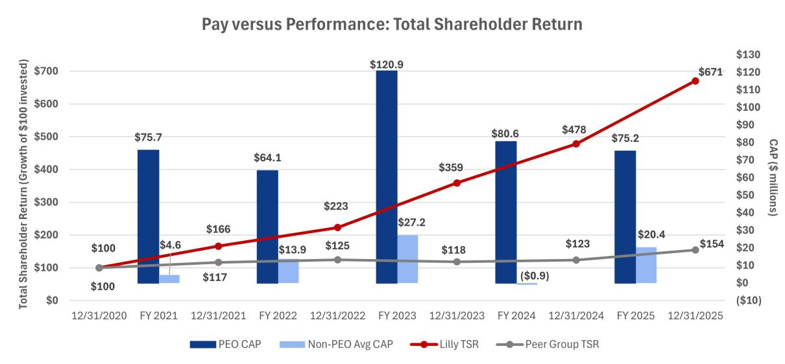

Pay versus Net Income

Lilly does not utilize GAAP or non-GAAP net income as a metric in any of its incentive programs. Generally, CAP is not heavily correlated with GAAP net income because GAAP net income includes certain items that the Committee believes are not reflective of underlying business performance. By excluding the impact of (i) amortization of intangible assets primarily associated with costs of marketed products acquired or licensed from third parties, (ii) net losses or gains on investments in equity securities, and (iii) other specified items that are not reflective of underlying business performance, the Committee believes non-GAAP net income better represents the company’s operating performance. For comparison purposes, the graph below reflects both GAAP net income and non-GAAP net income against PEO and average non-PEO NEO CAP.

The GAAP and non-GAAP net income results include significantly higher acquired IPR&D charges. While immediately expensed for accounting purposes, the company views investments in acquired IPR&D as important contributions to its product pipeline, which is a key driver of future company performance. For additional information on financial results, see Appendix A.

69

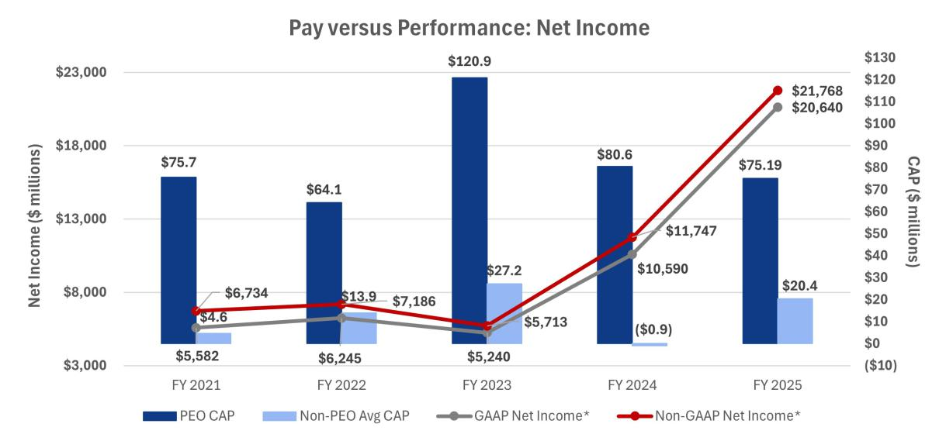

- GAAP net income and non-GAAP net income are discrete outcomes. GAAP net income and non-GAAP net income figures shown in the graphic above both include acquired IPR&D charges, net of taxes, as follows: $785.5 million in 2021, $813.2 million in 2022, $3.70 billion in 2023, $3.18 billion in 2024, and $2.91 billion in 2025.

Pay versus Adjusted Non-GAAP EPS

Lilly has chosen adjusted non-GAAP EPS as its most important company selected measure (CSM). Lilly leverages annual non-GAAP EPS derived from the board-approved business plan to set targets for the bonus. Significant sustained profitability growth contributes to higher total CAP as seen in the graphic below. For additional information on non-GAAP financial metrics, see Appendix A.
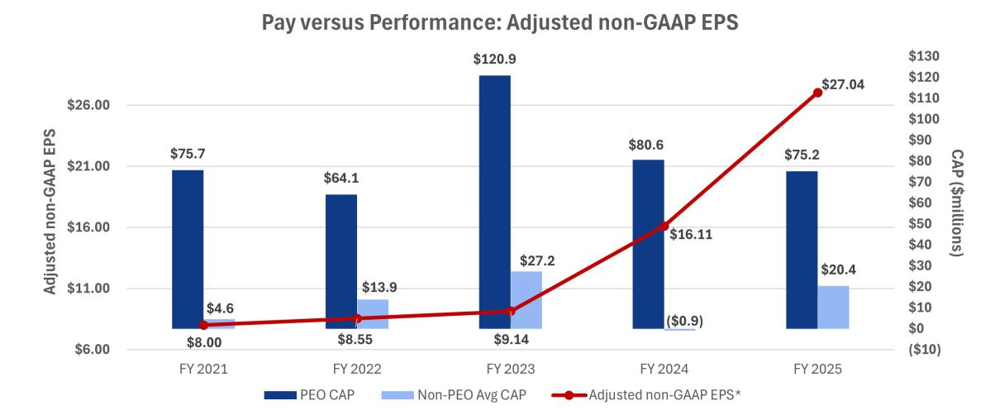

- Adjusted non-GAAP EPS data points are discrete outcomes.

Pay versus Revenue

Lilly strives to make breakthrough medicines available to patients around the globe. Given a growing portfolio of new medicines, we motivate our entire workforce to reach as many patients as possible. The combination of a strong product portfolio and effective patient delivery yields higher sales volume and, generally, higher revenue. As such, revenue is one of our most important measures to ensure we are continuously growing the number of patients we serve. Generally, our revenue over the preceding five-year period aligns with the growth in PEO and average non-PEO CAP.

70

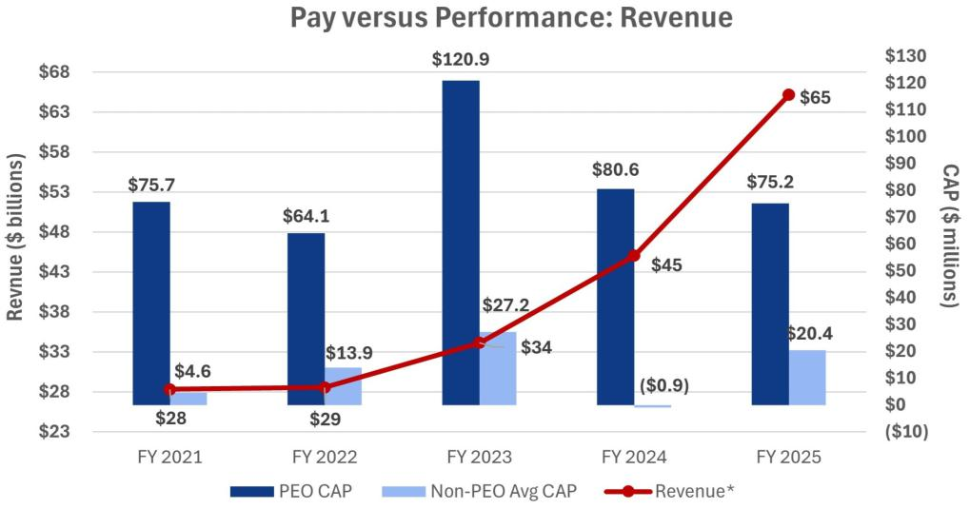

- Revenue data points are discrete outcomes.

Pay versus Performance: Conclusions

The Committee believes in pay for performance and has structured Lilly compensation programs to reward leaders when the company delivers strong results. Lilly has achieved strong cumulative TSR, EPS and revenue growth over the immediately preceding five-year period. As a result, shareholders have been rewarded with significant total stock returns, and leadership has been rewarded with above-target payouts from their incentive compensation programs.

Audit Matters

Item 3. Ratification of the Appointment of the Independent Auditor

Audit Committee Oversight of the Independent Auditor

The Audit Committee is responsible for the appointment, compensation, retention, and oversight of the independent auditor and oversees the process for reviewing and evaluating the lead audit partner. Further information regarding the Audit Committee’s oversight of the independent auditor can be found in the Audit Committee charter, available online at lilly.com/about/leadership/governance.

Evaluation Process: In connection with the decision regarding whether to reappoint the independent auditor each year (subject to shareholder ratification), the Audit Committee assesses the independent auditor’s performance. This assessment includes:

- the independent auditor’s qualifications and experience;

- the communication and interactions with the auditor over the course of the year;

- the auditor’s independence, objectivity, and professional skepticism; and

- the independent auditor’s tenure.

These criteria are assessed against an internal and an external scorecard and are discussed with management during a private session.

Based on the Audit Committee’s assessment of Ernst & Young LLP’s (EY) performance during 2025, the Audit Committee believes that the continued retention of EY to serve as the company's independent auditor is in the

71

best interests of the company and its shareholders and has therefore reappointed EY as the company’s independent auditor for 2026.

Benefits of Longer Tenure: EY has served as the independent auditor for the company since 1940. There are several benefits of retaining a longer-tenured independent auditor, including:

- Qualifications and experience - institutional knowledge and expertise regarding the company’s global operations, accounting policies and practices, and internal controls over financial reporting.

- Competitive fees - audit and other fees are competitive with peer companies because of familiarity with the company and its operations.

Independence Controls

- EY’s internal independence assessment - EY conducts periodic internal reviews of its audit and other work, assesses the adequacy of partners and other personnel working on the company’s account and rotates the lead assurance engagement partner, the global coordinating partner, and other partners on the engagement consistent with independence requirements.

- Limits on non-audit services - The Audit Committee pre-approves audit and permissible non-audit services provided by EY in accordance with its pre-approval policy (described below).

Audit Committee Oversight: Oversight includes regular private sessions with EY, discussions on the scope of audit, an annual evaluation (described above) when determining whether to reengage EY and rotation of lead assurance engagement partner and global coordinating partner.

Representatives of EY are expected to participate in the Annual Meeting and will be available to respond to questions. Those representatives will have the opportunity to make a statement if they wish to do so.


RECOMMENDATION FOR

The board recommends that you vote FOR ratifying the appointment of EY as the independent auditor for 2026.

Audit Committee Report

The Audit Committee reviews the company’s financial reporting process on behalf of the board. Management has the primary responsibility for the financial statements and the reporting process, including the systems of internal controls and disclosure controls. In this context, the Audit Committee has met and held discussions with management and the independent auditor. Management represented to the Audit Committee that the company’s consolidated financial statements for the year ended December 31, 2025, were prepared in accordance with GAAP, and the Audit Committee has reviewed and discussed the audited financial statements and related disclosures with management and the independent auditor, including a review of the significant management judgments underlying the financial statements and disclosures.

The independent auditor reports directly to the Audit Committee, which has sole authority to appoint and to replace the independent auditor (subject to shareholder ratification).

The Audit Committee has discussed with the independent auditor the matters required to be discussed with the Audit Committee by the standards of the Public Company Accounting Oversight Board (PCAOB), the SEC, and the NYSE, including the quality, not just the acceptability, of the accounting principles, the reasonableness of significant judgments, and the clarity of the disclosures in the financial statements. In addition, the Audit Committee has received the written disclosures and the letter from the independent auditor required by applicable PCAOB rules regarding communications with the Audit Committee concerning independence and has discussed with the independent auditor the auditor’s independence from the company and its management. In concluding that the auditor is independent, the Audit Committee determined, among other things, that the non-audit services provided by EY (as described below) were compatible with its independence. Consistent with the requirements of the Sarbanes-Oxley Act of 2002 (the Sarbanes-Oxley Act), the Audit Committee has adopted policies to ensure the independence of the independent auditor, such as prior committee approval of non-audit services and required audit partner rotation.

72

The Audit Committee discussed with the company’s internal and independent auditors the overall scope and plans for their respective audits, including internal control testing under Section 404 of the Sarbanes-Oxley Act. The Audit Committee periodically meets with the internal and independent auditors, with and without management present, and in private sessions with members of senior management (such as the chief financial officer and the chief accounting officer) to discuss the results of their examinations, their evaluations of the company’s internal controls, and the overall quality of the company’s financial reporting. The Audit Committee also periodically meets in executive session.

In reliance on the reviews and discussions referred to above, the Audit Committee recommended to the board (and the board subsequently approved the recommendation) that the audited consolidated financial statements be included in the company’s Annual Report on Form 10-K for the year ended December 31, 2025, for filing with the SEC. The Audit Committee has also appointed EY as the company’s independent auditor, subject to shareholder ratification, for 2026.

Audit Committee

Jamere Jackson, Chair

Ralph Alvarez

Jon Moeller

Gabrielle Sulzberger

Services Performed by the Independent Auditor

The Audit Committee pre-approves all services performed by the independent auditor, in part to assess whether the provision of such services might impair the auditor’s independence. The Audit Committee’s policy and procedures are as follows:

- Audit services: The Audit Committee approves the annual audit services engagement and, if necessary, any changes in terms, conditions, and fees resulting from changes in audit scope, company structure, or other matters. Audit services include internal controls attestation work under Section 404 of the Sarbanes-Oxley Act. The Audit Committee may also pre-approve other audit services, which are those services that only the independent auditor reasonably can provide.

- Audit-related services: Audit-related services are assurance and related services that are reasonably related to the performance of the audit or reviews of the financial statements, and that are traditionally performed by the independent auditor. The Audit Committee believes that the provision of these services does not impair the independence of the auditor.

- Tax services: The Audit Committee believes that, in appropriate cases, the independent auditor can provide tax compliance services, tax planning, and tax advice without impairing the auditor’s independence.

- Other services: The Audit Committee may approve other services to be provided by the independent auditor if (i) the services are permissible under SEC and PCAOB rules, (ii) the Audit Committee believes the provision of the services would not impair the independence of the auditor, and (iii) management believes that the auditor is the best choice to provide the services.

Pre-approval process: At the beginning of each audit year, management requests pre-approval from the Audit Committee of the annual audit, statutory audits, and quarterly reviews for the upcoming audit year as well as any other services known at that time. Management will also present at that time an estimate of all fees for the upcoming audit year and known services. As specific engagements are identified thereafter that were not initially approved, they are brought forward to the Audit Committee for approval. To the extent approvals are required between regularly scheduled Audit Committee meetings, pre-approval authority is delegated to the committee chair.

For each engagement, management provides the Audit Committee with information about the services and fees, sufficiently detailed to allow the committee to make an informed judgment about the nature and scope of the services and the potential for the services to impair the independence of the auditor.

After the end of the audit year, management provides the committee with a summary of the actual fees incurred for the completed audit year.

73

Independent Auditor Fees

The following table shows the fees incurred for services rendered on a worldwide basis by EY in 2025 and 2024. All such services were pre-approved by the Audit Committee in accordance with the pre-approval policy.

 |  | 2025 | 2024
 |  | ($ millions)* | ($ millions)*
Audit Fees | Annual audit of consolidated and subsidiary financial | $17.4 | $16.1
 | statements, including Sarbanes-Oxley 404 attestation, reviews
 | of quarterly financial statements
Audit-Related | Primarily related to assurance and related services reasonably | $0.8 | $1.3
Fees | related to the performance of the audit or reviews of the
 | financial statements primarily related to employee benefit plan
 | and other ancillary audits, and due diligence services on
 | potential acquisitions
Tax Fees | Tax compliance services, tax planning, tax advice | $1.4 | $1.2
 | Primarily related to consulting and compliance services
Other | Advisory services related to regulatory and contractual matters | — | $0.2
Total |  | $19.6 | $18.8

* Numbers may not add due to rounding

Management Proposals

Item 4. Proposal to Amend the Company’s Articles of Incorporation to Eliminate the Classified Board Structure

The company’s articles of incorporation provide that the board is divided into three classes, with each class elected every three years. The board, after review by its Directors and Corporate Governance Committee, has approved, and recommends that the shareholders approve, amendments to eliminate the classified board structure in order to provide for the annual election of all directors (the Declassification Amendments). From 2010 through 2012 and again from 2018 through 2025, the board submitted this management proposal to shareholders seeking approval to eliminate the company’s classified board structure; however, under the company’s articles of incorporation the proposal requires the vote of 80 percent of the outstanding shares to be approved and on each prior occasion failed to receive the required vote.

If approved, the Declassification Amendments would become effective following the Annual Meeting upon the company making the required filings of the Declassification Amendments with the Secretary of State of Indiana. Directors elected prior to the effectiveness of the Declassification Amendments would serve the remainder of their respective three-year terms and each director elected after the Annual Meeting would serve a one-year term, ending at the next annual meeting of shareholders. Thereafter, the company’s classified board structure would be fully eliminated starting with the 2029 annual meeting of shareholders. In the case of any vacancy on the board occurring after the Annual Meeting created by an increase in the number of directors, the vacancy would be filled through an appointment by the board, with the new director to serve a term ending at the next annual meeting of shareholders. Vacancies created by resignation, removal or death would be filled by appointment by the board of a new director to serve until the end of the term of the director being replaced. This proposal would not change the present number of directors or the board’s authority to change that number and to fill any vacancies or newly created directorships.

Background of Proposal

As part of its ongoing review of corporate governance matters, the board, taking into account the input of the Directors and Corporate Governance Committee, considered the advantages and disadvantages of maintaining the classified board structure. The board considered the view of certain shareholders who believe that classified boards have the effect of reducing the accountability of directors to shareholders because shareholders are

74

unable to evaluate and consider all directors for election on an annual basis. The board gave considerable weight to the favorable votes of a strong majority of the outstanding shares for management’s proposals in prior years.

The board also considered the benefits of retaining the classified board structure. A classified structure may promote shareholder value by providing continuity and stability in the management of the business and affairs of the company, as a majority of the board always has prior experience as directors of the company. In addition, under certain circumstances, classified boards may protect shareholder value by forcing an entity seeking control of the company to initiate discussions at arm’s-length with the board of the company, because the entity cannot replace the majority of the board in a single election. The board also considered that even without a classified board (and without the supermajority voting requirements, which the board also recommends eliminating), the company would have appropriate safeguards to protect the interests of all shareholders and discourage a would-be acquirer from proceeding with a proposal that undervalues the company or is opportunistic. These include other provisions of the company’s articles of incorporation and bylaws, as well as certain provisions of Indiana corporation law.

After balancing these interests, the board has decided to resubmit this proposal to eliminate the classified board structure. The affirmative vote of at least 80 percent of the outstanding shares of common stock is needed to approve this proposal. Unless such vote is received, the present classification of the board will continue.

Text of the Amendments

Article 9(b) of the company’s articles of incorporation contains the provisions that will be affected if this proposal is adopted. This article, set forth in Appendix B to this proxy statement, shows the proposed changes, with deletions indicated by strikeouts and additions indicated by underlining. The board has also adopted conforming amendments to the company’s bylaws, to be effective immediately upon, and subject to, the effectiveness of the amendments to the articles of incorporation.


RECOMMENDATION FOR

The board recommends that you vote FOR amending the company’s articles of incorporation to eliminate the classified board structure.

Item 5. Proposal to Amend the Company’s Articles of Incorporation to Eliminate Supermajority Voting Provisions

The company’s articles of incorporation provide that nearly all matters submitted to a vote of shareholders can be adopted by a majority of the votes cast. However, the company’s articles of incorporation require certain fundamental corporate actions to be approved by the holders of 80 percent of the outstanding shares of common stock. Those actions are:

- amending certain provisions of the articles of incorporation that relate to the number and terms of office of directors:

– the company’s classified board structure (as described under Item 4)

– a provision that the number of directors shall be specified solely by resolution of the board

- removing directors prior to the end of their elected term

- entering into mergers, consolidations, recapitalizations, or certain other business combinations with a “related person”—a party who has acquired at least five percent of the company’s stock (other than the Endowment or a company benefit plan) — without the prior approval of such action or transaction by the directors not affiliated with such shareholder

- modifying or eliminating any of the above supermajority voting requirements.

The board, after review by the Directors and Corporate Governance Committee, has approved, and recommends that the shareholders approve, amendments to eliminate the supermajority voting requirements (the

75

Supermajority Voting Amendments). From 2010 through 2012 and again from 2018 through 2025, the board submitted this management proposal to shareholders seeking approval to eliminate these supermajority voting requirements; however, under the company’s articles of incorporation the proposal requires the vote of 80 percent of the outstanding shares to be approved and on each prior occasion failed to receive the required vote.

Background of Proposal

As part of its ongoing review of corporate governance matters, the board, taking into account the input of the Directors and Corporate Governance Committee, considered the advantages and disadvantages of maintaining the supermajority voting requirements. The board considered the potential adverse consequences of maintaining the supermajority voting requirements. The board believes it is important to maintain shareholder confidence by demonstrating that the board is responsive and accountable to shareholders and committed to strong corporate governance. This requires the board to carefully balance sometimes competing interests. In this regard, the board gave considerable weight to the favorable votes of a strong majority of the outstanding shares for management’s proposal in the previous four years. Many shareholders believe that supermajority voting requirements impede accountability to shareholders and contribute to board and management entrenchment. The board also considered that, even without the supermajority vote (and without the classified board, which the board also recommends eliminating), the company has appropriate safeguards to protect the interests of all shareholders and to discourage a would-be acquirer from proceeding with a proposal that undervalues the company or is opportunistic and to assist the board in responding to such proposals. These include other provisions of the company’s articles of incorporation and bylaws as well as certain provisions of Indiana corporation law.

The board also considered that under certain circumstances, supermajority voting requirements can provide benefits to the company and all its shareholders by making it more difficult for one or a few large shareholders to facilitate a takeover of the company or implement certain significant changes to the company without more widespread shareholder support.

After balancing these interests, the board has decided to resubmit this proposal to eliminate the supermajority voting requirements. The affirmative vote of at least 80 percent of the outstanding shares of common stock is needed to approve this proposal. Unless such vote is received, the supermajority voting requirements will continue to be in effect.

Text of Amendments

Articles 9(c), 9(d), and 13 of the company’s articles of incorporation contain the provisions that will be affected if this proposal is adopted. These articles, set forth in Appendix B to this proxy statement, show the proposed changes with deletions indicated by strikeouts and additions indicated by underlining. The board has also adopted conforming amendments to the company’s bylaws, to be effective immediately upon, and subject to, the effectiveness of the amendments to the articles of incorporation.

RECOMMENDATION FOR

The board recommends that you vote FOR amending the company’s articles of incorporation to eliminate supermajority voting requirements.

76

Shareholder Proposals

Item 6. Shareholder Proposal to Amend the Bylaws to Require an Independent Board Chair

Mercy Investment Services, Inc., as lead filer with several additional co-filers, and beneficial owner of shares of our common stock having a market value in excess of $2,000, has submitted the following proposal:


RESOLVED: Shareholders request the Board of Directors adopt as policy, and amend the bylaws as necessary, to require henceforth that the Chair of the Board of Directors, whenever possible, be an independent member of the Board. This independence policy shall apply prospectively so as not to violate any contractual obligations. If the Board determines that a Chair who was independent when selected is no longer independent, the Board shall select a new Chair who satisfies the requirements of the policy within a reasonable amount of time. Compliance with this policy is waived if no independent director is available and willing to serve as Chair. This policy would be phased in for the next chief executive officer (CEO) transition.

WHEREAS: We believe:

- The role of the CEO and management is to run the company.

- The role of the Board of Directors is to provide independent oversight of management and the CEO.

- There is a potential conflict of interest for a CEO to have a non-independent director act as Chair.

In our view, shareholders are best served by an independent Board Chair who can provide a balance of power between the CEO and the Board. Taking this step is in the long-term interests of shareholders and will promote effective oversight of management.

As of 2024, approximately 40 percent¹ of S&P 500 firms had an independent chair. ISS reported in September 2025 that 81 percent² of investors responding to its policy survey indicated that an independent chair is their preferred model.

Pharmaceutical companies are particularly in need of effective and unconflicted oversight because of the industry's high legal and regulatory risks related to product safety and the industry's commercial practices. Eli Lilly is not immune to litigation and regulatory attention.

- In August of 2025, the state of Texas sued for allegedly bribing and inducing medical providers to prescribe its most profitable drugs, including the high-demand GLP-1 medications. These inducements were designed to steer providers toward prescribing Eli Lilly's drugs³.

- An ongoing battle between Michigan and the company continues. The state is trying to investigate Eli Lilly's pricing practices around insulin; these proceedings go back to 2022 and continue to make news even in November of 2025⁴.

- Eli Lilly is one of three pharmaceutical companies named as defendants in a lawsuit filed July of this year on behalf of the University of Pennsylvania and its health system. The suit alleges 20 years of price fixing on drugs that treat diabetes, like insulin.

The risk of lawsuits, sustained public controversy and regulatory intervention, whether ultimately found to be justified or not, are strong arguments for the need for continuous, effective and unconflicted board oversight of corporate management.

In order to ensure that our Board can provide rigorous oversight for our Company with greater independence and accountability, we urge a vote FOR this shareholder proposal.
__________________________________
- https://www.conference-board.org/publlcations/Board-Practices-and-Composition-2024-Edition
² https://www.issgovernance.com/file/policy/active/policy-survey-summary-2025.pdf
³ https://www.texasattorneygeneral.gov/news/releases/attorney-general-ken-paxton-sues-blg-pharma-drug-manufacturer-eli-lilly-bribing-providers-prescribe

⁴ https://www.michIganpublic.org/criminal-justice-legal-system/2025-11-06/michigan-supreme-court-hears-arguments-in-eli-lilly-insulin-case

77

Lilly’s Opposing Statement

The board, after review by its Directors and Corporate Governance Committee, recommends a vote AGAINST this proposal.


As discussed in more detail below, the change requested by the proposal is unnecessary because:

- The proposal would lock in a mandatory leadership structure that eliminates the flexibility to evaluate and adopt what the board believes to be the most effective leadership structure under the relevant facts and circumstances at any given point in time.

- Lilly’s leadership structure is the same as all of the U.S.-incorporated companies from our pharma peer group, and Lilly’s shareholders expressly rejected similar proposals seeking to mandate an independent board chair each of the last three times this proposal was put forth for consideration, thus endorsing our flexible approach.

- Lilly’s current board leadership structure and corporate governance practices provide effective, independent oversight of management.

Mandating an Independent Chair Eliminates Flexibility

Mandating an independent board chair would eliminate the board’s flexibility to adopt the most effective leadership structure for Lilly's needs. The board believes there is no "one-size-fits-all" approach and that the proposal would unnecessarily restrict the board’s ability to exercise its fiduciary duty to determine the appropriate board leadership structure for the company given the specific circumstances and leadership needs at any particular point in time.

Our Approach Aligns with our U.S. Pharma Peer Group¹ and has had Strong Shareholder Support.

Lilly's approach is consistent with market standards and has strong shareholder support. All eight U.S.-incorporated companies from our pharma peer group have a combined board chair and CEO.¹

In addition, as of April 30, 2025, 58% of companies in the S&P 500 do not have independent board chairs, and among the companies with non-independent chairs, 91% have a lead or presiding independent director.²

Notably, Lilly’s shareholders rejected similar proposals in 2020, 2021, and 2022 to mandate a leadership structure, with nearly two-thirds of votes cast on such proposals supporting continued flexibility.

Our Board Leadership Structure and Corporate Governance Practices Provide Strong Independent Oversight of Management

Our robust governance framework ensures balanced leadership through a strong lead independent director and sound principles of corporate governance. Eleven of 12 directors are independent, and they collectively bring extensive leadership experience, industry expertise, and other critical skills, and individually have demonstrated the willingness to think and act independently on behalf of shareholders.

All standing committees consist solely of independent directors and are led by independent committee chairs. Our lead independent director, elected annually by independent directors, has clearly defined responsibilities including:

  - leading CEO selection processes;

  - overseeing annual performance evaluations of the chair/CEO;

  - serving as liaison between chair and independent directors;

  - presiding at meetings when the chair is absent and at executive sessions;

  - calling independent director meetings as needed;

¹ See the U.S.-incorporated companies that are part of our pharma peer group companies list in “Compensation Discussion and Analysis— Talent and Compensation Committee’s Processes and Analyses—Benchmarking Compensation”.

- Source: 2025 U.S. Spencer Stuart Board Index, available at https://www.spencerstuart.com/research-and-insight/us-board-index. 78

- approving meeting agendas;

- meeting with shareholders;

- leading the annual board assessment process and director succession planning; and

- retaining advisors for independent directors.

Furthermore, the board has instituted a number of governance best practices to ensure effective independent oversight, including:

- executive sessions of the independent directors scheduled after every regular board meeting that are presided over by our lead independent director;

- an annual performance evaluation of the chair and CEO conducted by the independent directors, the results of which are reviewed with the CEO and considered by the Talent and Compensation Committee and independent directors in establishing the CEO’s compensation for the next year;

- an annual performance evaluation of the lead independent director by the board as part of the annual board assessment process;

- independent director access to management whenever deemed necessary by the independent directors; and

- the ability of independent directors and all committees to retain their own independent advisors, at the company’s expense, whenever they deem it desirable to do so.

Why Our Current Structure Works Best

The combined chair/CEO role provides deep strategic insights and consistent communication vital to our innovative research and development business with prolonged development cycles. Meanwhile, our lead independent director—currently a sitting CEO—provides "outside in" analysis and ensures productive partnership between independent directors and management. A mandatory independent chair policy is unnecessary and not in the best interests of the company and its shareholders.

RECOMMENDATION AGAINST

The board recommends that you vote AGAINST this proposal.

79

Item 7. Shareholder Proposal to Prepare an Annual Lobbying Report

CommonSpirit Health, a beneficial owner of shares of our common stock having a market value in excess of $2,000, has submitted the following proposal:


Resolved, shareholders of Eli Lilly (“Lilly”) request the preparation of a report, updated annually, omitting any proprietary data and produced at reasonable cost, disclosing:

Payments by Lilly used for direct or indirect lobbying, in each indirect case including the amount of the payment and the recipient.

For purposes of this proposal, payments used for direct lobbying are the annual aggregate amounts reported at the federal and state levels, broken out by federal and individual state. Payments used for indirect lobbying are payments to trade associations or social welfare groups that are used for lobbying as defined by tax law. Both direct and indirect lobbying include efforts at the state and federal levels.

The report shall be posted on Lilly’s website

Supporting Statement

As long-term shareholders of Lilly, we support transparency and accountability in corporate lobbying. Companies and investors may benefit if lobbying leads to improved policies, reduced regulation or taxation, or government contracts or subsidies. However, lobbying activities also create costs and can create risks for a corporation – and by extension, shareholders. Currently, shareholders must search the federal and 50 state lobbying databases to assemble a picture of a company’s lobbying. And state disclosure requirements vary widely,¹ with an analysis of Lilly’s disclosures finding 25 out of 48 states did not disclose amounts spent.²

Lilly spent $8,430,000 on federal lobbying for 2024. This does not include state lobbying, where Lilly also lobbies. Lilly lists support of ten trade associations yet fails to disclose the amounts of its payments to those groups used for lobbying. And Lilly’s disclosure leaves out its memberships in and payments to social welfare groups, like the Alliance for Competitive Taxation and the Alliance for Patient Access.

The International Corporate Governance Network policy on lobbying recommends a company commit to public disclosure of its lobbying activities and any direct or indirect expenditure beyond a de minimis level (e.g., a contribution equal to or less than $10,000). Many companies already provide annual lobbying reports to shareholders, including Cardinal Health, Exxon, Procter & Gamble and Xcel Energy, which report on their federal and state lobbying and indirect lobbying through trade associations and social welfare groups, and Amazon and Walmart, which provide full state lobbying reports. Among our company’s peers, Biogen, Gilead Sciences, Merck and Pfizer each provide an annual report of their trade association payments used for lobbying to shareholders. Companies are required to report this information at the federal and state levels, so it is not overly burdensome to provide it to shareholders.

We urge Lilly to expand its lobbying disclosure.

_______________________________________
- https://www.ncsl.org/ethics/how-states-define-lobbying-and-lobbyist.
- https://www.citizen.org/news/despite-company-claims-eli-lilly-fails-to-disclose-its-state-lobbying-spending-for-half-the-country/.

80

Lilly’s Opposing Statement

The board, after review by its Directors and Corporate Governance Committee, recommends a vote AGAINST this proposal.


As discussed in more detail below, the change requested by the proposal is unnecessary because:

- Lilly publicly discloses a detailed report with information regarding our direct and indirect lobbying expenditures and our membership in trade associations that lobby in the U.S., including the percentage of such payments attributed to lobbying; and

- Requiring Lilly to prepare a separate report with this information would not provide meaningful additional information to shareholders in relation to the resources it would require.

Lilly Already Publicly Discloses a Detailed Lobbying Report

Lilly believes it is important to be a responsible participant in political and public policy debates, including directly and indirectly through membership in trade associations and organizations. Lilly’s engagement in the political arena focuses on three key areas: innovation; health care delivery; and pricing and reimbursement.

In recent years, following feedback from shareholders, Lilly substantially enhanced its disclosures related to its direct and indirect lobbying activities. Lilly’s dedication to transparency is reflected in its ranking as a top performer (Tier 1) in the CPA-Zicklin Index (which benchmarks S&P 500 companies' transparency and governance over their political spending) for the past two consecutive years.¹

Lilly provides disclosure about its lobbying and other political activities on its website at lilly.com/about/our-views/public-policy/political-participation (the Public Policy Website). This disclosure is updated at least annually (with certain disclosures updated more frequently) and:

- describes the board’s oversight of political expenditures and lobbying activities;

- includes a report of Lilly’s political contributions to candidates for public office (directly from Lilly and through the company’s exclusively employee-led political action committee (LillyPAC));

- provides Lilly’s total federal lobbying spending and links to the website to find its federal lobbying disclosures;

- details Lilly’s state lobbying activities, including a chart for locating its state lobbying disclosures on each state’s website;

- lists trade associations to which Lilly pays annual membership dues of $50,000 or more (and specifies those trade associations on which Lilly has a board seat) and the portion of Lilly’s payments to each of those groups that is used for lobbying;

- discusses the public policy positions Lilly supports; and

- outlines Lilly’s core principles and key areas of public policy effort when advocating for improvements to the U.S. healthcare system.

Lilly includes corporate political contributions in our Report of Political Financial Contributions posted on our Public Policy Website. Additional details regarding the company’s corporate contributions, LillyPAC’s contributions, contribution data, and the company’s direct lobbying expenses are also already made available to the public from numerous public sources. This extensive disclosure regarding Lilly’s lobbying and political spending reflects Lilly’s commitment to transparency on this topic.

- Source: 2025 CPA-Zicklin Index of Corporate Political Disclosure and Accountability, available at https://www.politicalaccountability.net/wp-content/uploads/2025/11/2025-CPA-Zicklin-Index.pdf; 2024 CPA-Zicklin Index of Corporate Political Disclosure and Accountability, available at https://www.politicalaccountability.net/wp-content/uploads/2025/01/2024-CPA-Zicklin-Index.pdf.

81

A Separate Report Would Not Provide Meaningful Additional Information to Shareholders

We do not believe that publishing the standalone report requested by the proposal would provide meaningful additional information to shareholders to merit the resources required to provide the requested report. For these reasons, we believe the proposal is not in the best interests of the company and its shareholders.

RECOMMENDATION AGAINST

The board recommends that you vote AGAINST this proposal.

Other Information

Meeting and Voting Logistics

The 2026 Annual Meeting will be held virtually via live webcast designed to provide shareholders the opportunity to participate virtually to facilitate shareholder attendance and to provide a consistent experience to all shareholders, regardless of location. You will be able to attend the Annual Meeting, vote, and submit questions virtually via webcast by visiting virtualshareholdermeeting.com/LLY2026 and entering the 16-digit control number found on the proxy card, voting instruction form, or notice you received.

Vote Early: Even if you plan to attend the Annual Meeting, we encourage you to vote prior to the meeting, either online, by telephone, or by mail.

Beneficial Shareholders: Shareholders who hold their shares beneficially through an institutional holder of record, such as a broker or bank (sometimes referred to as holding shares in street name), will receive voting instructions from that holder of record. If you do not provide voting instructions to the holder of record, your shares will not be voted on any proposal on which the broker does not have discretionary authority to vote. See below for more information.

Voting Deadlines: You may vote your shares prior to the Annual Meeting until 11:59 p.m. EDT on May 3, 2026, online, or by telephone. If you are voting by mail, your marked, signed, and dated proxy card must be received by 11:59 p.m. EDT on May 3, 2026. Shareholders who hold their shares in the 401(k) Plan must vote by April 29, 2026, so the plan trustee can vote their shares accordingly. See below for more information.

Quorum

A majority of the outstanding shares entitled to vote, present or represented by proxy, constitutes a quorum for the Annual Meeting. As of February 25, 2026, 944,818,881 shares of company common stock were issued and outstanding.

Who Can Vote

Shareholders as of the close of business on February 25, 2026 (the record date) may vote or have their shares voted at the Annual Meeting.

You have one vote for each share of common stock you held on the record date, including shares:

- held directly in your name as the shareholder of record;

- held for you in an account with a broker, bank, or other nominee; and

- attributed to your account in the company’s 401(k) Plan.

Why You May Receive Multiple Notices, Proxy Materials, or Emails

If you received more than one notice, full set of proxy materials, or email related to proxy materials, you hold shares in more than one account. You will need to cast a vote for each notice, full set of proxy materials, or email you receive. If you do not receive a proxy
card, you may have elected to receive your proxy statement electronically, in which case you should have received an email with directions on how to access this proxy statement and how to vote your shares. If you wish to request a paper copy of these materials and a proxy card,

82

please call 1-800-579-1639 on or before April 20, 2026, to facilitate timely delivery.

Voting Choices

 |  |  |  | Broker | Effect of
 | Required |  | Effect of | Discretionary | Effect of
Voting Matter | Required | Voting Options | Effect of | Voting | Broker
Voting Matter | Vote | Voting Options | Abstentions | Allowed? | Non-Votes
Election of directors | Majority of | FOR, AGAINST or | No effect - not | No | No effect
 | votes cast | ABSTAIN (for each | counted as a
 |  | director nominee) | “vote cast”
Advisory vote on | Majority of | FOR, AGAINST or | No effect - not | No | No effect
compensation paid to named | votes cast | ABSTAIN | counted as a
executive officers |  |  | “vote cast”
Ratification of the appointment | Majority of | FOR, AGAINST or | No effect - not | Yes | Not
of the independent auditor | votes cast | ABSTAIN | counted as a |  | applicable
 |  |  | “vote cast”
Proposal to amend the | 80% of | FOR, AGAINST or | Treated as a | No | Treated as a
company's articles of | outstanding | ABSTAIN | vote AGAINST |  | vote
incorporation to eliminate the | shares |  | the proposal |  | AGAINST
classified board structure |  |  |  |  | the proposal
Proposal to amend the | 80% of | FOR, AGAINST or | Treated as a | No | Treated as a
company's articles of | outstanding | ABSTAIN | vote AGAINST |  | vote
incorporation to eliminate | shares |  | the proposal |  | AGAINST
supermajority voting provisions |  |  |  |  | the proposal
Shareholder Proposals | Majority of | FOR, AGAINST or | No effect - not | No | No effect
 | votes cast | ABSTAIN (for each | counted as a
 |  | shareholder | “vote cast”
 |  | proposal)

Additional Items of Business

We do not expect any items of business to be submitted to shareholders at the Annual Meeting other than the proposals referred to in this proxy statement. Nonetheless, if necessary, the persons named on the proxy have discretionary authority to vote the shares represented thereby with respect to any other matters that might be brought before the meeting. Those persons intend to vote on any such matters in accordance with their best judgment.

Vote Tabulation

Votes are tabulated by an independent inspector of election, Broadridge Financial Solutions, Inc.

List of Shareholders of Record

A list of the names of shareholders entitled to vote at the Annual Meeting will be available to shareholders for five business days prior to the Annual Meeting for any purpose germane to the Annual Meeting. Please contact us at shareholderproposals@lilly.com if you wish to examine the list prior to the Annual Meeting. The shareholder list will also be available during the virtual Annual Meeting for examination by shareholders who access the Annual Meeting using their 16-digit control number at virtualshareholdermeeting.com/LLY2026.

The 2027 Annual Meeting

The company’s 2027 annual meeting of shareholders is currently scheduled for May 3, 2027.

83

How to Vote

You may vote by any one of the following methods:

Shareholders of Record | Shares Held by a Broker | Shares Held in the
Shareholders of Record | Shares Held by a Broker | Company 401(k) Plan


Online



Telephone

Mail


At the

Meeting

Vote online at ProxyVote.com. | The broker will ask you how | Vote online at
Vote online at ProxyVote.com. | you want your shares to be | ProxyVote.com.
 | voted. You may instruct your
 | broker or other nominee to
 | vote your shares by following

Call 1-800-690-6903 using a touch-tone | instructions that the broker or | Call 1-800-690-6903 using a
phone and follow the instructions | nominee provides to you. | touch-tone phone and follow
provided. | Most brokers offer voting by | the instructions provided.
 | mail, by telephone, and
 | online. You may submit new
 | voting instructions by | Sign, date, and return the
 | contacting your broker or | Sign, date, and return the
Sign, date, and return each proxy card | contacting your broker or | voting instruction form you
you received in the prepaid envelope. | other nominee or, if your | received in the prepaid
you received in the prepaid envelope. | broker provides you with a | received in the prepaid
 | broker provides you with a | envelope.
 | 16-digit control number found | envelope.
 | on the voting instruction form
 | on the voting instruction form | Plan shares cannot be voted
 | for ProxyVote.com, by | Plan shares cannot be voted
Follow the instructions at | signing in with your 16-digit | at the meeting. The Trustee
virtualshareholdermeeting.com/LLY2026 control number and voting at |  | must receive your
to vote during the meeting. | the Annual Meeting. | instructions by one of the
 |  | methods above by April 29,
 |  | 2026.



 | 11:59 p.m. EDT on May 3, 2026, unless | Please refer to the | 11:59 p.m. EDT on April 29,
Voting | you are voting at the meeting | information provided by your | 2026
Deadline |  | broker, bank or other
 |  | nominee

We encourage you to vote by mail, by telephone, or online even if you plan to attend the Annual Meeting.

General: Follow the instructions on your proxy card, voting instruction form or notice. If you received these materials electronically, follow the instructions in the email message that notified you of their availability.

Signing your proxy card or voting instruction form: Sign your name exactly as it appears. If you are signing in a representative capacity (e.g., as an attorney-in-fact, executor, administrator, guardian, trustee, or the officer or agent of a corporation or partnership), please indicate your name and your title or capacity. If the stock is held in custody for a minor (e.g., under the Uniform Transfers to Minors Act), the custodian should sign, not the minor. If the stock is held in joint ownership, one owner may sign on behalf of all. If you return your signed proxy but do not indicate your voting preferences, the proxy holder will vote on your behalf based upon the board’s recommendations.

Voting Deadlines:

- Shareholders of record may vote their shares until 11:59 p.m. EDT on May 3, 2026, by mail, online, or by telephone. If you are voting by mail, your marked, signed, and dated proxy card must be received by May 3, 2026. You have the right to change your vote or revoke your proxy before it is voted at the Annual Meeting by (i) timely notifying the General Counsel and Secretary in writing, (ii) timely delivering a later-dated proxy by mail, (iii) timely casting a new vote online or by telephone, or (iv) voting at the Annual Meeting.

- Shareholders who hold their shares in the 401(k) Plan must vote by 11:59 p.m. EDT on April 29, 2026 (mailed ballots must be received by the trustee by this time), so the plan trustee can vote the shares accordingly.

- Shareholders whose shares are held by a broker should follow the instructions and deadlines on your proxy card, voter instruction form or notice. If you received these materials electronically, follow the instructions in

84

the email message that notified you of their availability. You may submit new voting instructions by contacting your broker or other nominee or by voting at the Annual Meeting.

Broker Non-Votes: If your shares are held through a broker and you give the broker instructions, your shares will be voted as you direct. If you do not provide voting instructions, your shares will not be voted on any proposal on which the broker does not have discretionary authority to vote. This is called a “broker non-vote.” In these cases, the broker can register your shares as being present at the Annual Meeting for purposes of determining the presence of a quorum and will be able to use their discretionary voting authority under NYSE rules to vote your shares on the ratification of EY as the independent auditor for 2026. However, the broker will not be able to vote on those matters for which specific authorization is required under NYSE rules, such as to vote on the election of directors, the advisory approval of executive compensation, or the shareholder or management proposals without instructions from you, in which case a broker non-vote will occur, and your shares will not be voted on these matters.

Additional Voting Information for shares held in the company 401(k) Plan: If you hold shares in the company 401(k) Plan, unless you decline, your vote will apply to a proportionate number of other shares held by participants in the 401(k) Plan for which voting directions are not received (except for a small number of shares from a prior stock ownership plan, which can be voted only on the directions of the participants to whose accounts the shares are credited).

All participants are named fiduciaries under the terms of the 401(k) Plan and under the Employee Retirement Income Security Act (ERISA) for the limited purpose of voting shares credited to their accounts and the portion of undirected shares to which their vote applies.

If you do not want to have your vote applied to the undirected shares, you must so indicate when you vote. Otherwise, the trustee will automatically apply your voting preferences to the undirected shares proportionally with all other participants who elected to have their votes applied in this manner.

If you do not vote by the deadline, your shares will be voted in accordance with instructions received from other plan participants who have elected to have their voting preferences applied proportionally to all shares for which voting instructions are not otherwise received.

Attending the Annual Meeting

Who: All shareholders as of close of business on February 25, 2026 are entitled to participate.

When: Monday, May 4, 2026, starting at 9:30 a.m. EDT and ending at or before 10:00 a.m. EDT. Following the formal meeting, there will be an opportunity for shareholder questions.

Where: The live webcast of the Annual Meeting can be accessed by shareholders on the day of the meeting at virtualshareholdermeeting.com/LLY2026 using the 16-digit control number found on the proxy card, voting instruction form, or notice you previously received. Online access to the webcast will open 15 minutes prior to the start of the Annual Meeting. We encourage you to access the meeting in advance of the designated start time.

Although you will not be able to attend the Annual Meeting at a physical location, we have designed the Annual Meeting live webcast to provide shareholders the opportunity to participate virtually to facilitate shareholder attendance and provide a consistent experience to all shareholders, regardless of location.

Asking Questions: Shareholders are encouraged to submit questions in advance of the Annual Meeting by visiting ProxyVote.com and entering your 16-digit control number. During the meeting, if you wish to submit a question, log into the virtual meeting website at virtualshareholdermeeting.com/LLY2026 using your 16-digit control number, click on “Q&A,” type your question into the “Submit a Question” field, and click “Submit.” In order to provide an opportunity to as many shareholders as possible who wish to ask a question, each shareholder may be limited to one question. We reserve the right to edit profanity or other inappropriate language, to simplify language and to exclude questions regarding topics that are not pertinent to meeting matters or company business. If we receive substantially similar questions, we may group such questions together and provide a single response to avoid repetition. As appropriate, responses to questions relevant to meeting matters that we do

85

not have time to respond to by the 10:00 a.m. EDT end time will be posted to our website following the meeting. Questions regarding topics that are not pertinent to meeting matters or company business will not be answered.

Technical Assistance: Support staff will be available on the meeting day should you experience any technical difficulties in accessing the virtual meeting. Instructions for requesting technical assistance will be available at virtualshareholdermeeting.com/LLY2026.

Other Matters

Notice and Access

We distribute proxy materials to many shareholders via the internet under the SEC’s “Notice and Access” rules to reduce production and mailing costs and to help preserve environmental resources. Using this method of distribution, on or about March 20, 2026, we mailed the Notice Regarding the Availability of Proxy Materials that contains basic information about the Annual Meeting and instructions on how to view all proxy materials and vote. If you receive the notice and prefer to receive proxy materials by regular mail or email, follow the instructions in the notice for making this request, and the materials will be sent promptly to you via the preferred method. If you prefer to vote by phone rather than online, the website listed on the notice (ProxyVote.com) has instructions for voting by phone.

Householding

We have adopted a procedure approved by the SEC called “householding.” Under the householding procedure, certain shareholders, whether they own registered shares or shares in street name, who have the same address and who receive either notices or paper copies of the proxy materials in the mail will receive only one copy of our proxy materials, or a single notice, for all shareholders at that address, unless one or more of the shareholders at that address has previously notified us that they want to receive separate copies. Each 401(k) Plan participant will continue to receive a copy of all of the proxy materials. Regardless of how you own your shares, if you received a single set of proxy materials as a result of householding, and one or more shareholders at your address would like to have separate copies of these materials with respect to the Annual Meeting or in the future, or if you would like to request that only a single set of proxy materials be sent to the household, please contact Broadridge Financial Solutions, Inc., at 1-866-540-7095 or 51 Mercedes Way, Edgewood, NY 11717.

Other Information Regarding the Company’s Proxy Solicitation

The board is soliciting proxies for the Annual Meeting. We will pay all expenses in connection with our solicitation of proxies. We will pay brokers, nominees, fiduciaries, or other custodians their reasonable expenses for sending proxy material to and obtaining instructions from persons for whom they hold stock of the company. We expect to solicit proxies primarily by mail and email, but directors, officers, and other employees of the company may also solicit in person or by telephone, fax, or email. We have retained Georgeson LLC to assist in the distribution and solicitation of proxies. Georgeson may solicit proxies by personal interview, telephone, fax, mail, and email. We expect that the fee for those services will not exceed approximately $17,500 plus reimbursement of customary out-of-pocket expenses.

Corporate Governance Materials

The company’s main corporate website address is lilly.com. We also make available through our investor relations website, free of charge, our company filings with the SEC as soon as reasonably practicable after we electronically file them with, or furnish them to, the SEC. The reports we make available include annual reports on Form 10-K, quarterly reports on Form 10-Q, current reports on Form 8-K, proxy statements, registration statements, and any amendments to those documents. The website link to our SEC filings is investor.lilly.com/financial-information/sec-filings. This proxy statement and the annual report to shareholders are also available at ProxyVote.com as well as on our website at lilly.com/about/annual-reports, and the articles of incorporation, bylaws, and all committee charters are available online at lilly.com/about/leadership/governance. Certain documents and information referenced in this proxy statement are available on our website. However, except as otherwise expressly provided in this proxy statement, we are not including the information contained on our

86

website, or any information that may be accessed by links on our website, as part of, or incorporating it by reference into, this proxy statement.

By order of the Board of Directors,

Anat Hakim

Executive Vice President, General Counsel and Secretary

March 20, 2026

Electronic Delivery of Proxy Materials

Help Us Help the Environment

We encourage shareholders to voluntarily elect to receive future proxy materials and annual reports electronically to help contribute to our sustainability efforts.

The benefits include:

- you receive immediate and convenient access to the materials,

- you can help reduce our impact on the environment, and

- you can help reduce our printing and mailing costs.

How to Enroll


Shareholders of Record

Internet www.proxyvote.com under the

“Delivery Settings” tab

Telephone 1-800-690-6903 and follow the instructions provided

Email Send a blank email with your

control number in the subject line

to: sendmaterial@proxyvote.com

Shares Held by Broker

Contact Contact your bank, broker or other nominee

87

Appendix A - Summary of Adjustments Related to the Annual Cash Bonus

Consistent with past practice, the Talent and Compensation Committee adjusted the reported financial results on which the 2025 annual cash bonus was determined to eliminate the distorting effect of certain unusual items on incentive compensation performance measures. The adjustments were intended to:

- align award payments with the underlying performance of the core business

- avoid volatile, artificial inflation or deflation of awards due to unusual items during any year in the performance period, and, where relevant, the previous (comparator) year

- eliminate certain counterproductive short-term incentives—for example, incentives to refrain from acquiring new technologies, to defer disposing of underutilized assets, or to defer settling legacy legal proceedings to protect current bonus payments

- facilitate comparisons with peer companies

To ensure the integrity of the adjustments, the Talent and Compensation Committee reviews and approves adjustment guidelines at least annually. These guidelines are generally consistent with the company guidelines for reporting non-GAAP financial measures to the investment community, which are reviewed by the Audit Committee. The adjustments apply equally to income and expense items. The Talent and Compensation Committee reviews all adjustments and retains downward discretion (i.e., discretion to reduce compensation below the amounts that are yielded by the adjustment guidelines).

Adjustments for 2025 Bonus Plan

For 2025 bonus calculations, the Talent and Compensation Committee made the following adjustments to reported EPS consistent with our external reporting of non-GAAP financial measures:

- Eliminated the impact of amortization of intangible assets

- Eliminated the impact of asset impairments, restructuring, and other special charges

- Eliminated the impact of net gains and losses on investments in equity securities

- Eliminated the estimated impact of U.S. tax law change related to adjusting the tax provision for prior periods and remeasuring the deferred tax assets and liabilities.

In addition to the adjustments consistent with our reporting of non-GAAP financial measures, the Talent and Compensation Committee made the following adjustments:

- Eliminated the impact of acquired in-process research and development (IPR&D) charges

- Eliminated the revenue and EPS impacts of business development transactions to divest certain products, which were not in the company’s 2025 bonus targets for revenue and EPS

- Eliminated the estimated impact of U.S. tax law change related to adjusting the tax provision for the remaining 2025 periods, which was not included in the company’s 2025 bonus target for EPS.

- Eliminated the impact of the difference between actual foreign exchange rates and the foreign exchange rates that were assumed in the company’s 2025 bonus targets for revenue and EPS.

A reconciliation of adjustments to our reported revenue is below:

 | 2025
Key product revenue | $43,658.2
Foreign exchange rate impact | (346.8)
Adjusted key product revenue | $43,311.4

A-1

A reconciliation of adjustments to our reported EPS is below:

 | 2025
EPS as reported | $22.95
Amortization of intangible assets | 0.43
Asset impairments, restructuring, and other special charges | 0.46
Net losses on investments in equity securities | (0.03)
U.S. tax law change | 0.39
Non-GAAP EPS | 24.21
Acquired IPR&D charges | 3.08
Remaining impact of U.S. tax law change | 0.28
Divestitures of products and collaboration amendment revenue | (0.11)
Foreign exchange rate impact | (0.40)
Adjusted non-GAAP EPS for purposes of annual cash bonus | $27.06

*Numbers may not add due to rounding

Adjustments for 2023-2024 Performance Award

The Performance Award program ended on December 31, 2024. For the 2023-2024 performance award payout calculations, the Talent and

Compensation Committee made the following adjustments to reported EPS consistent with our reporting of non-GAAP financial measures:

- 2024 and 2023: Eliminated the impact of amortization of intangible assets

- 2024 and 2023: Eliminated the impact of asset impairments, restructuring, and other special charges

- 2024 and 2023: Eliminated the impact of net gains and losses on investments in equity securities

In addition to the adjustments consistent with our reporting of non-GAAP financial measures, the Talent and Compensation Committee made the following adjustment:

- 2024 and 2023: Eliminated the impact of charges recognized for acquired IPR&D A reconciliation of adjustments to our reported 2024 and 2023 EPS is below:
 |  |  | % Change
 | 2024 | 2023 | 2024 vs. 2023
EPS as reported | $11.71 | $5.80 | 101.9 %
Amortization of intangible assets | 0.49 | 0.45
Asset impairment, restructuring, and other
special charges | 0.75 | 0.06
Net losses on investments in equity securities | 0.04 | 0.02
Non-GAAP EPS | 12.99 | 6.32
Acquired IPR&D charges | 3.52 | 4.10
Adjusted Non-GAAP EPS for purposes of performance
awards | $16.51 | $10.42 | 58.4%

*Numbers may not add due to rounding

A-2

Appendix B - Proposed Amendments to the Company’s Articles of Incorporation

Proposed changes to the company’s articles of incorporation are shown below related to Items 4 and 5. The changes shown to Article 9(b) will be effective if Item 4, “Proposal to Amend the Company’s Articles of Incorporation to Eliminate the Classified Board Structure,” receives the vote of at least 80 percent of the outstanding shares. The changes to Articles 9(c), 9(d), and 13 will be effective if Item 5, “Proposal to Amend the Company’s Articles of Incorporation to Eliminate Supermajority Voting Provisions,” receives the vote of at least 80 percent of the outstanding shares. Additions are indicated by underlining and deletions are indicated by strike-outs. The full text of the company’s articles of incorporation can be found on our website at lilly.com/about/leadership/governance.

- The following provisions are inserted for the management of the business and for the conduct of the affairs of the Corporation, and it is expressly provided that the same are intended to be in furtherance and not in limitation or exclusion of the powers conferred by statute:

  - The number of directors of the Corporation, exclusive of directors who may be elected by the holders of any one or more series of Preferred Stock pursuant to Article 7(b) (the “Preferred Stock Directors”), shall not be less than nine, the exact number to be fixed from time to time solely by resolution of the Board of Directors, acting by not less than a majority of the directors then in office.

  - Prior to the 2027 annual meeting of directors, Tthe Board of Directors (exclusive of Preferred Stock Directors) shall be divided into three classes, with the term of office of one class expiring each year. At the annual meeting of shareholders in 1985, five directors of the first class shall be elected to hold office for a term expiring at the 1986 annual meeting, five directors of the second class shall be elected to hold office for a term expiring at the 1987 annual meeting, and six directors of the third class shall be elected to hold office for a term expiring at the 1988 annual meeting. Commencing with the annual meeting of shareholders in 19862027, each class of directors whose term shall then expire shall be elected to hold office for a threeone-year term expiring at the next annual meeting of shareholders. In the case of any vacancy on the Board of Directors, including a vacancy created by an increase in the number of Ddirectors, the vacancy shall be filled by election of the Board of Directors with the director so elected to serve for the remainder of the term of the director being replaced or, in the case of an additional director, for the remainder of the term of the class to which the director has been assigned until the next annual meeting of shareholders. All directors shall continue in office until the election and qualification of their respective successors in office. When the number of directors is changed, any newly created directorships or any decrease in directorships shall be so assigned among the classes by a majority of the directors then in office, though less than a quorum, as to make all classes as nearly equal in number as possible. No decrease in the number of directors shall have the effect of shortening the term of any incumbent director. Election of directors need not be by written ballot unless the By-laws so provide.

  - Any director or directors (exclusive of Preferred Stock Directors) may be removed from office at any time, but only for cause and only by the affirmative vote of at least 80%a majority of the votes entitled to be cast by holders of all the outstanding shares of Voting Stock (as defined in Article 13 hereof), voting together as a single class.

  - Notwithstanding any other provision of these Amended Articles of Incorporation or of law which might otherwise permit a lesser vote or no vote, but in addition to any affirmative vote of the holders of any particular class of Voting Stock required by law or these Amended Articles of Incorporation, the affirmative vote of at least 80% of the votes entitled to be cast by holders of all the outstanding shares of Voting Stock, voting together as a single class, shall be required to alter, amend or repeal this Article 9.

- In addition to all other requirements imposed by law and these Amended Articles and except as otherwise expressly provided in paragraph (c) of this Article 13, none of the actions or transactions listed below shall be effected by the Corporation, or approved by the Corporation as a shareholder of any majority-owned subsidiary of the Corporation if, as of the record date for the determination of the shareholders entitled to vote thereon, any Related Person (as hereinafter defined) exists, unless the applicable requirements of paragraphs (b), (c), (d), (e), and (f) of this Article 13 are satisfied.

B-1

- The actions or transactions within the scope of this Article 13 are as follows:

  - any merger or consolidation of the Corporation or any of its the Corporation’s subsidiaries into or with such Related Person;

  - any sale, lease, exchange, or other disposition of all or any substantial part of the assets of the Corporation or any of itsthe Corporation’s majority-owned subsidiaries to or with such Related Person;

  - the issuance or delivery of any Voting Stock (as hereinafter defined) or of voting securities of any of the Corporation’s majority-owned subsidiaries to such Related Person in exchange for cash, other assets or securities, or a combination thereof;

  - any voluntary dissolution or liquidation of the Corporation;

(iv) any reclassification of securities (including any reverse stock split), or recapitalization of the Corporation, or any merger or consolidation of the Corporation with any of its subsidiaries, or any other transaction (whether or not with or otherwise involving a Related Person) that has the effect, directly or indirectly, of increasing the proportionate share of any class or series of capital stock of the Corporation, or any securities convertible into capital stock of the Corporation or into equity securities of any subsidiary, that is beneficially owned by any Related Person; or

(vi) any agreement, contract, or other arrangement providing for any one or more of the actions specified in the foregoing clauses (i) through (iv).

  - The actions and transactions described in paragraph (a) of this Article 13 shall have been authorized by the affirmative vote of at least 80% of all a majority of the votes entitled to be cast by holders of all the outstanding shares of Voting Stock, voting together as a single class.

  - Notwithstanding paragraph (b) of this Article 13, the 80% voting special shareholder approval requirement set forth in paragraph (b) shall not be applicable if any action or transaction specified in paragraph (a) is approved by the Corporation’s Board of Directors and by a majority of the Continuing Directors (as hereinafter defined).

  - Unless approved by a majority of the Continuing Directors, after becoming a Related Person and prior to consummation of such action or transaction:

    - the Related Person shall not have acquired from the Corporation or any of its subsidiaries any newly issued or treasury shares of capital stock or any newly issued securities convertible into capital stock of the Corporation or any of its majority-owned subsidiaries, directly or indirectly (except upon conversion of convertible securities acquired by it prior to becoming a Related Person or as a result of a pro rata stock dividend or stock split or other distribution of stock to all shareholders pro rata);

    - such Related Person shall not have received the benefit, directly or indirectly (except proportionately as a shareholder), of any loans, advances, guarantees, pledges, or other financial assistance or tax credits provided by the Corporation or any of its majority-owned subsidiaries, or made any major changes in the Corporation’s or any of its majority-owned subsidiaries’ businesses or capital structures or reduced the current rate of dividends payable on the Corporation’s capital stock below the rate in effect immediately prior to the time such Related Person became a Related Person; and

    - such Related Person shall have taken all required actions within its power to ensure that the Corporation’s Board of Directors included representation by Continuing Directors at least proportionate to the voting power of the shareholdings of Voting Stock of the Corporation’s Remaining Public Shareholders (as hereinafter defined), with a Continuing Director to occupy an additional Board position if a fractional right to a director results and, in any event, with at least one Continuing Director to serve on the Board so long as there are any Remaining Public Shareholders.

- A proxy statement responsive to the requirements of the Securities Exchange Act of 1934, as amended, whether or not the Corporation is then subject to such requirements, shall be mailed

B-2

to the shareholders of the Corporation for the purpose of soliciting shareholder approval of such action or transaction and shall contain at the front thereof, in a prominent place, any recommendations as to the advisability or inadvisability of the action or transaction which the Continuing Directors may choose to state and, if deemed advisable by a majority of the Continuing Directors, the opinion of an investment banking firm selected by a majority of the Continuing Directors as to the fairness (or not) of the terms of the action or transaction from a financial point of view to the Remaining Public Shareholders, such investment banking firm to be paid a reasonable fee for its services by the Corporation. The requirements of this paragraph (e) shall not apply to any such action or transaction which is approved by a majority of the Continuing Directors.

- For the purpose of this Article 13:

  - the term “Related Person” shall mean any other corporation, person, or entity which beneficially owns or controls, directly or indirectly, 5% or more of the outstanding shares of Voting Stock, and any Affiliate or Associate (as those terms are defined in the General Rules and Regulations under the Securities Exchange Act of 1934) of a Related Person; provided, however, that the term Related Person shall not include (a) the Corporation or any of its subsidiaries, (b) any profit-sharing, employee stock ownership or other employee benefit plan of the Corporation or any subsidiary of the Corporation or any trustee of or fiduciary with respect to any such plan when acting in such capacity, or (c) Lilly Endowment, Inc.; and further provided, that no corporation, person, or entity shall be deemed to be a Related Person solely by reason of being an Affiliate or Associate of Lilly Endowment, Inc.;

  - a Related Person shall be deemed to own or control, directly or indirectly, any outstanding shares of Voting Stock owned by it or any Affiliate or Associate of record or beneficially, including, without limitation, shares

    - which it has the right to acquire pursuant to any agreement, or upon exercise of conversion rights, warrants, or options, or otherwise; or

    - which are beneficially owned, directly or indirectly (including shares deemed owned through application of clause a. above), by any other corporation, person, or other entity with which it or its Affiliate or Associate has any agreement, arrangement, or understanding for the purpose of acquiring, holding, voting, or disposing of Voting Stock, or which is its Affiliate (other than the Corporation) or Associate (other than the Corporation);

  - the term “Voting Stock” shall mean all shares of any class of capital stock of the Corporation which are entitled to vote generally in the election of directors;

  - the term “Continuing Director” shall mean a director who is not an Affiliate or Associate or representative of a Related Person and who was a member of the Board of Directors of the Corporation immediately prior to the time that any Related Person involved in the proposed action or transaction became a Related Person or a director who is not an Affiliate or Associate or representative of a Related Person and who was nominated by a majority of the remaining Continuing Directors; and

  - the term “Remaining Public Shareholders” shall mean the holders of the Corporation’s capital stock other than the Related Person.

- A majority of the Continuing Directors of the Corporation shall have the power and duty to determine for the purposes of this Article 13, on the basis of information then known to the Continuing Directors, whether (i) any Related Person exists or is an Affiliate or an Associate of another and (ii) any proposed sale, lease, exchange, or other disposition of part of the assets of the Corporation or any majority-owned subsidiary involves a substantial part of the assets of the Corporation or any of its subsidiaries. Any such determination by the Continuing Directors shall be conclusive and binding for all purposes.

- Nothing contained in this Article 13 shall be construed to relieve any Related Person or any Affiliate or Associate of any Related Person from any fiduciary obligation imposed by law.

- The fact that any action or transaction complies with the provisions of this Article 13 shall

B-3

not be construed to waive or satisfy any other requirement of law or these Amended Articles of Incorporation or to impose any fiduciary duty, obligation, or responsibility on the Board of Directors or any member thereof, to approve such action or transaction or recommend its adoption or approval to the shareholders of the Corporation, nor shall such compliance limit, prohibit, or otherwise restrict in any manner the Board of Directors, or any member thereof, with respect to evaluations of or actions and responses taken with respect to such action or transaction. The Board of Directors of the Corporation, when evaluating any actions or transactions described in paragraph (a) of this Article 13, shall, in connection with the exercise of its judgment in determining what is in the best interests of the Corporation and its shareholders, give due consideration to all relevant factors, including, without limitation, the social and economic effects on the employees, customers, suppliers, and other constituents of the Corporation and its subsidiaries and on the communities in which the Corporation and its subsidiaries operate or are located.

- Notwithstanding any other provision of these Amended Articles of Incorporation or of law which might otherwise permit a lesser vote or no vote, but in addition to any affirmative vote of the holders of any particular class of Voting Stock required by law or these Amended Articles of Incorporation, the affirmative vote of the holders of at least 80% of the votes entitled to be cast by holders of all the outstanding shares of Voting Stock, voting together as a single class, shall be required to alter, amend, or repeal this Article 13.

B-4

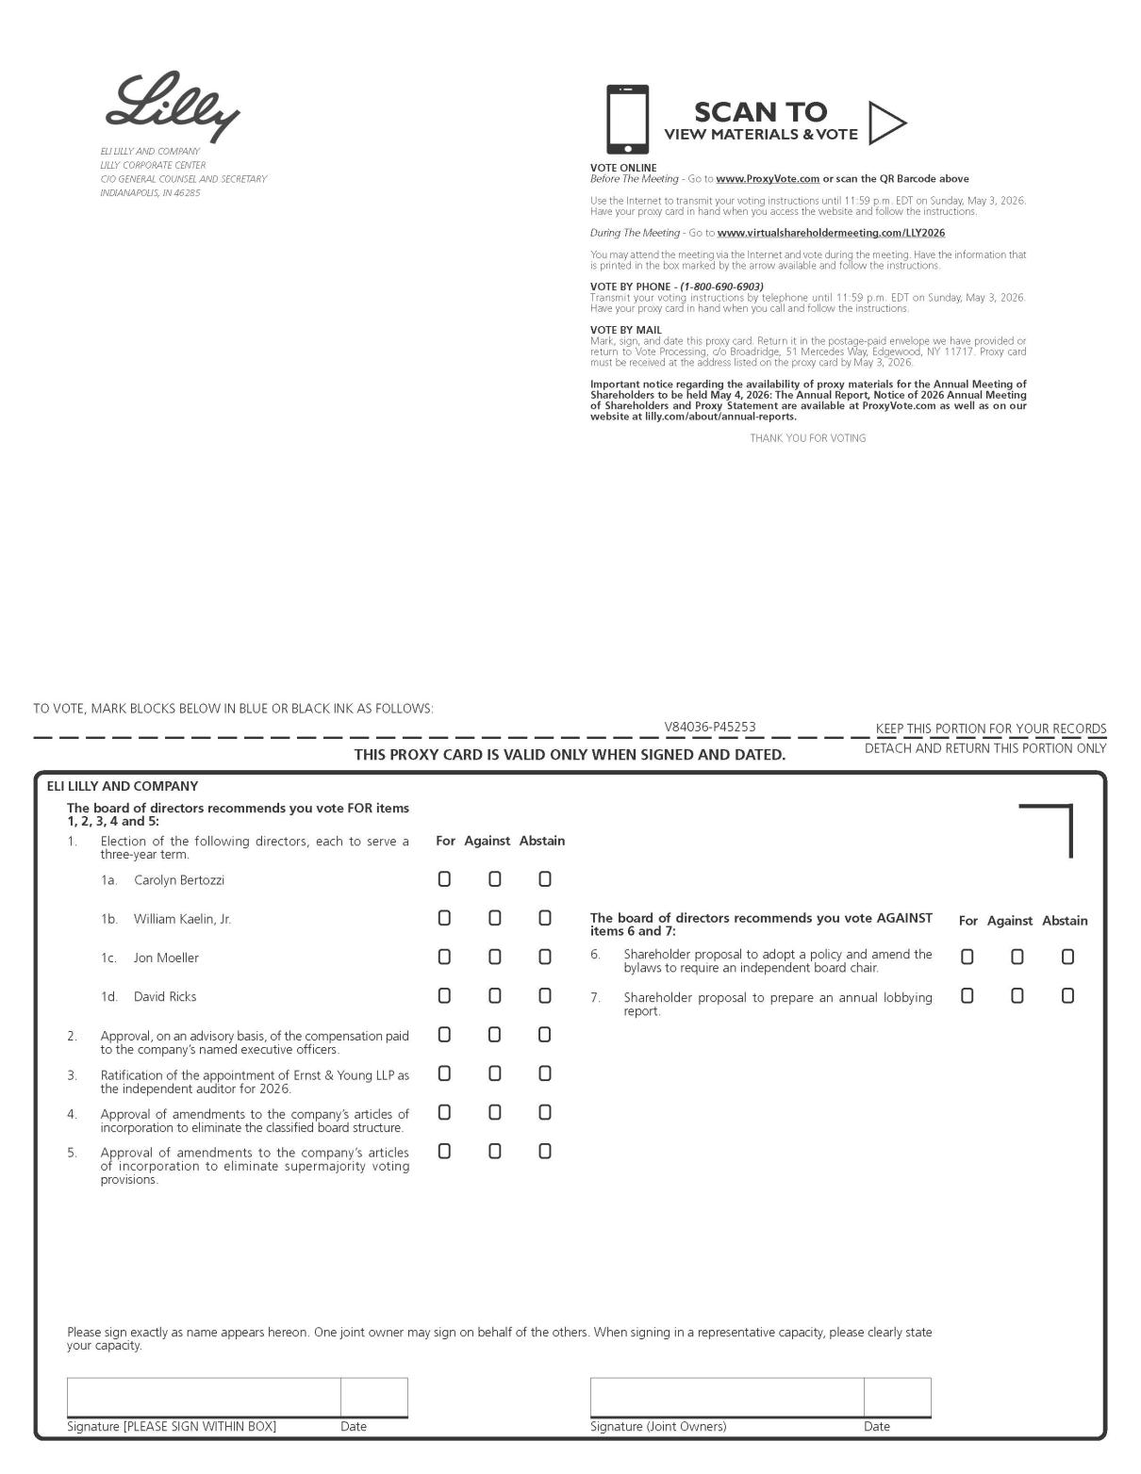

PC-1

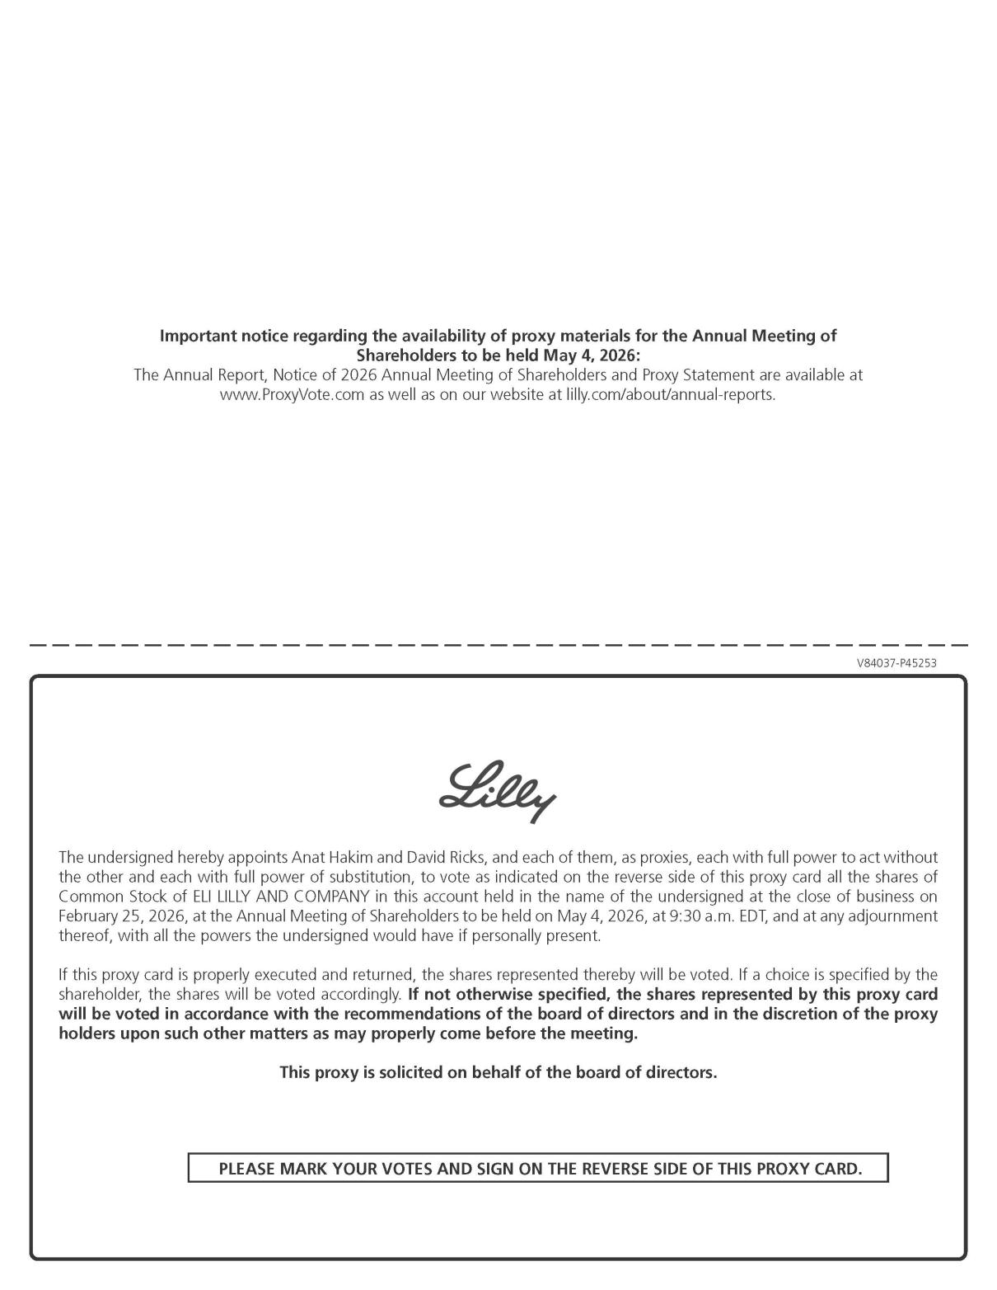

PC-2

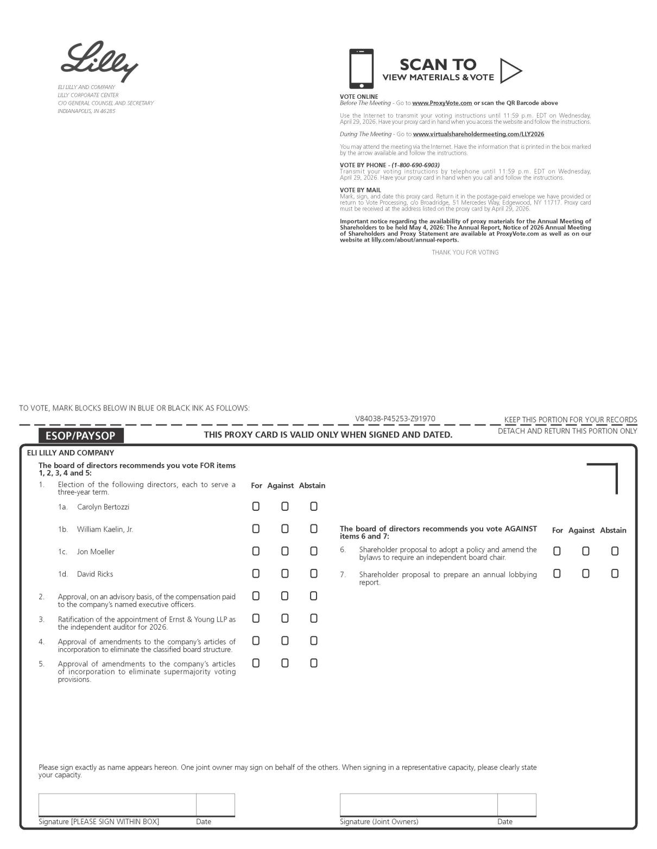

PC-3

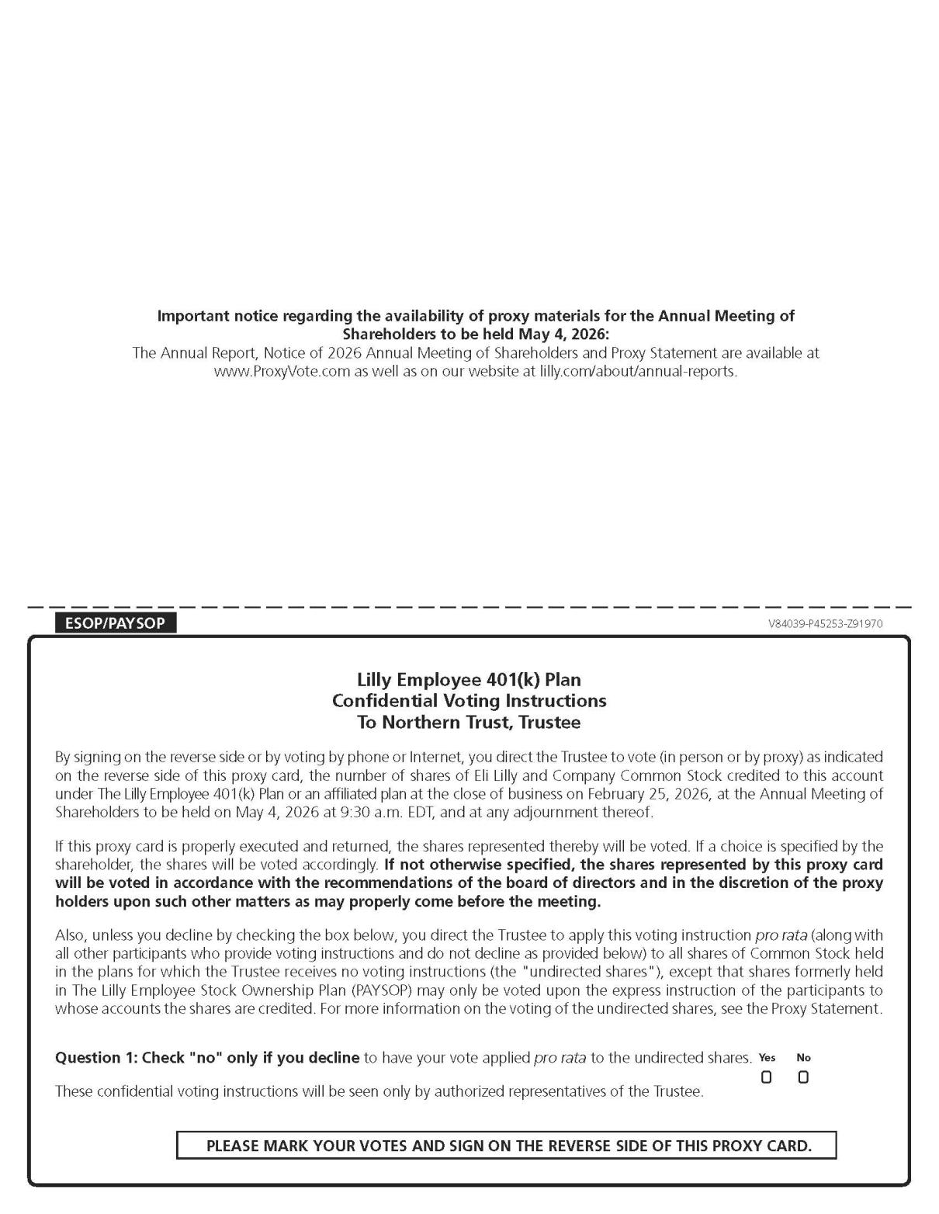

PC-4

